**sCRYPTOGRAPHY**

**Symmetric and Asymmetric**

**Hashing**

**Symmetric (classic)**

**1)Caeser**

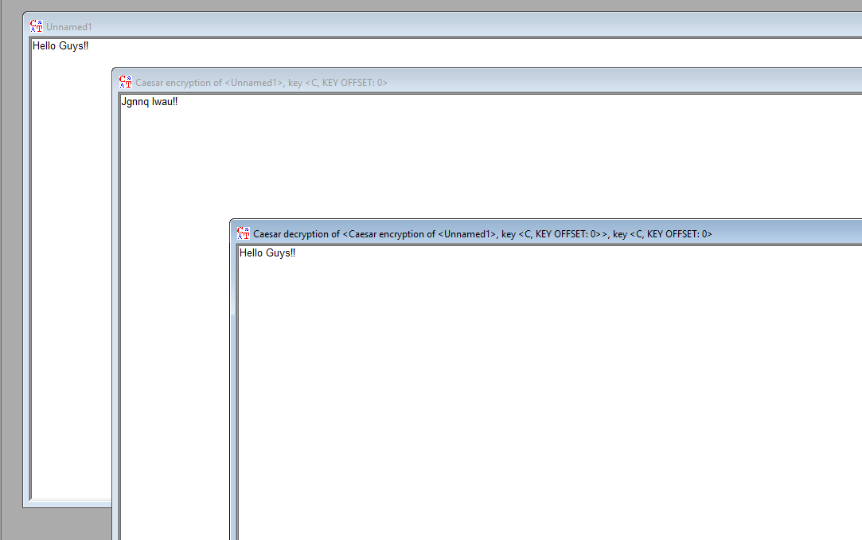

**2)Vigenere**

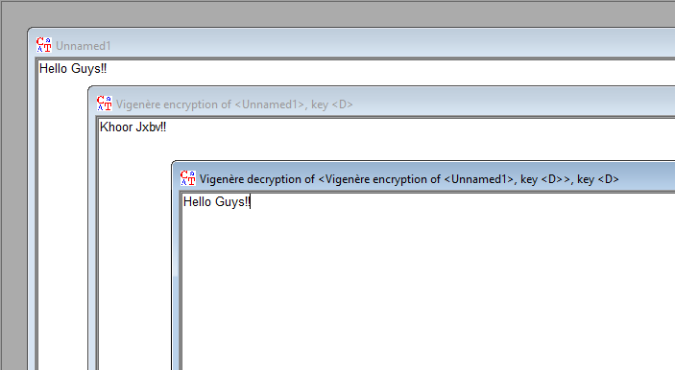

**ASYMMETRIC**

**RSA**

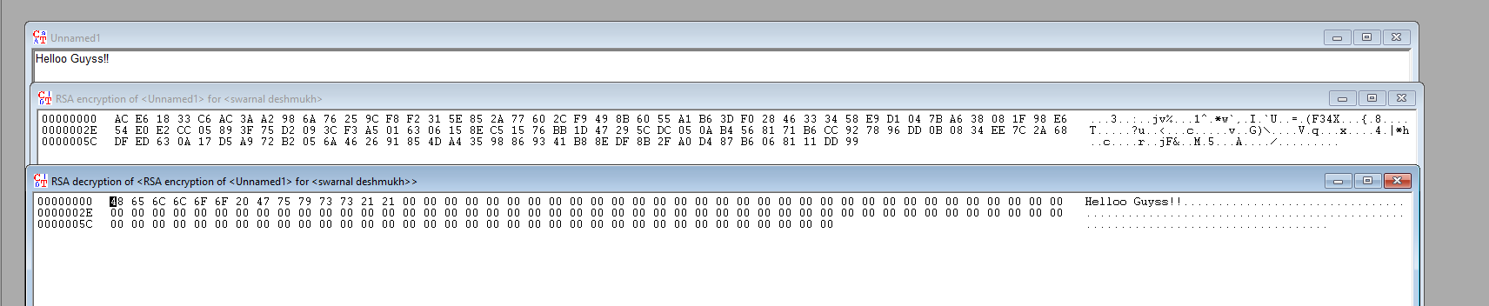

**HASHING ON CRYPTOOL**

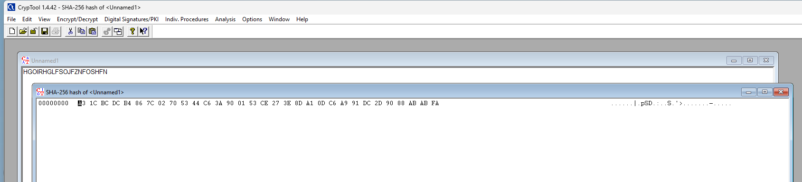

**HASHING ON HASHCALC**

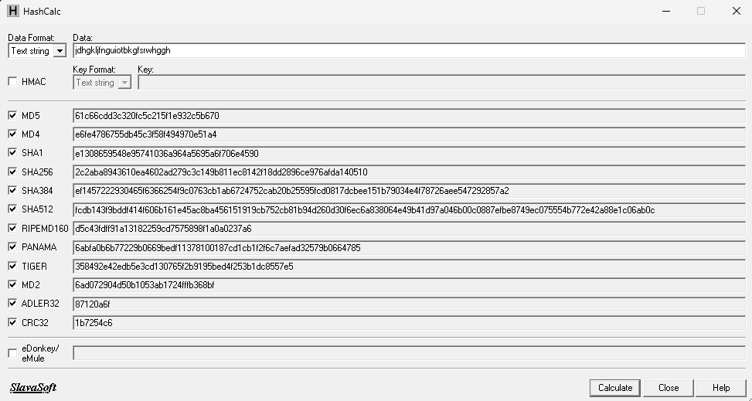

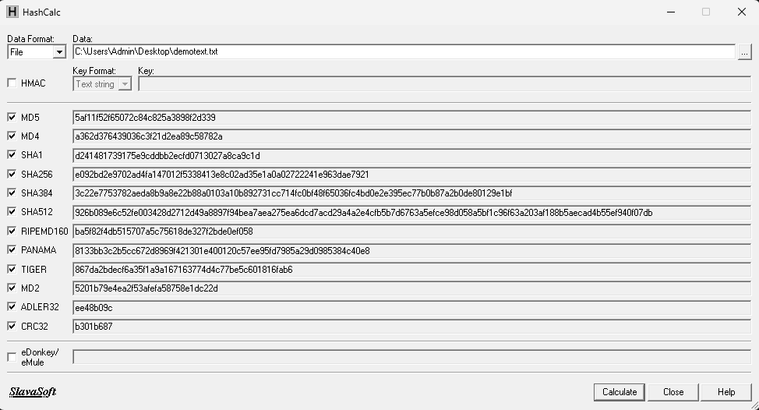

**HASHING USING HashMyFiles**

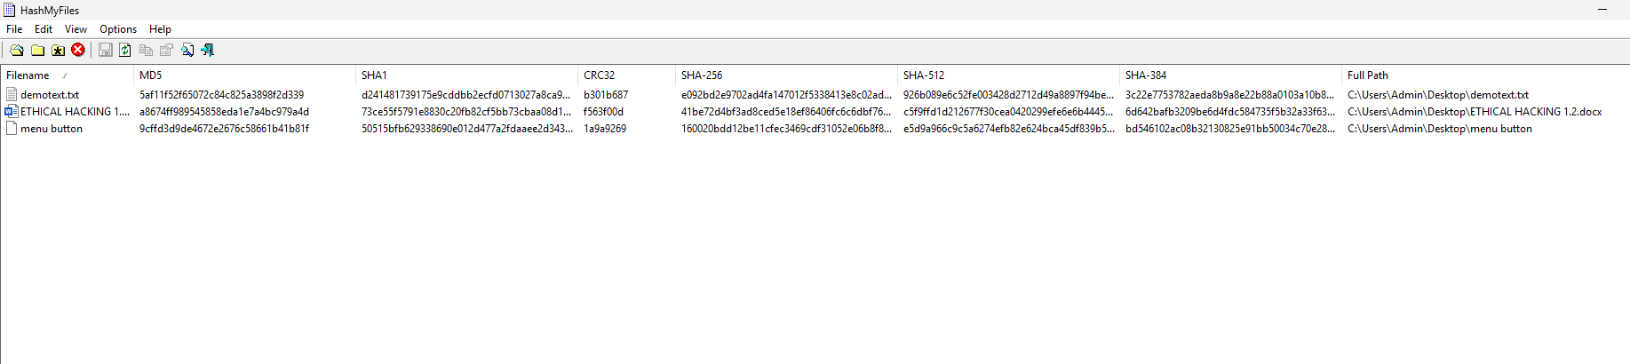

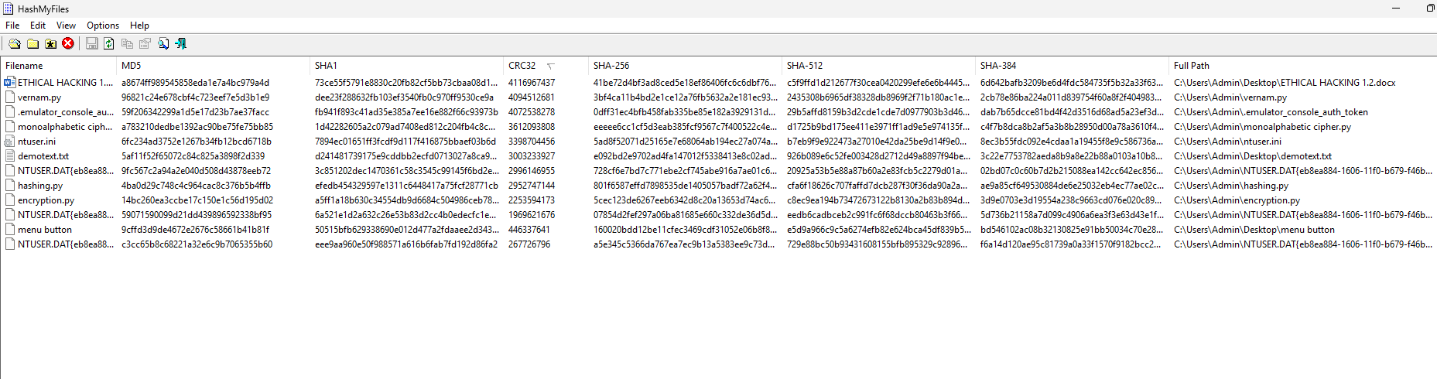

**PRACTICAL 2**

**HASHCAT**

**AIM: CRACKING THE HASHED PASSOWRD USING SHA-256 AND MD5.**

STEP1: DOWNLOAD HASHCAT FILES FROM WEBSITE AND EXTRACT THEM

Download the file having 7z in the ending

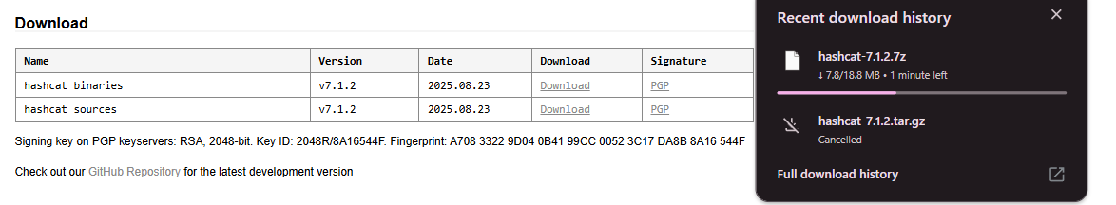

Extract it and open it

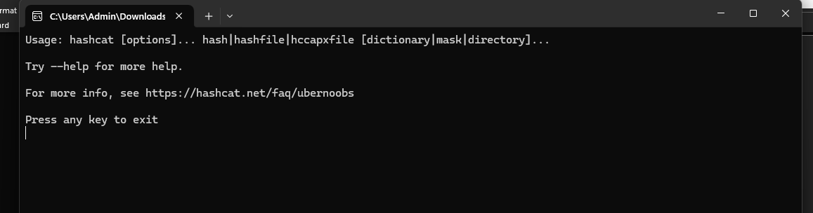

STEP2: CREATE TWO TXT DOCUMENT

abc.txt

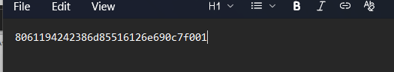

Take MD5 and SHA256 values for the text from HashCalc

wordlist.txt:

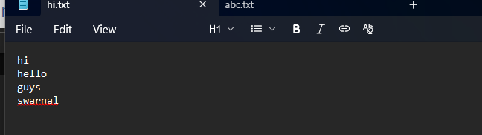

STEP4: MOVE THE TXT FILES TO THE HASHCAT FOLDER

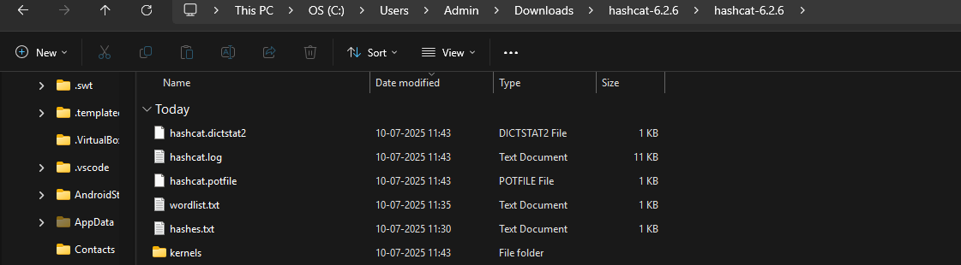

STEP5: OPEN CMD AND WRITE A COMMAND

**CMD:**

**For MD5**

hashcat.exe -m 0 -a 0 abc.txt hi.txt



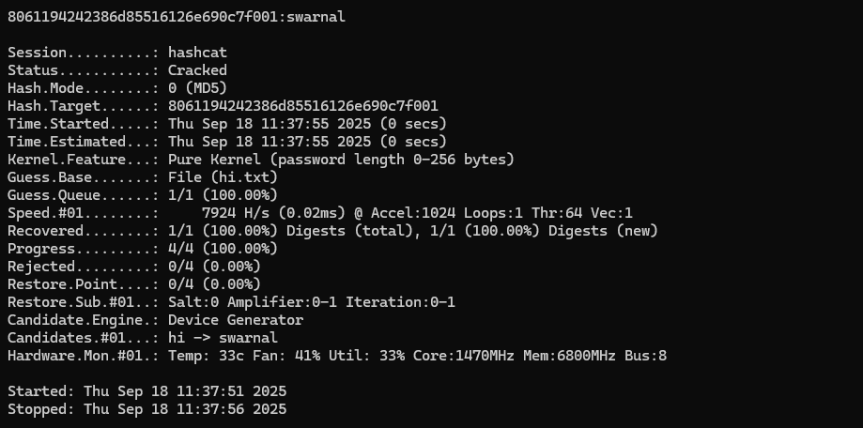

**For SHA 256**

hashcat.exe -m 1400 -a 0 abc.txt hi.txt



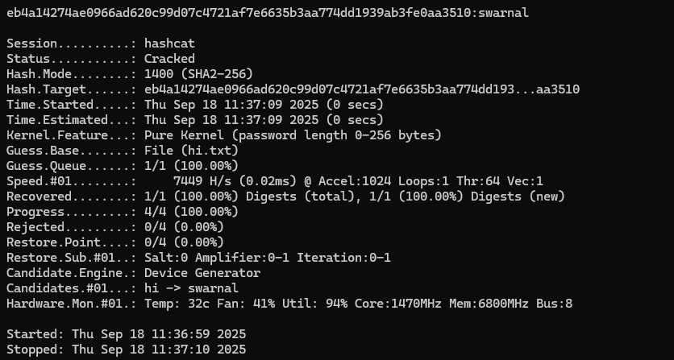

**PRACTICAL 3**

**GOOGLE DORKS AND RECONNAISSANCE**

**1.** **Display R programs in pdf format from Tutorialspoint**

**DORK**

**filetype:pdf https://www.tutorialspoint.com/ r program**

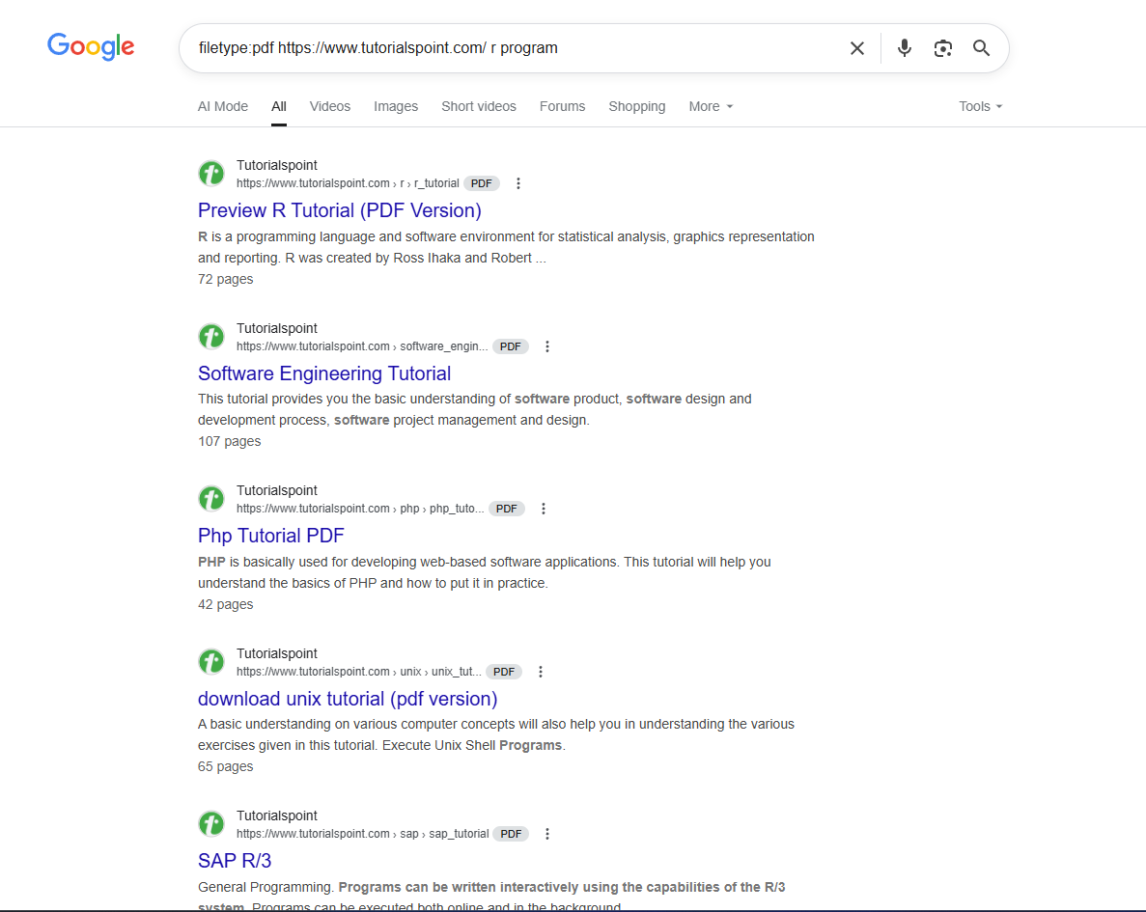

**2.Display facebook page of DSCIT**

**DORK**

**site: DCSIT facebook.com**

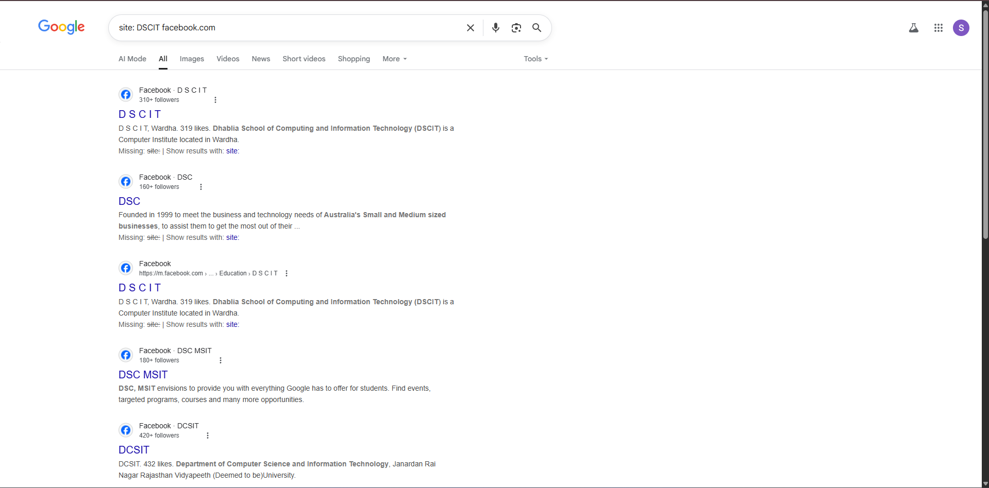

**3.Display all covid 19 vaccination details**

**DORK**

**intext: "Covid 19 vaccinations"**

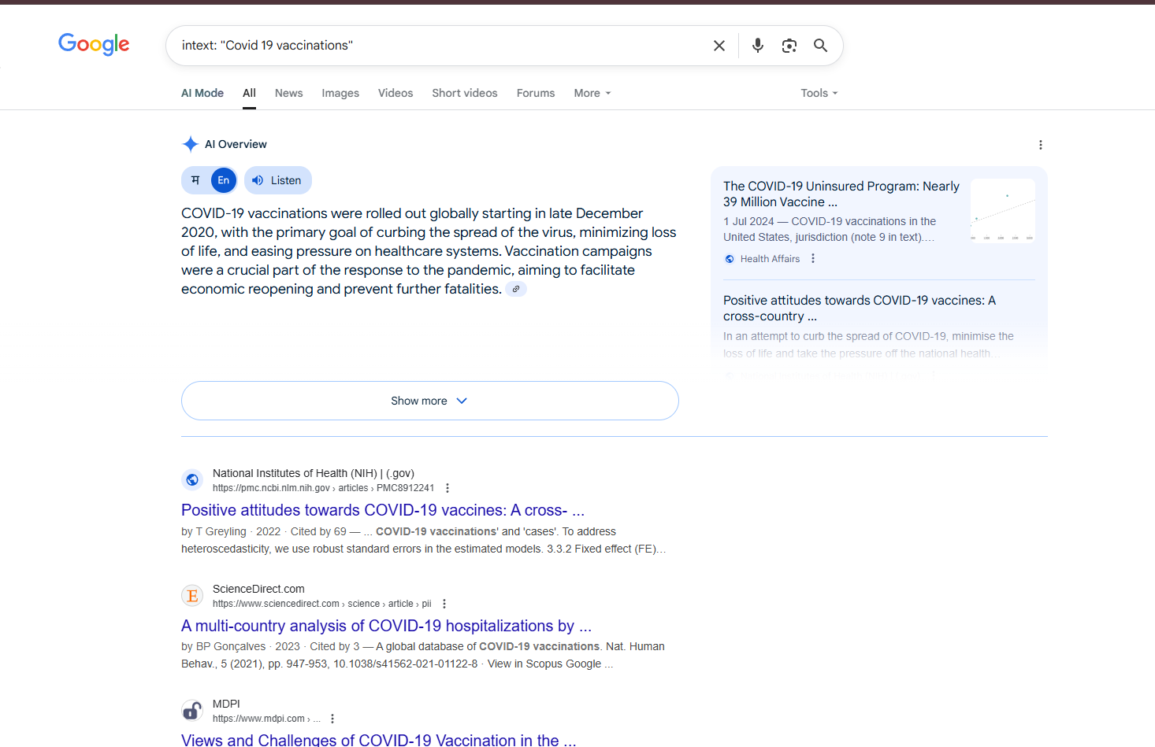

**4.** **Display all the websites from which we can access apple.com**

**DORK**

**link : “apple.com”**

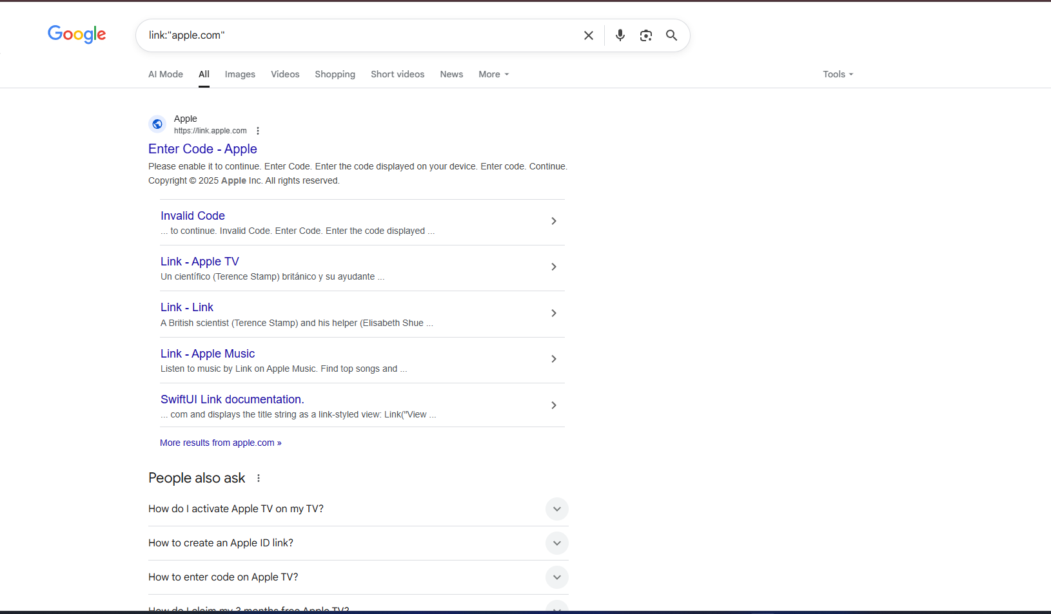

**5.** **Display insta pages related to Food channels.**

**DORK**

**site: Instagram.com food**

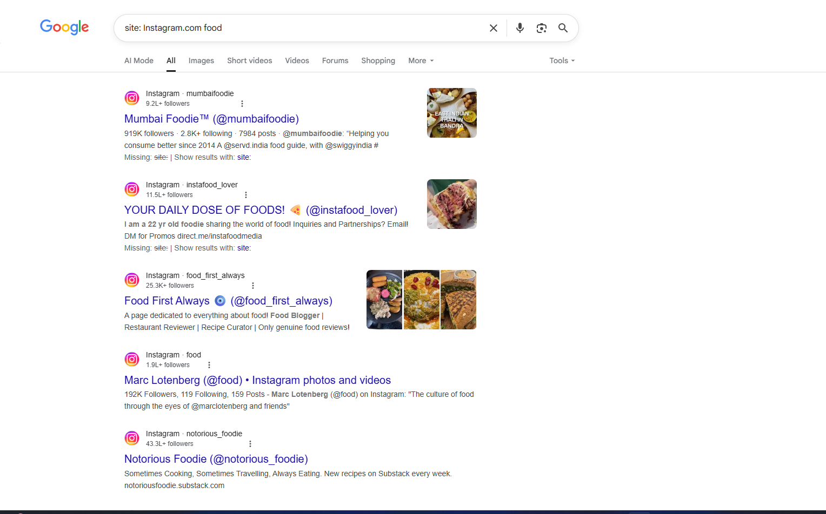

**6.Display all PDF files from NASA website**

**DORK**

**filetype : pdf site : nasa.gov**

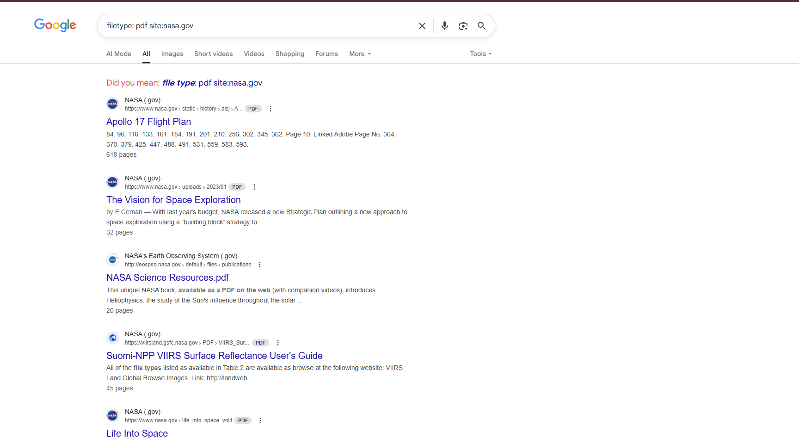

**7.Display all php files which consists information about Bill Gates**

**DORK**

**inurl:php intext:"Bill Gates"**



**8.** **Display information related to New education policy.**

**DORK**

**allintext:"new education policy"**

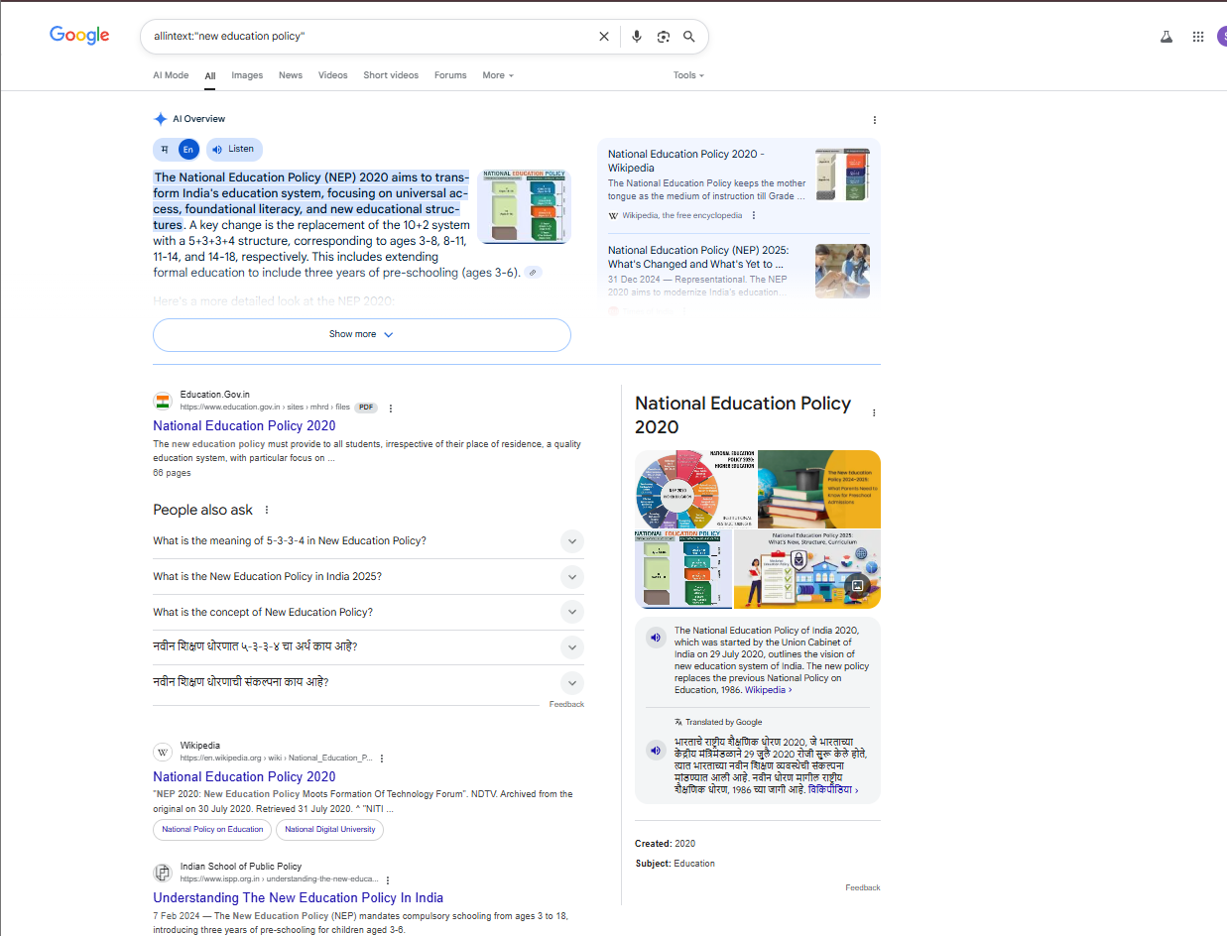

**9.** **Display today’s Australia weather**

**DORK**

**weather:australia**

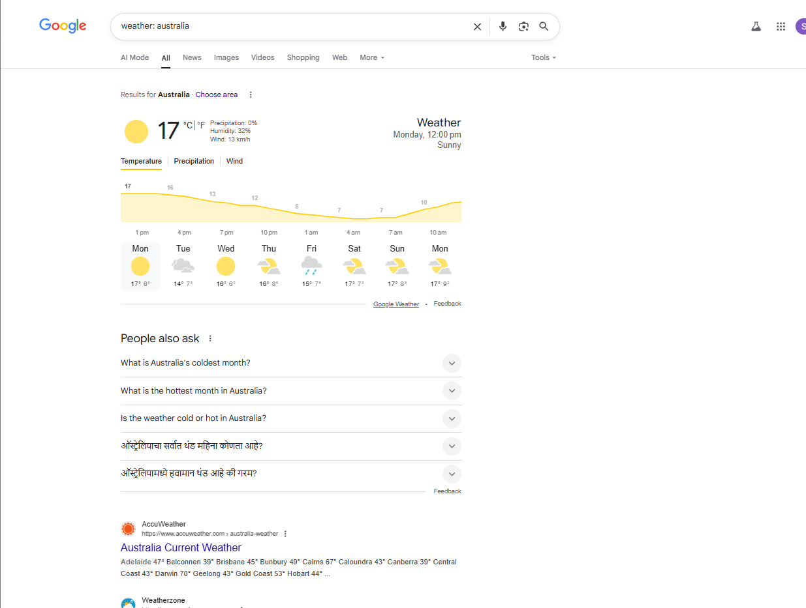

**10.** **Display all web pages who have secured their data by copyright**

**DORK**

**allintext:@copyright**

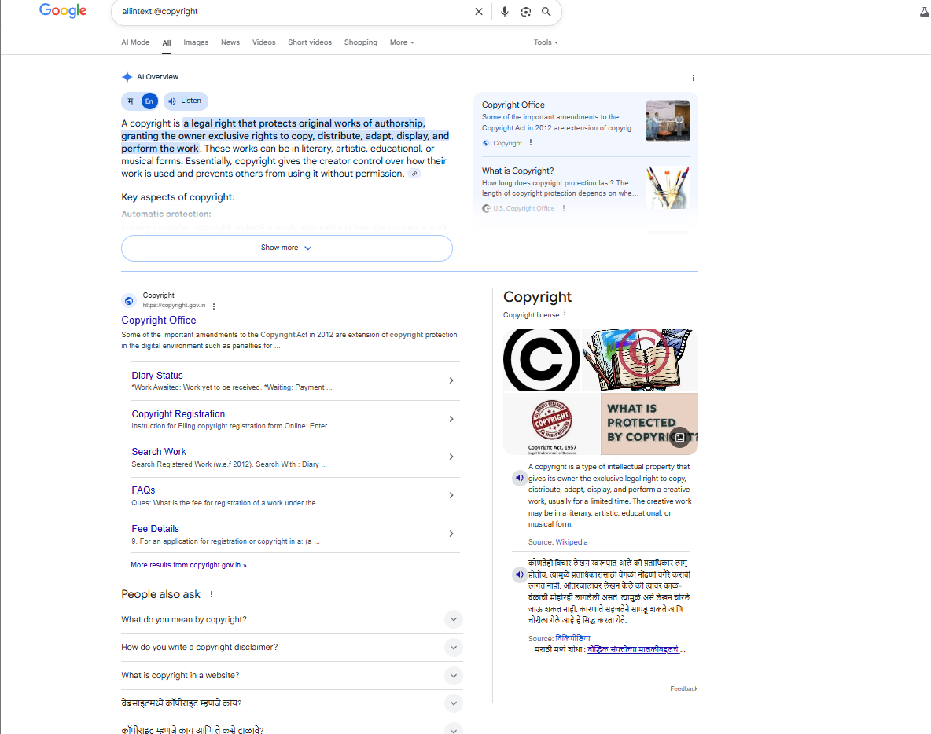

**11.** **Find all security plans at National level from government websites**

**DORK**

**Intext: “security plans” inurl:gov.in**

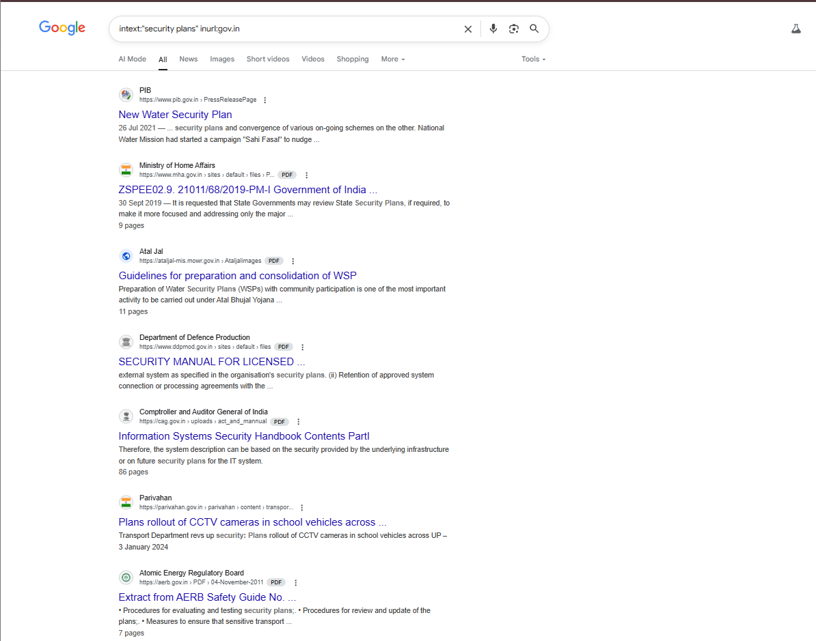

**12.** **Display mumbai cycling marathon 2023 web pages.**

**DORK**

**allintext:mumbai cycling marathon 2023 site:**

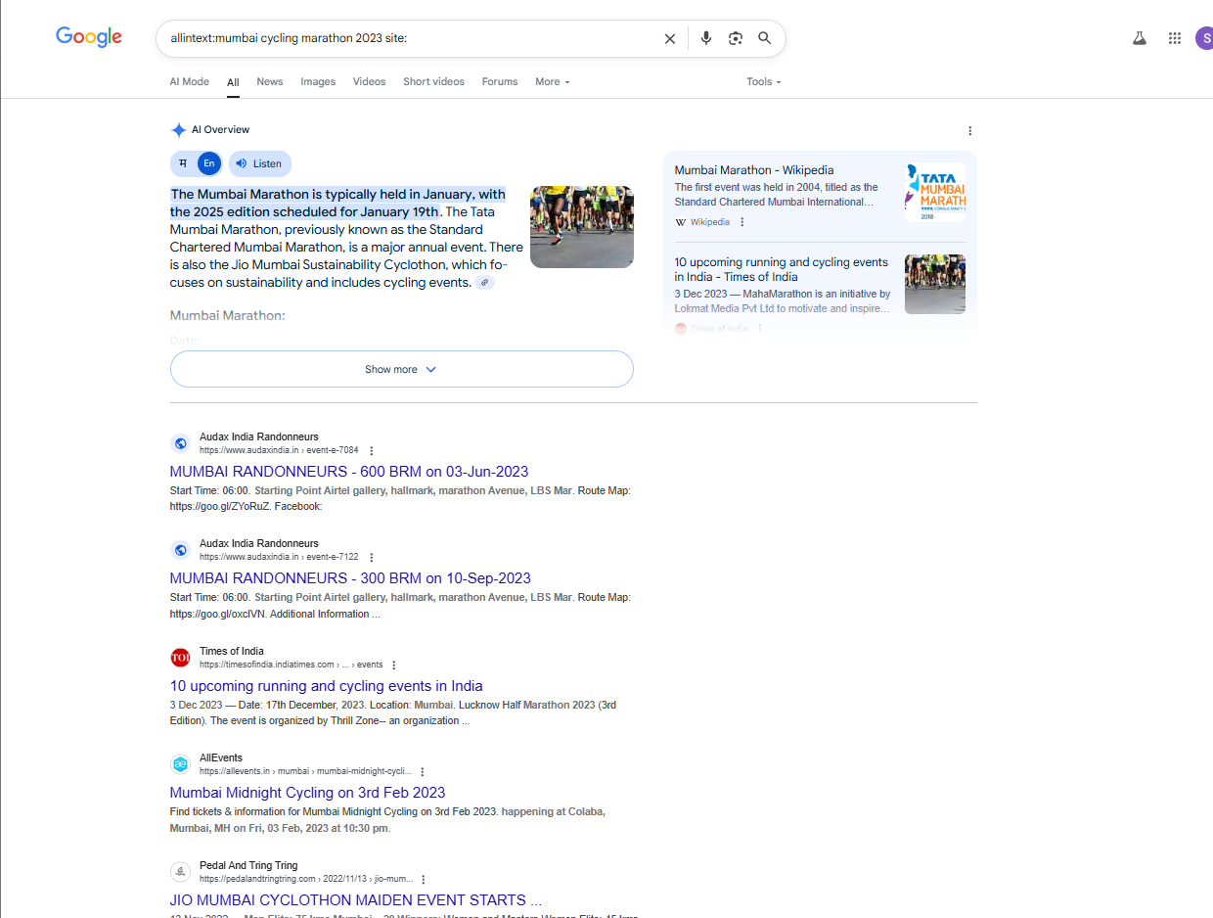

**13.Display all information about any error in python**

**DORK**

**error:TypeError python**

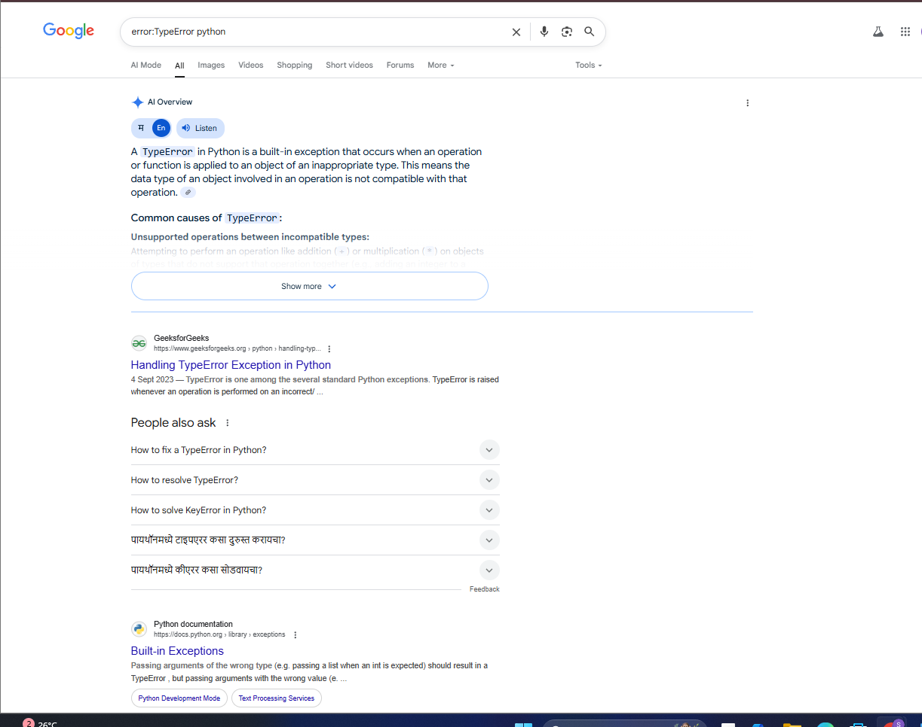

**14.Find routes from Mumbai to Gujrat**

**DORK**

**allintext: Mumbai to gujrat routes**

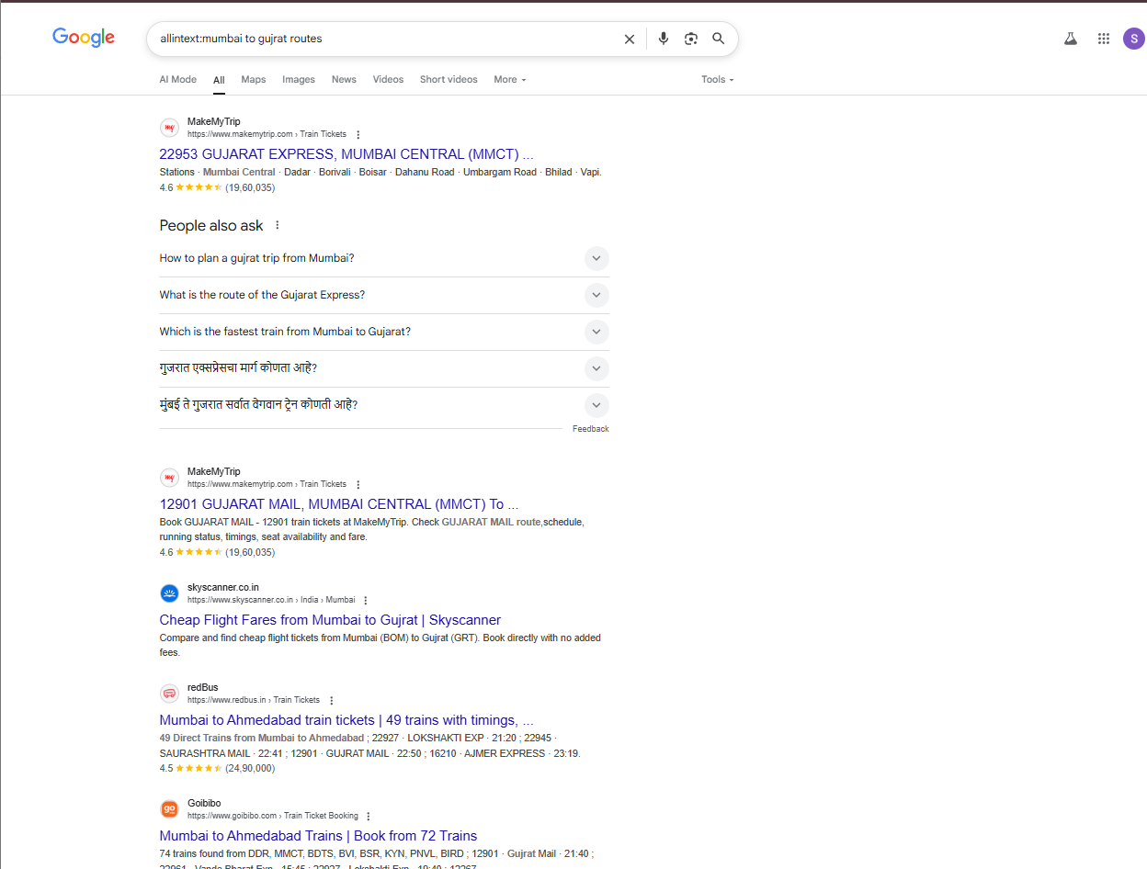

**15.Display all webpages to connect facebook**

**DORK**

**allintitle:connect to @facebook**

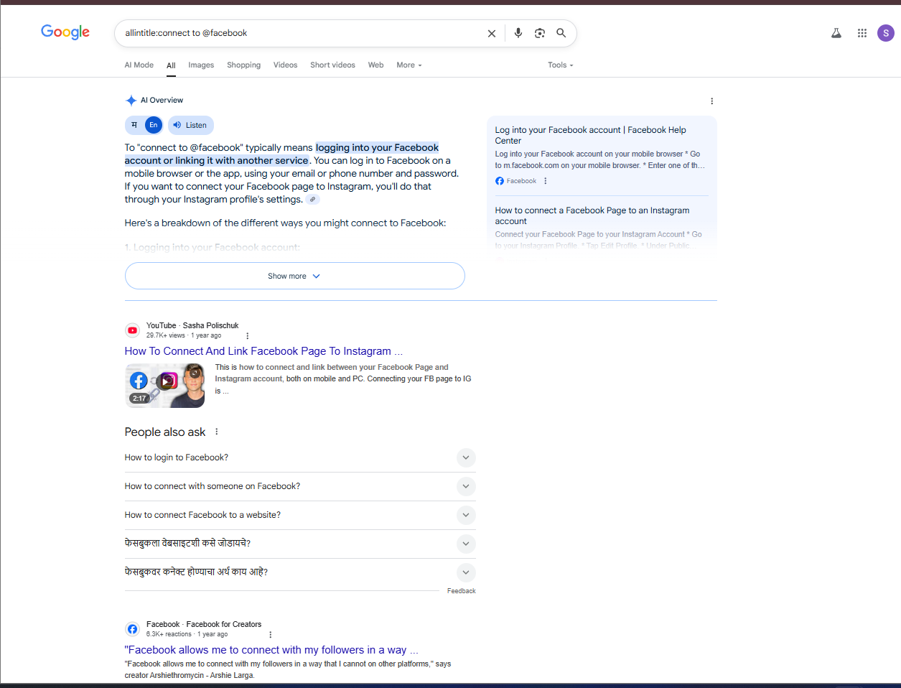

**16.Find white paper for bitcoin**

**DORK**

**intext:bitcoin filetype:pdf**

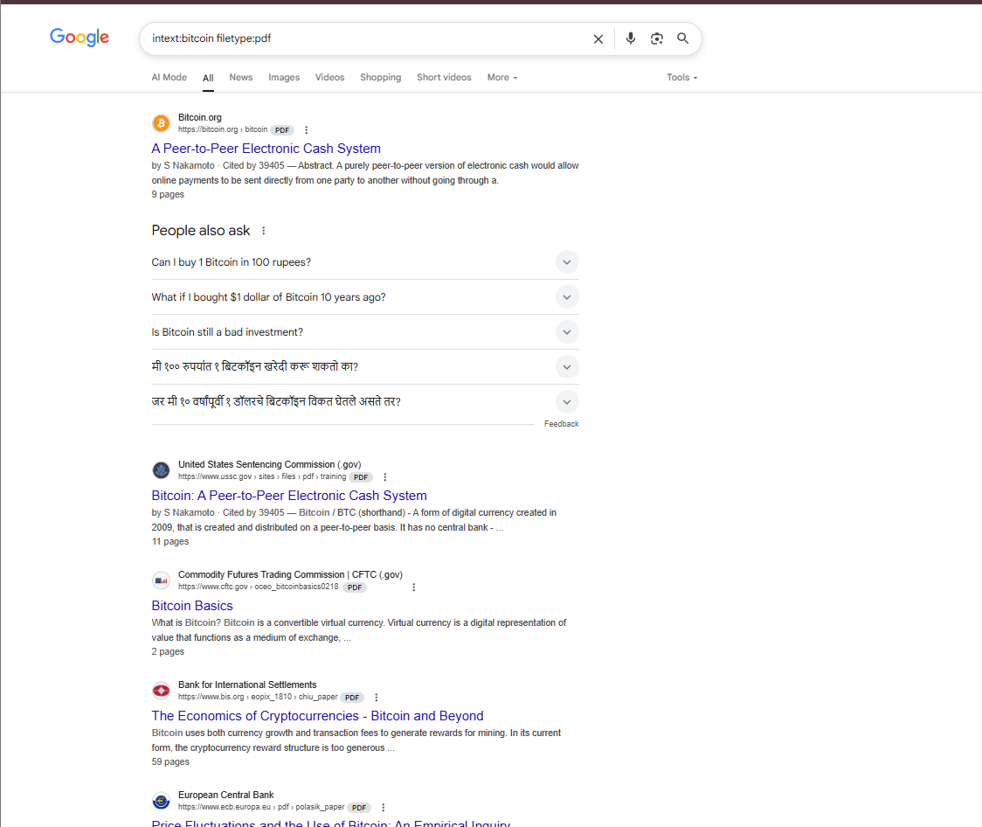

**17.Display Maharashtra pandemic report of today**

**DORK**

**allintext:Maharashtra Pandemic report of today**

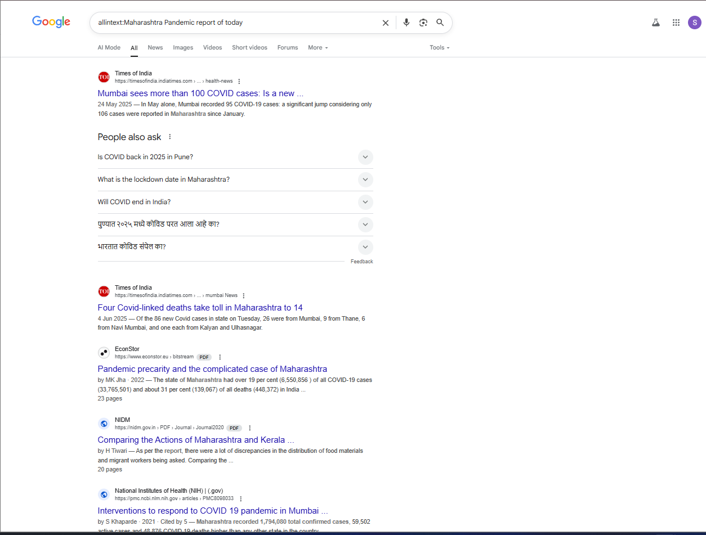

**18.** **Find Video of Modiji to explain importance of Yoga on yoga day**

**DORK**

**video:Modiji yoga day**

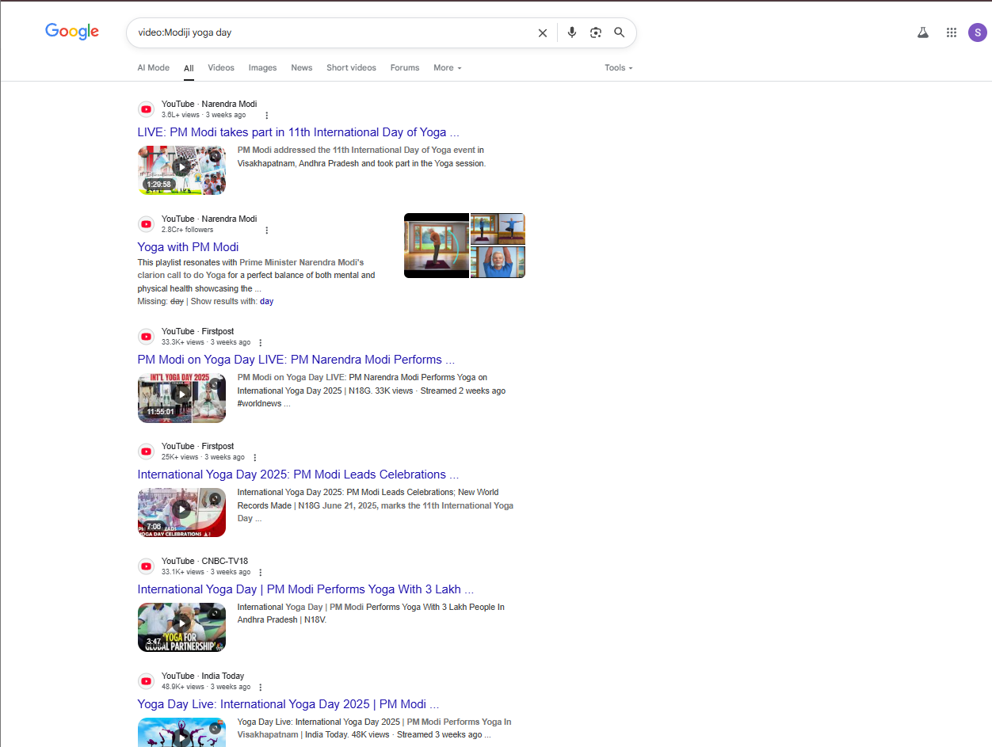

**19.** **Display ATKT timetable of June 2023 from Ruia college**

**DORK**

**allintext:ATKT timetable 2023 site:ruiacollege.edu**

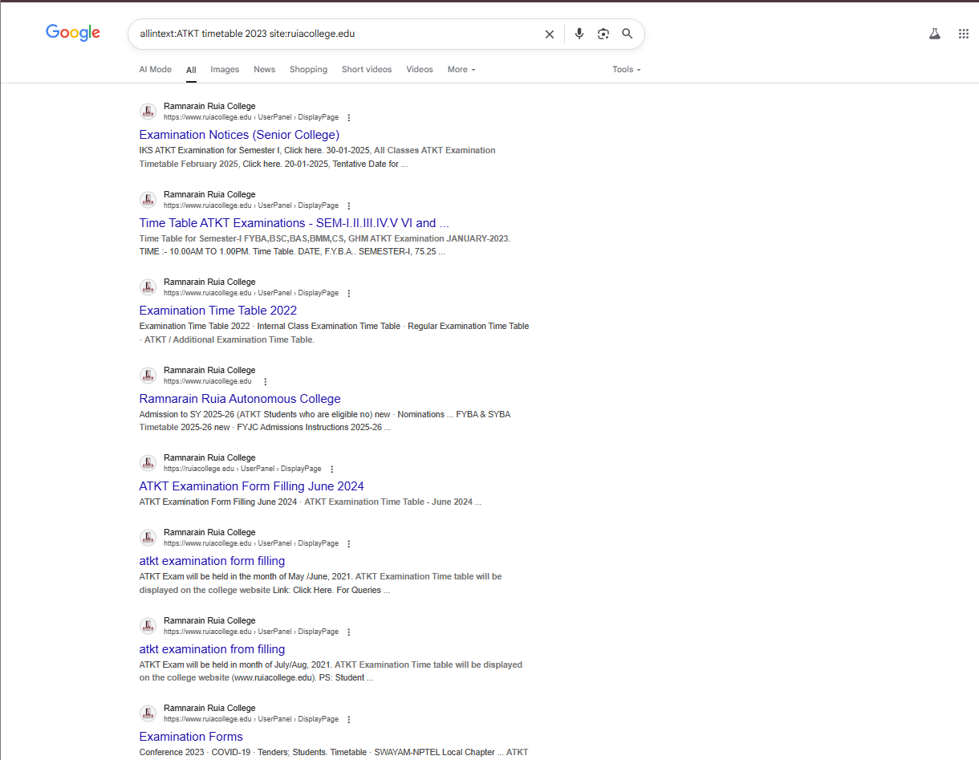

**20.Display today’s weather of Mumbai**

**DORK**

**intitle:weather mumbai**

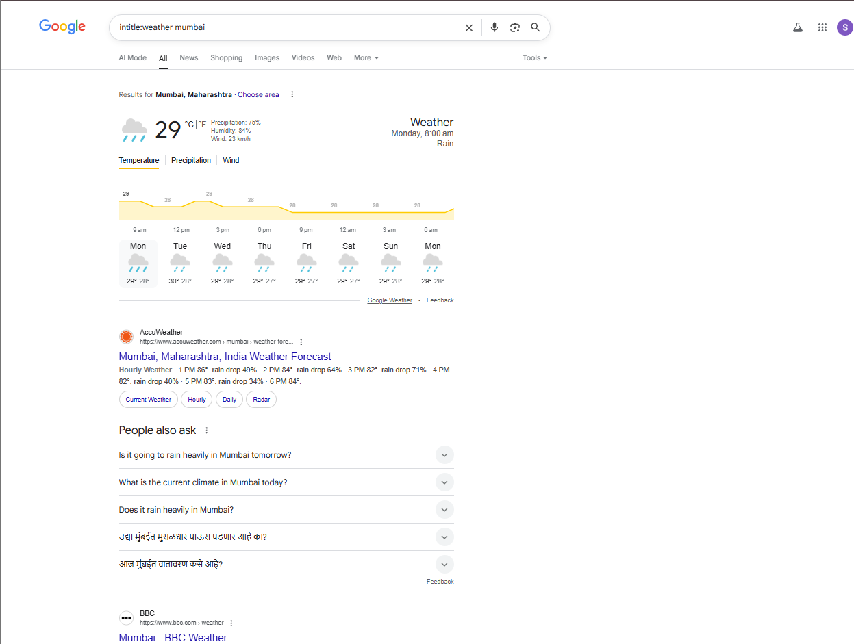

**21.** **Information about all websites having keyword “inspiration”.**

**DORK**

**intitle: inspiration**

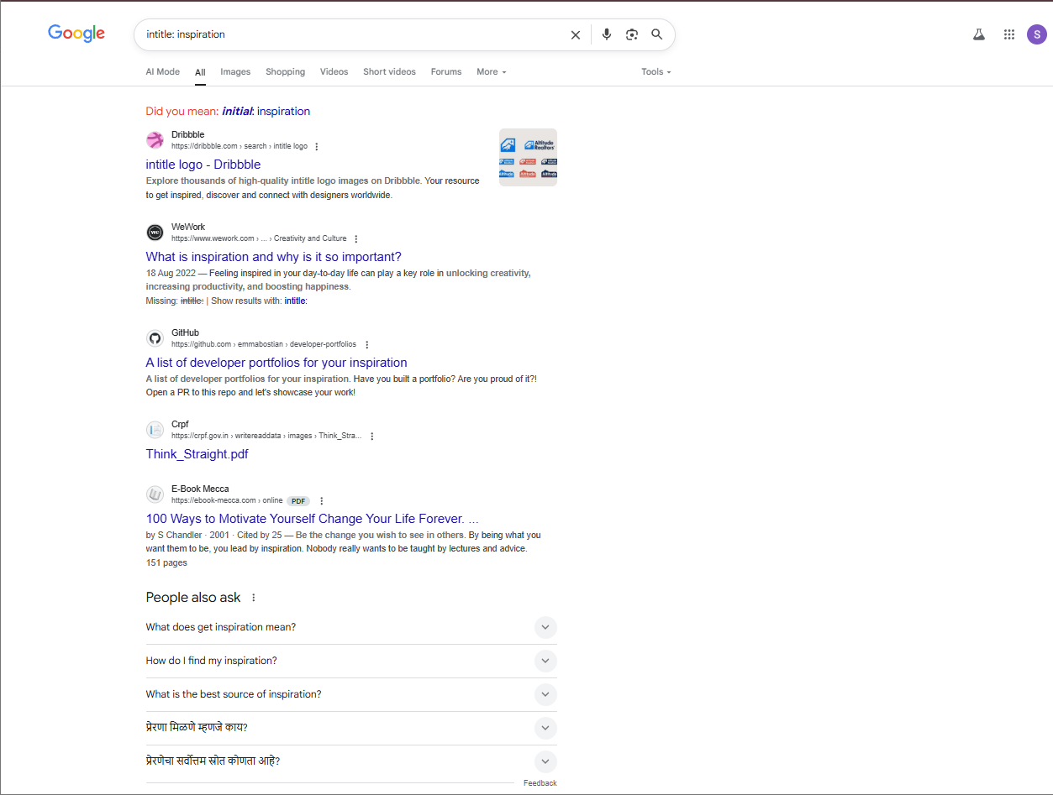

**22.** **Pdf files about cyber security.**

**DORK**

**filetype: pdf allintext:cyber security**

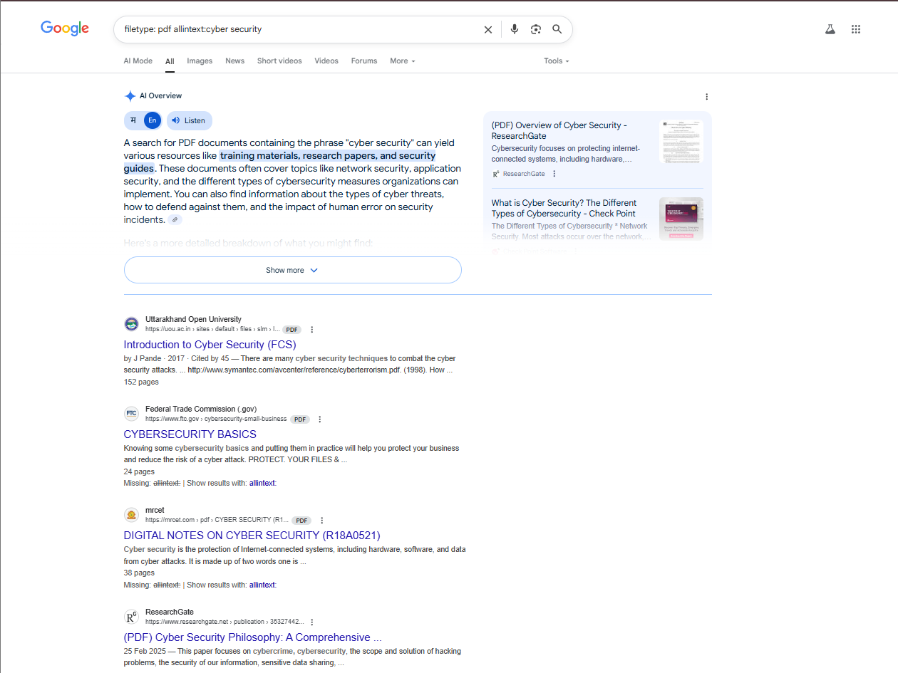

**23.Information about telegram**

**DORK**

**info:www.telegram.com**

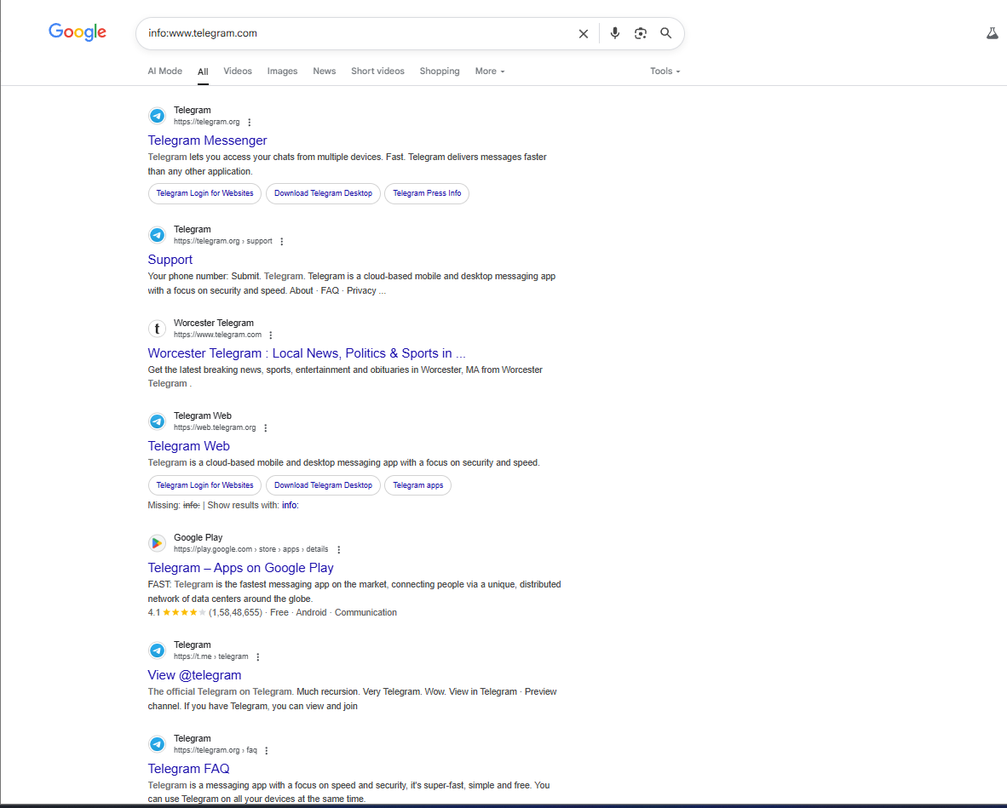

**24.** **Ruia college notice regarding admissions 2023.**

**DORK**

**allintext:admissions 2012 site:ruiacollege.edu**

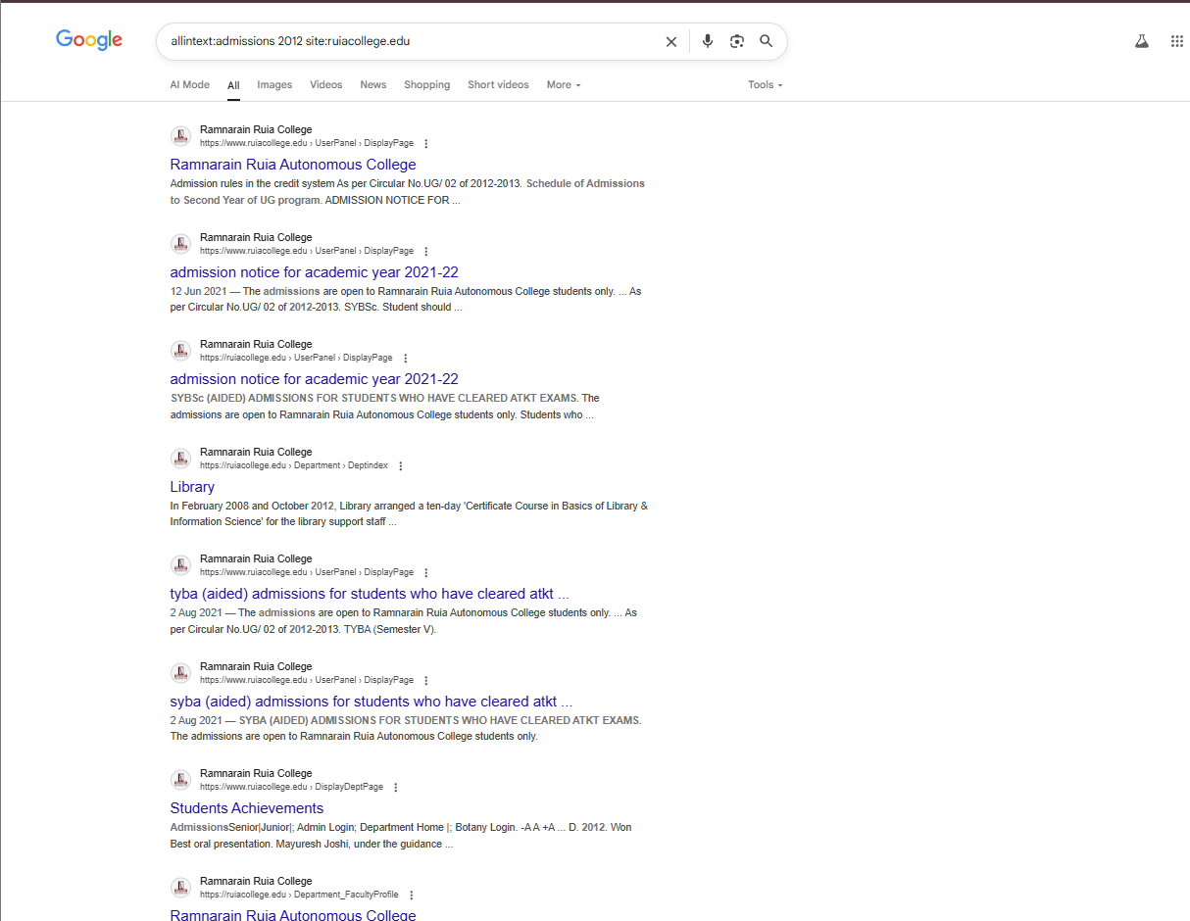

**25.Defination of term ‘hacking’**

**DORK**

**define:hacking**

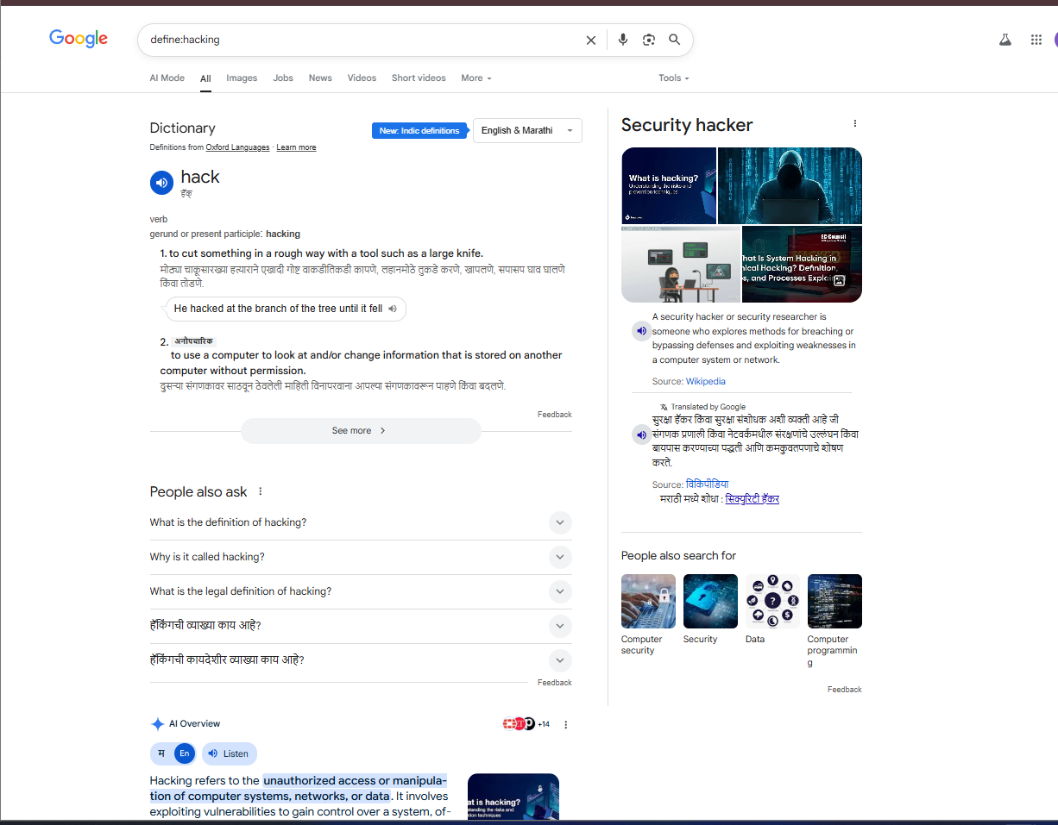

**RECONNAISSANCE**

**1.**

**CODE**

import whois

domain = whois.whois("www.yahoo.co.in")

print(domain)

**OUTPUT**

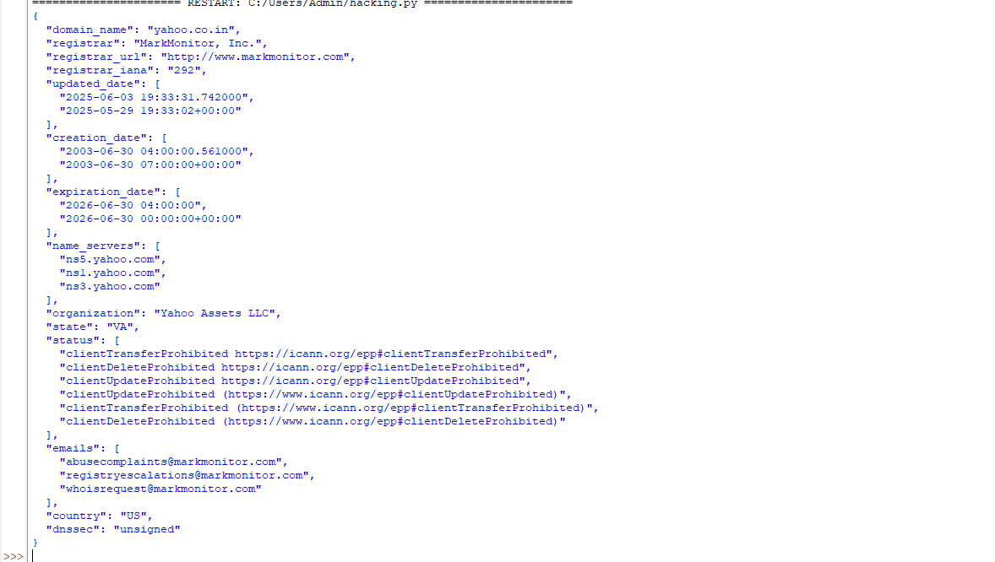

**2.**



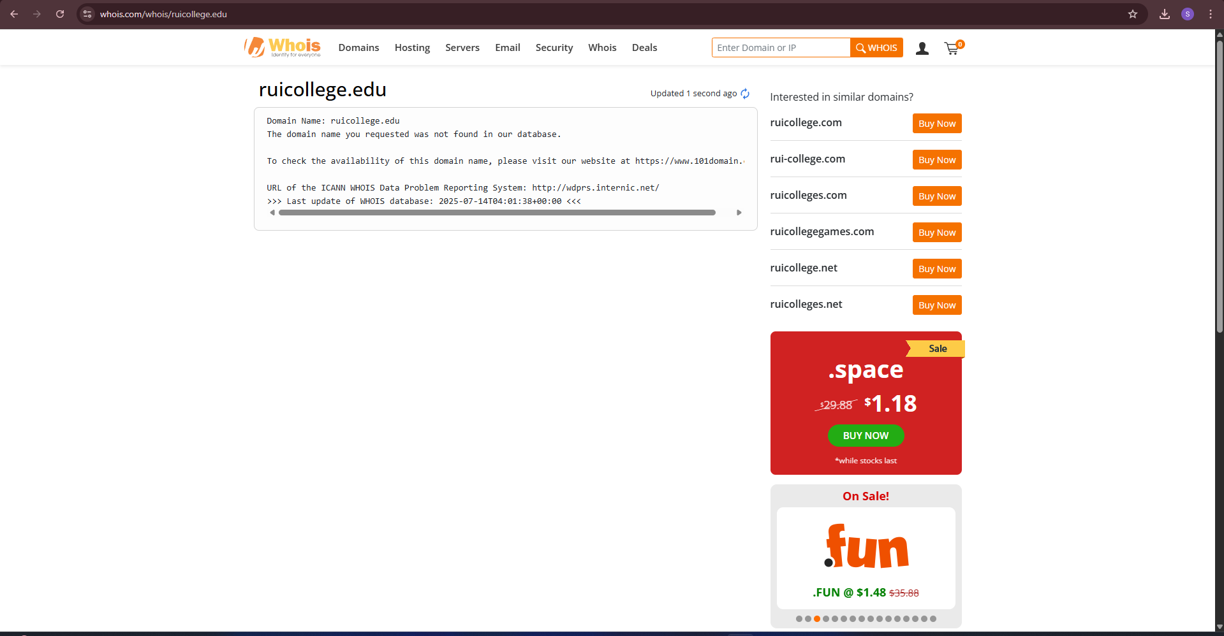

**ETHICAL HACKING PRACTICAL 4**

**CRYPT ANALYSIS USING CRYPTOOL**

**1.CEASER CIPHER**

**ENCRYPTION**

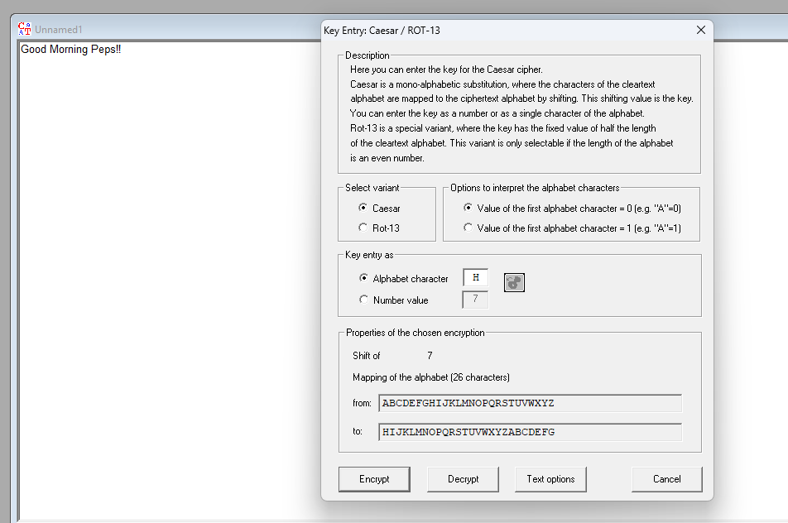

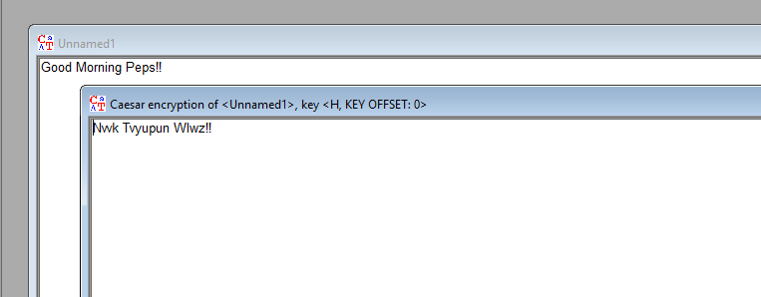

**DECRYPTION**

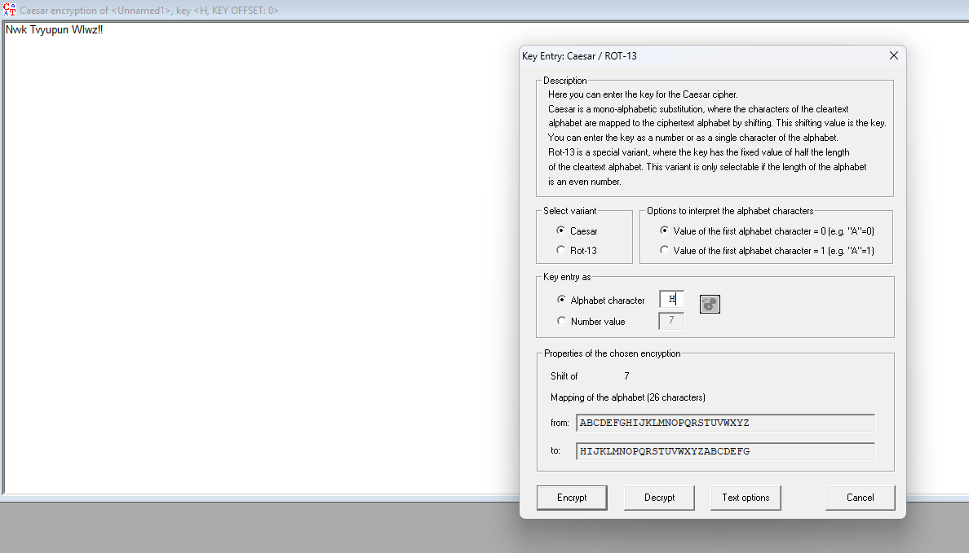

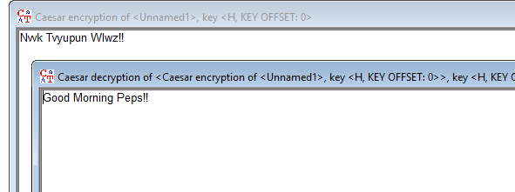

**2. VIGENERE CIPHER**

**ENCRYPTION**

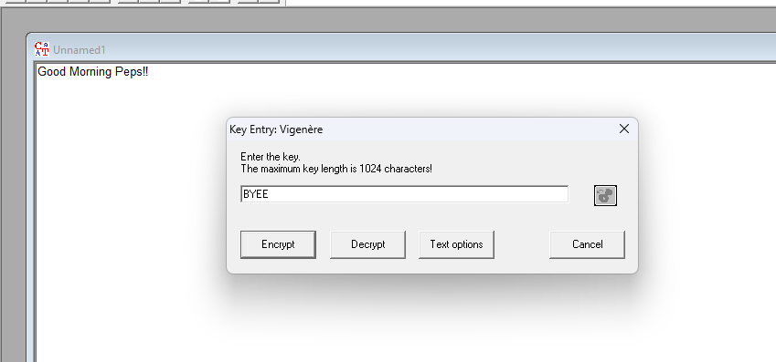

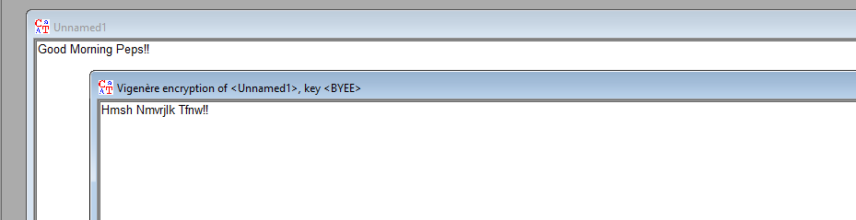

**DECRYPTION**

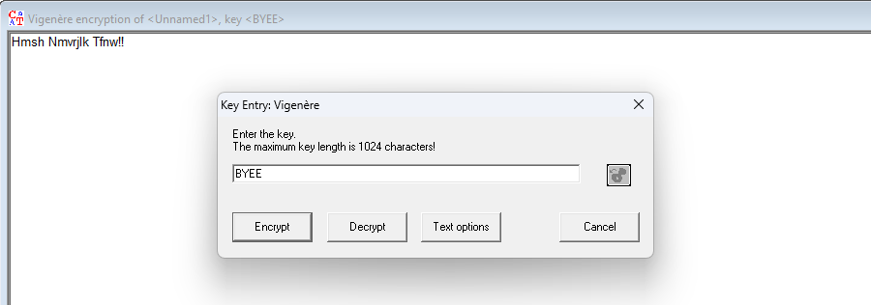

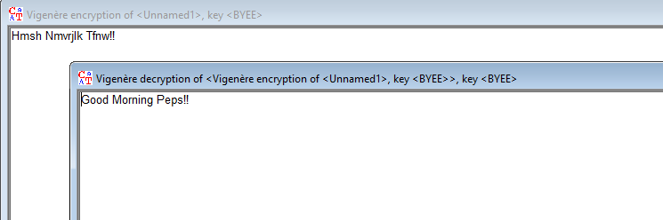

**3.PLAYFAIR CIPHER**

**ENCRYPTION**

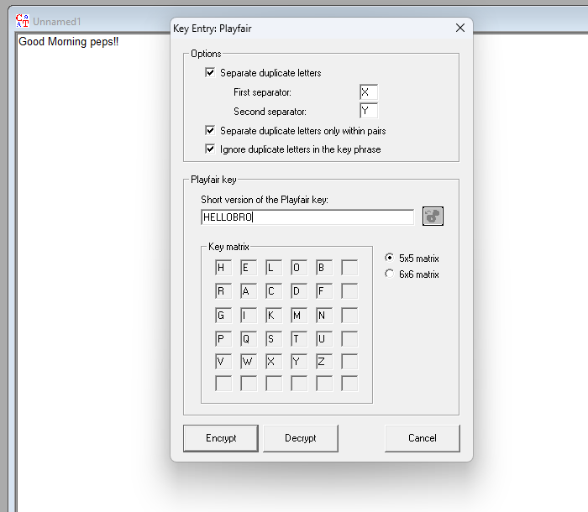

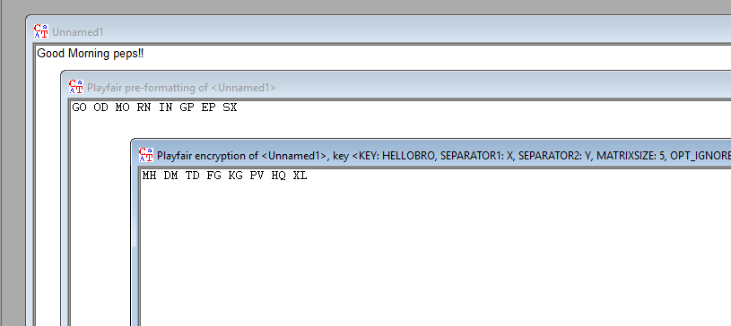

**DECRYPTION**

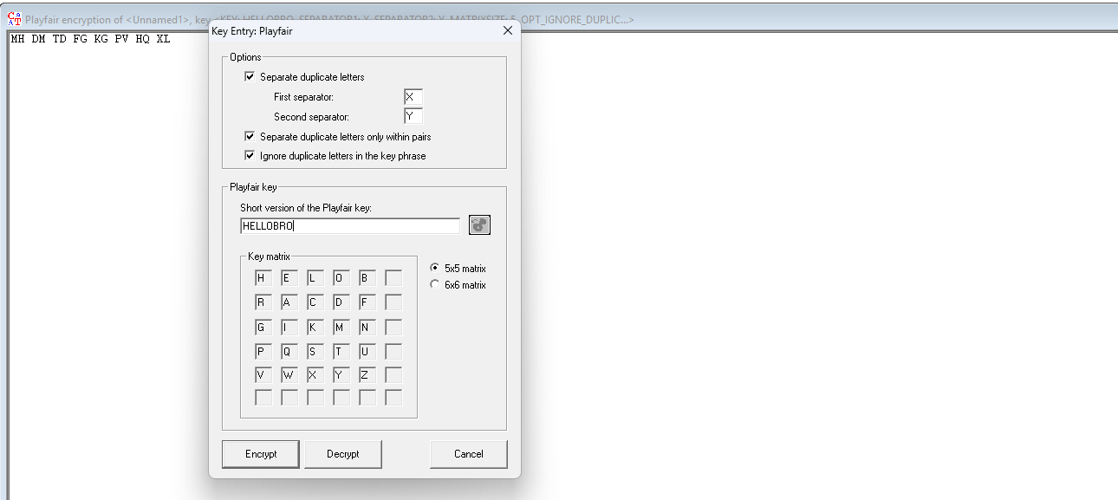

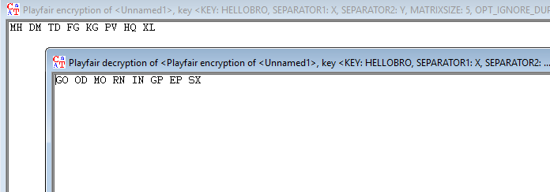

**4. DES CIPHER (ECB mode)**

**ENCRYPTION**

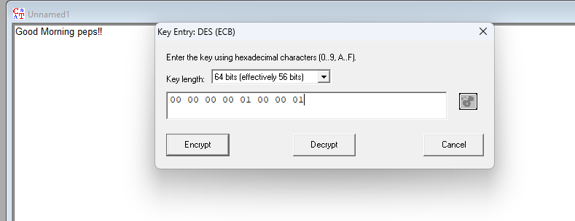

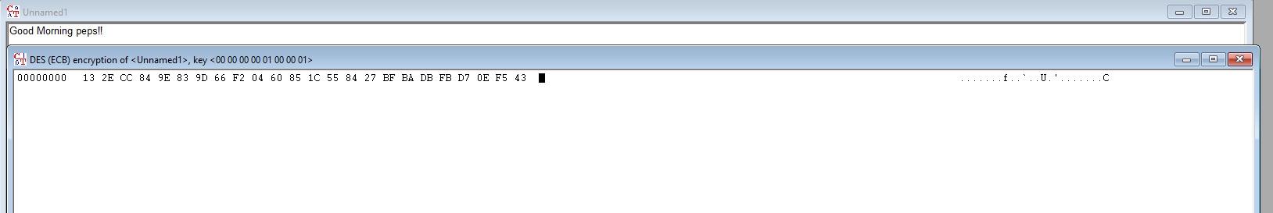

**DECRYPTION**

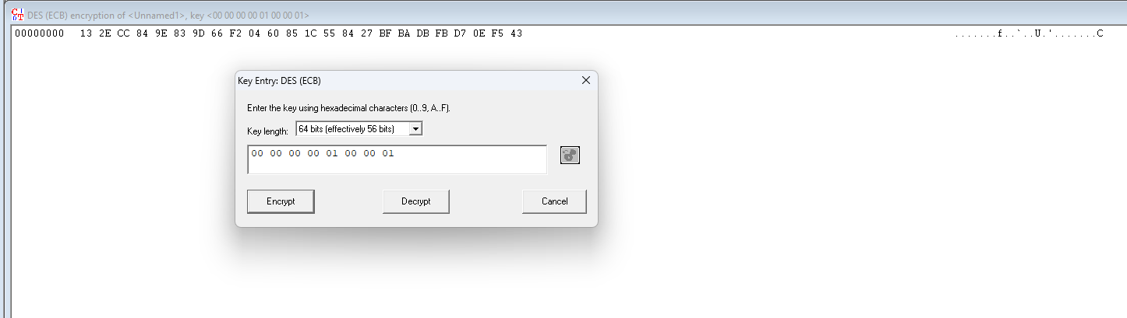

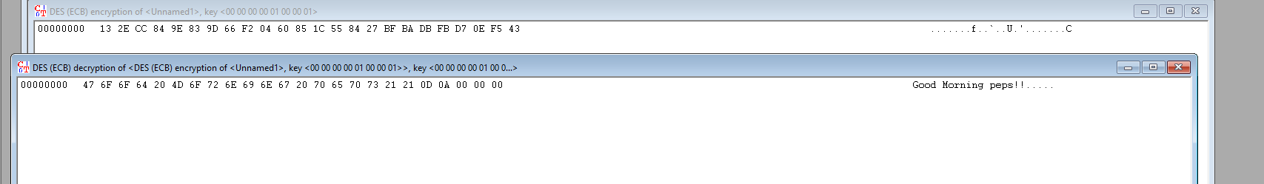

**5.AES CIPHER (CBC mode)**

**ENCRYPTION**

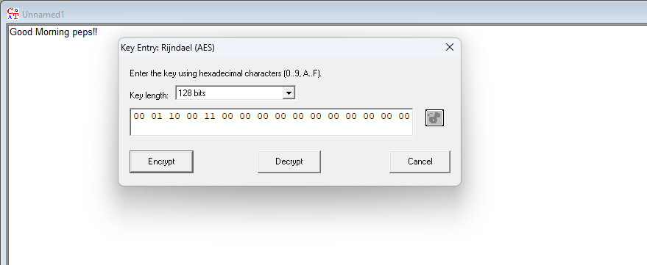

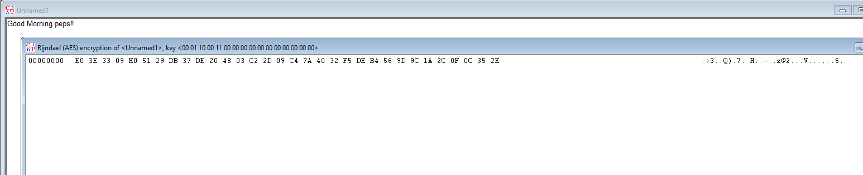

**DECRYPTION**

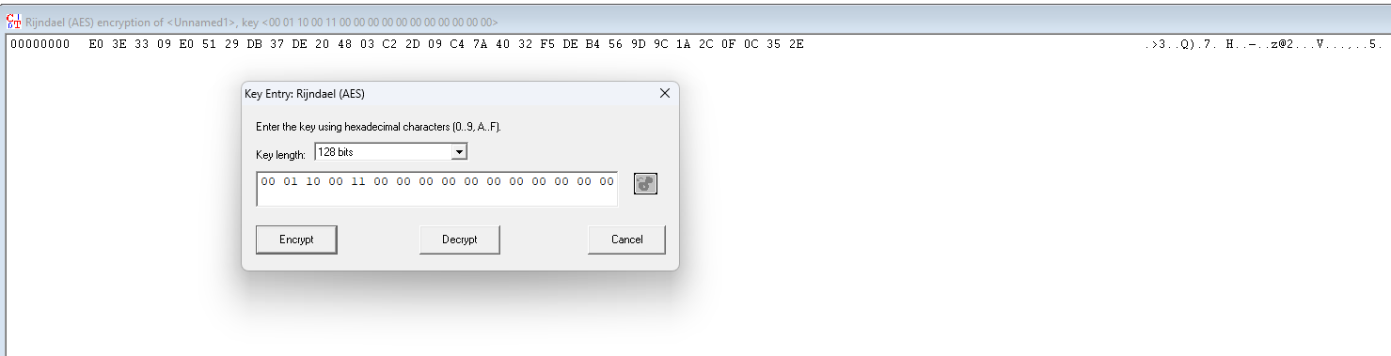

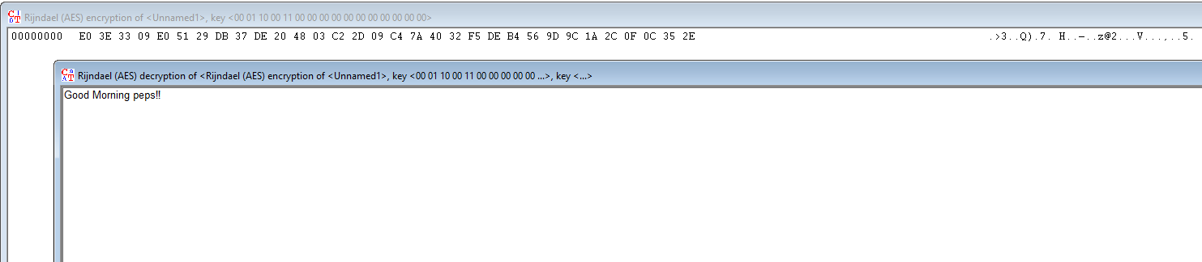

**6. RC4 CIPHER**

**ENCRYPTION**

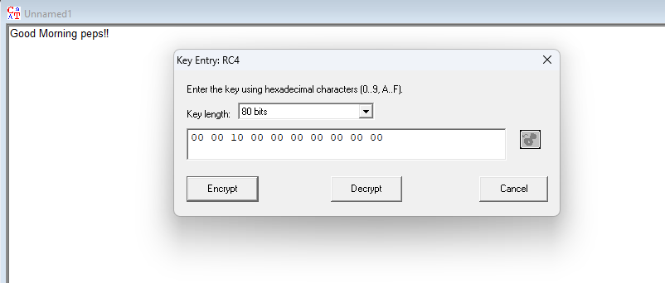

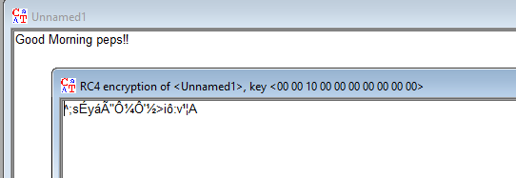

**DECRYPTION**

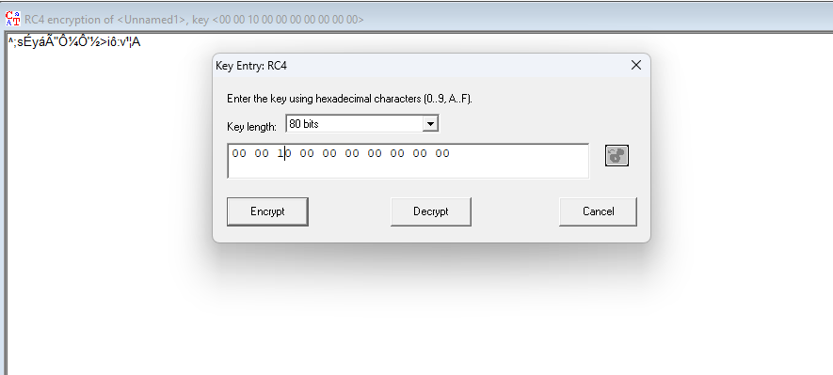

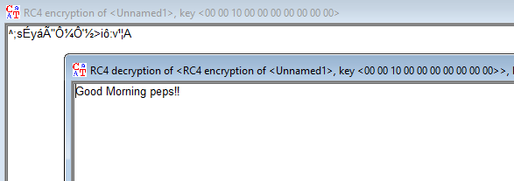

**7. BRUTE FORCE ANALYSIS of RC4 CIPHER**

**ENCRYPTION**

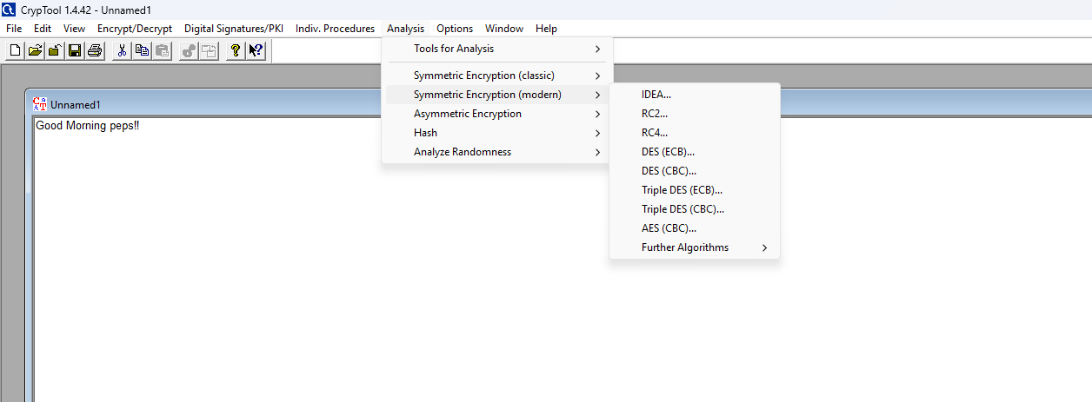

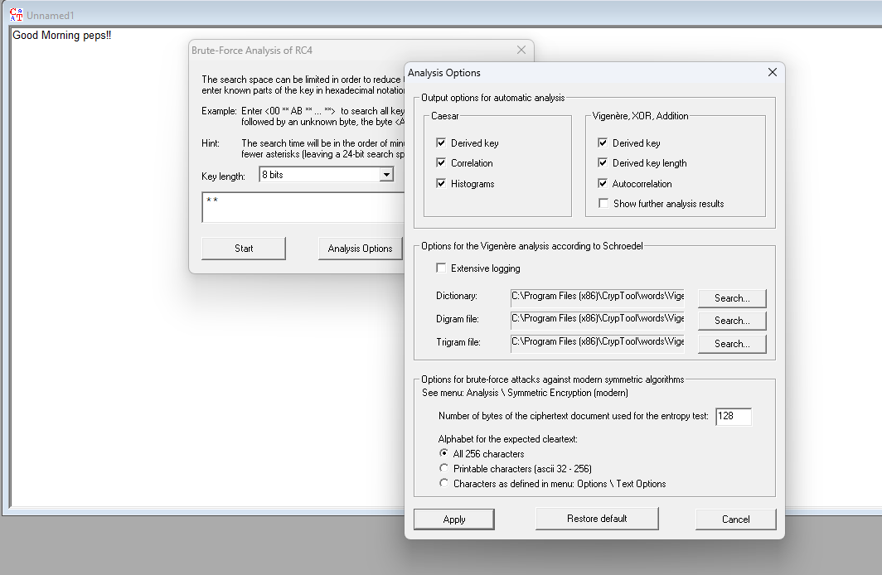

**Click cancel and then start**

**Select entropy and click on accept selection**

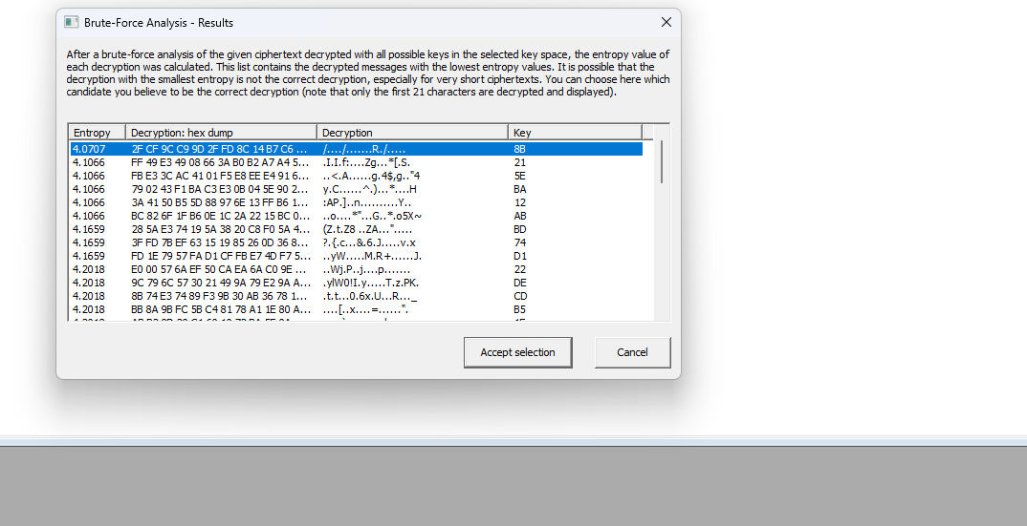

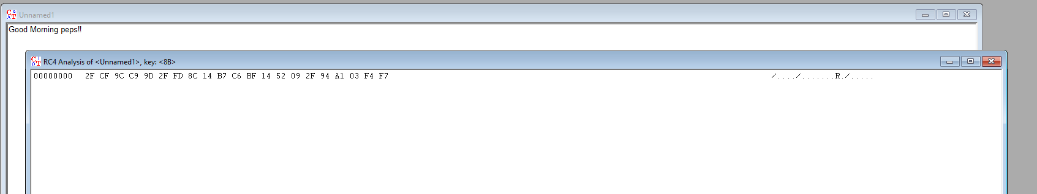

**DECRYPTION**

**Follow same steps like encryption**

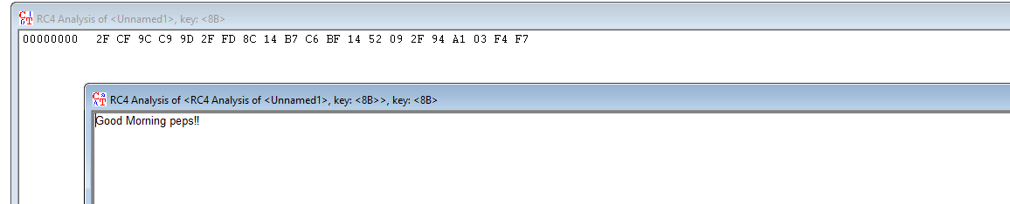

**ETHICAL HACKING PRACTICAL 5**

**NETWORKING COMMANDS**

**AIM: To study and know the functioning of various networking commands**

**1. ipconfig**

Description:

* Ipconfig gives the IP address and other network related information of the current system in use.
* Allows some control over TCP/IP connections as well.
* Displays information about network interfaces as well that are currently in operation.

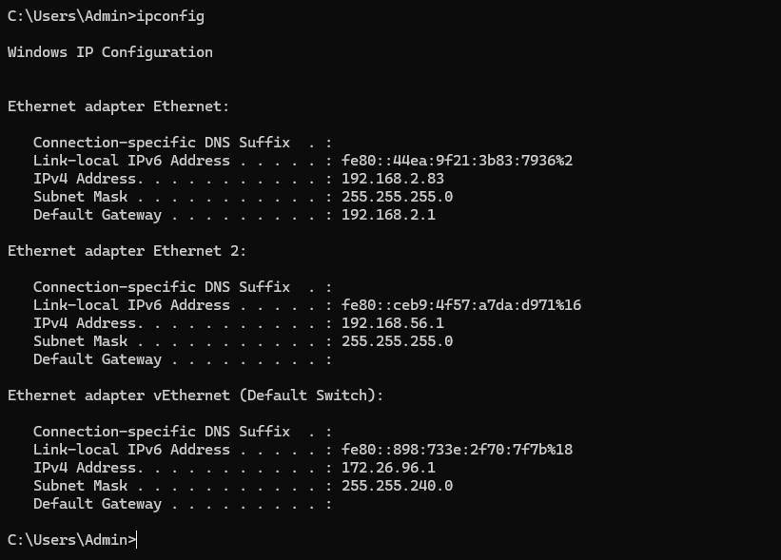

**Options in ipconfig**

**ipconfig/flushdns**

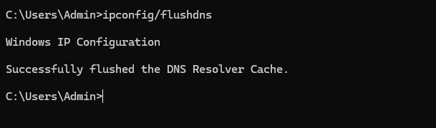

**ipconfig/registerdns**

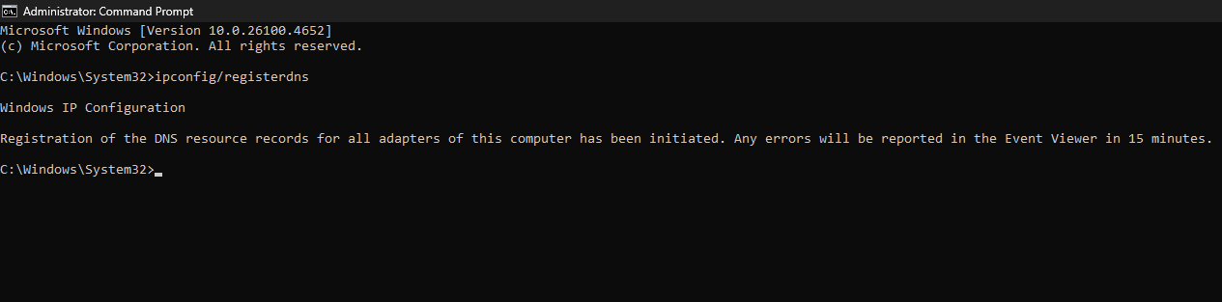

**ipconfig/release**

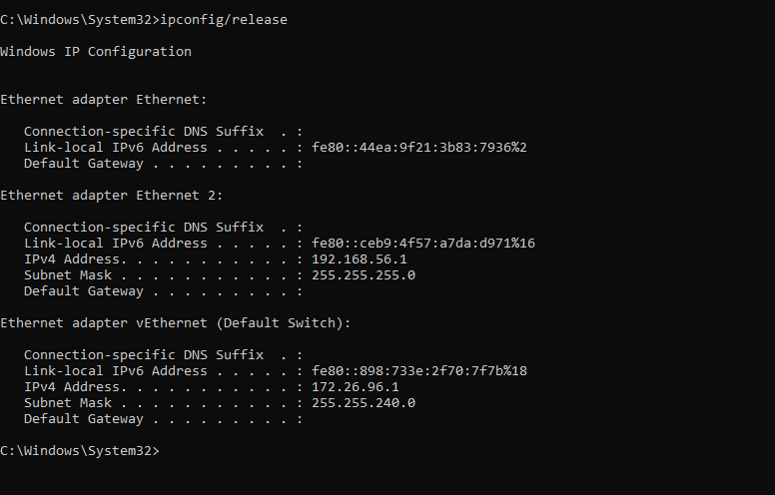

**ipconfig/renew**

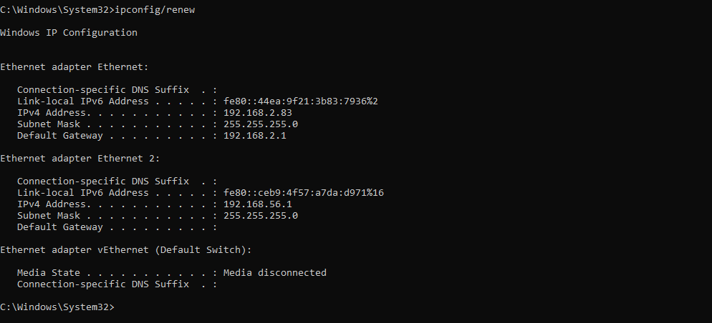

**2. netstat**

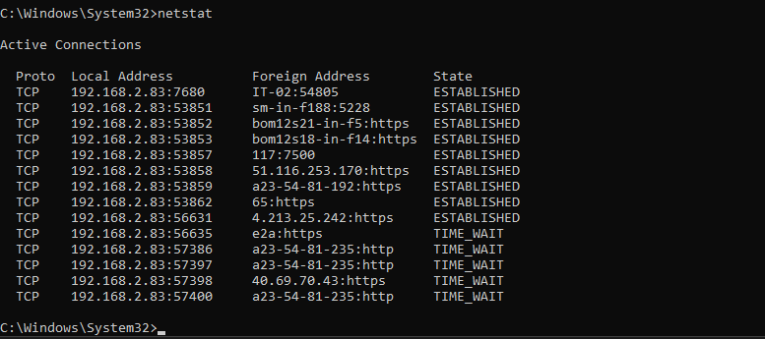

**Options in netstat**

**netstat -a**

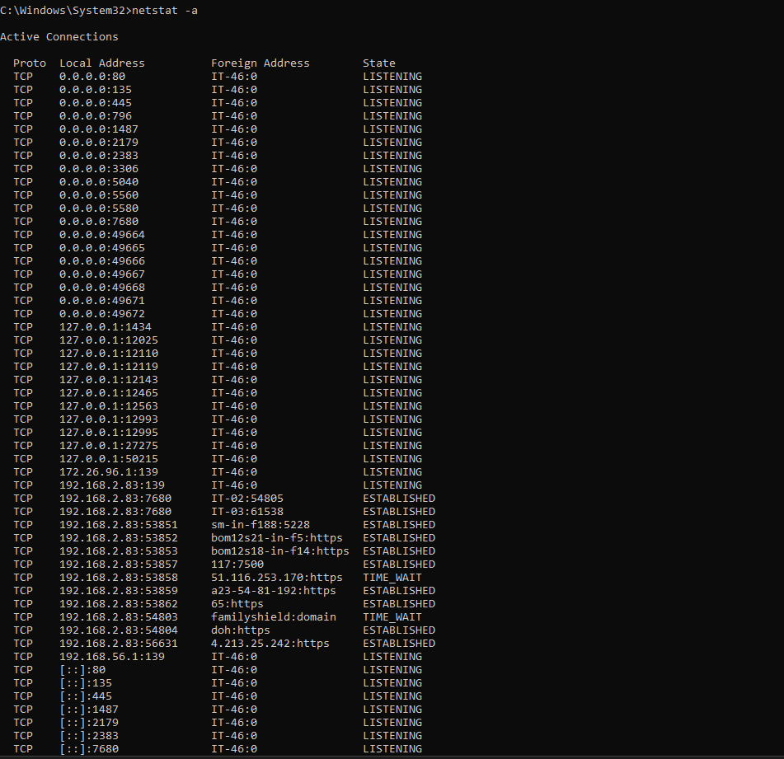

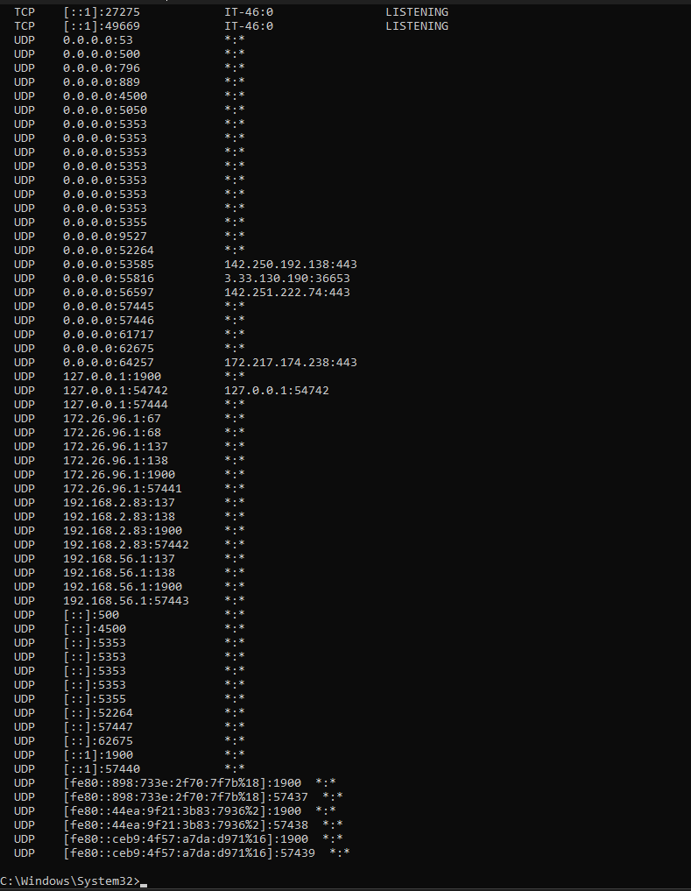

**netstat -s**

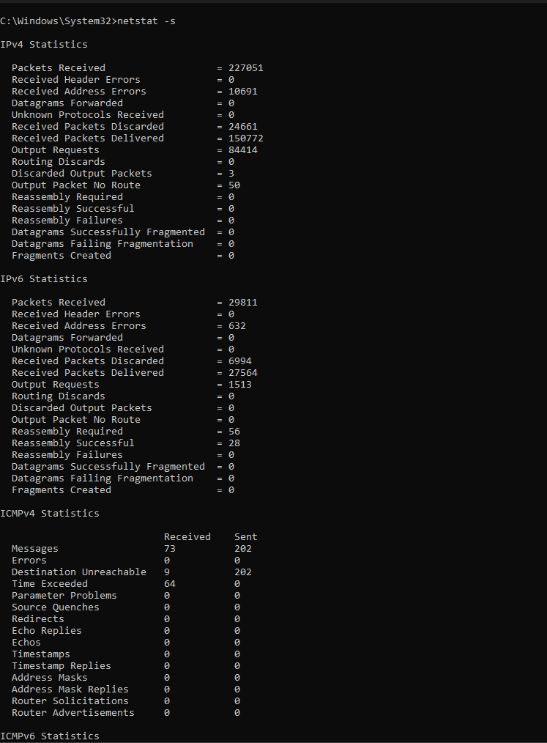

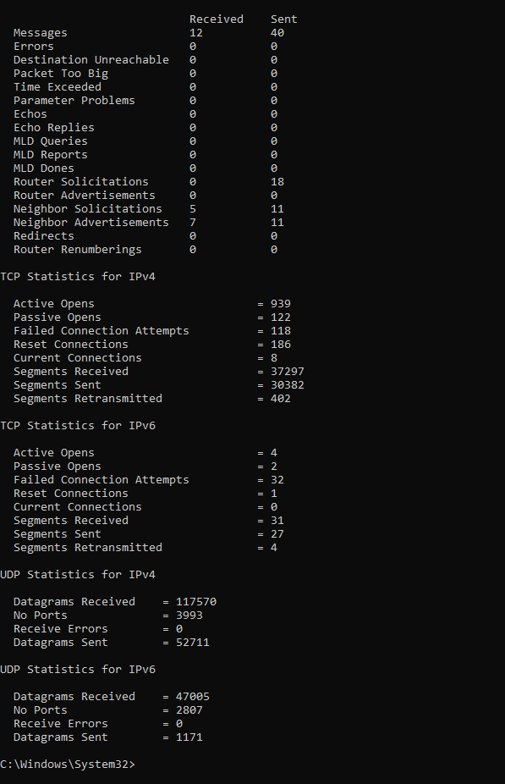

**netstat -r**

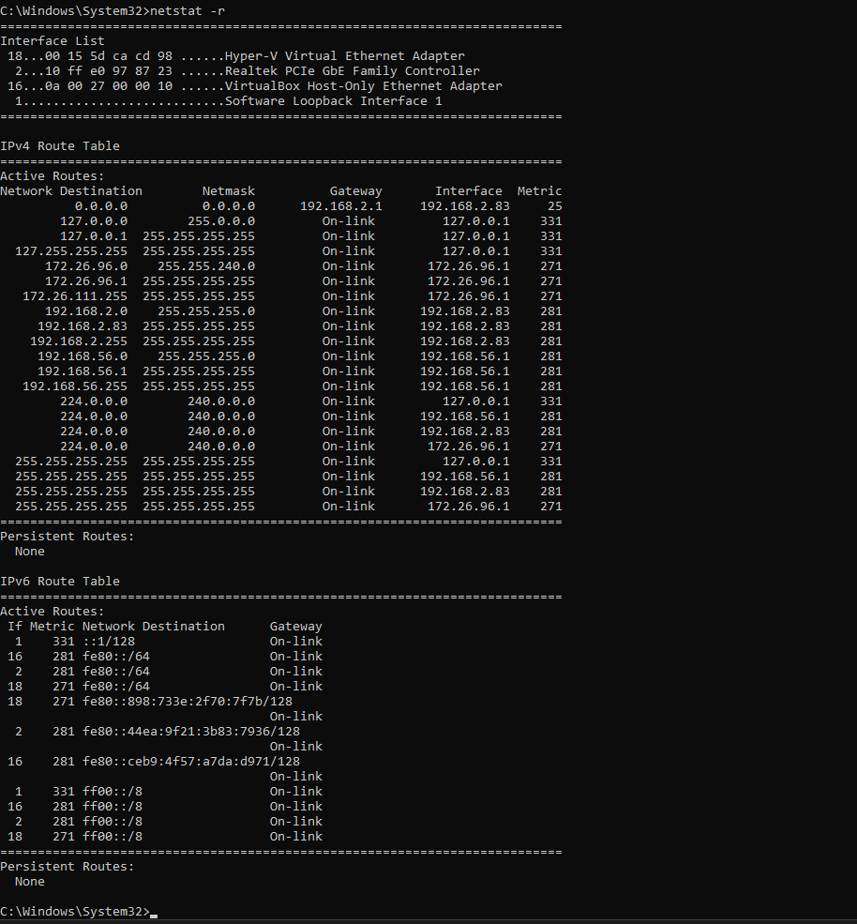

**netstat -i**

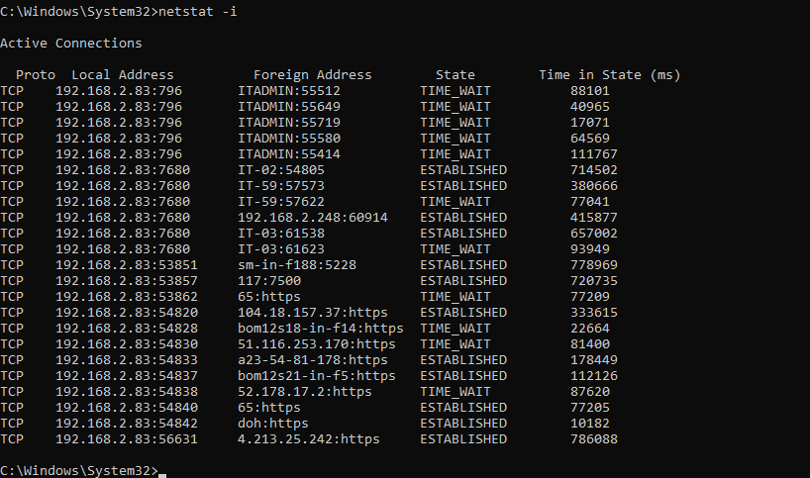

**netstat -f**

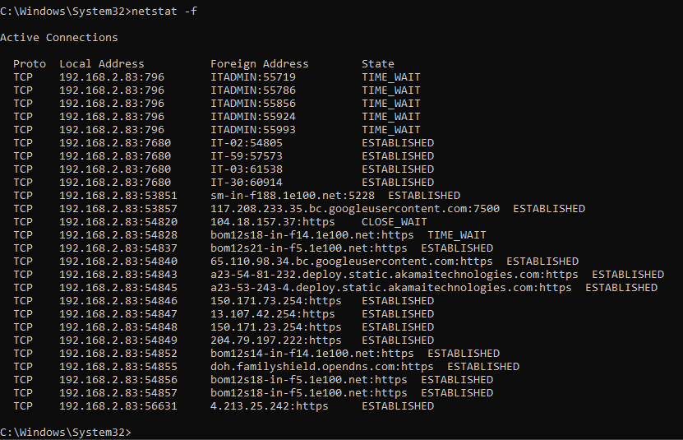

**3.ping “site”**

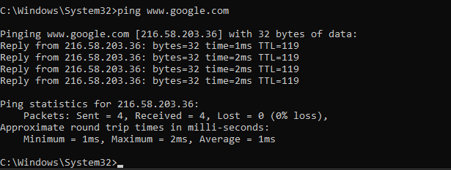

**Options in ping**

**ping -i 3 www.google.com**

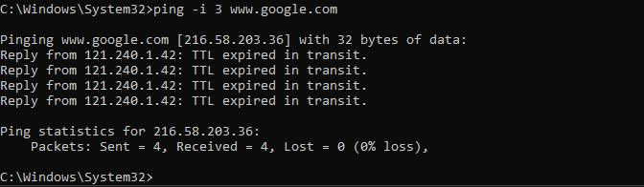

**ping -s 3 www.google.com**

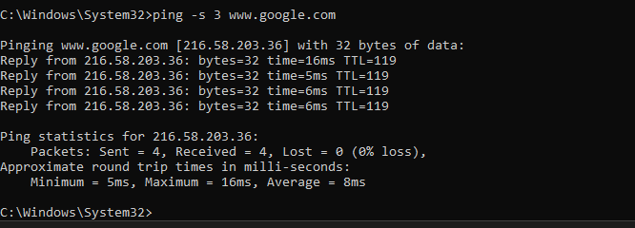

**ping -c 0 www.google.com**

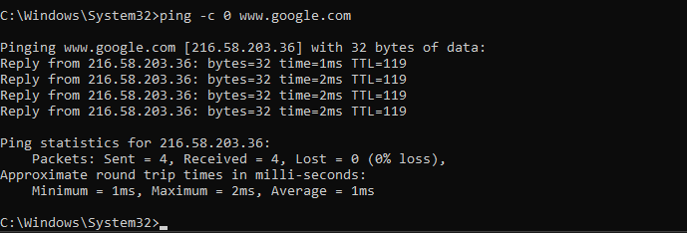

**ping -w 3 www.google.com**

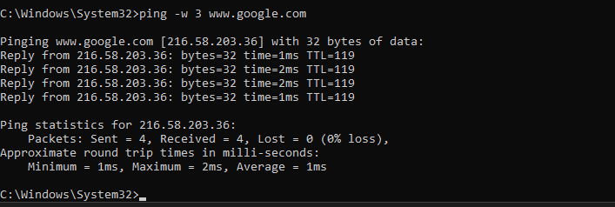

**4.tracert**

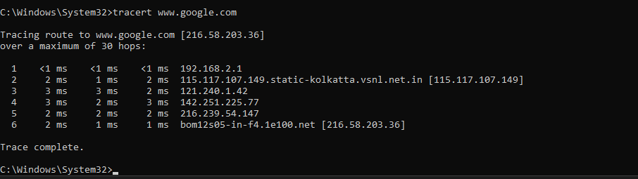

**Options in tracert**

**tracert -h 2 www.google.com**

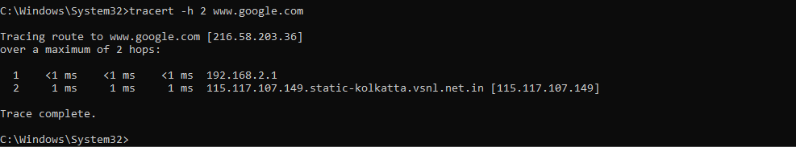

**tracert -w 3 www.google.com**

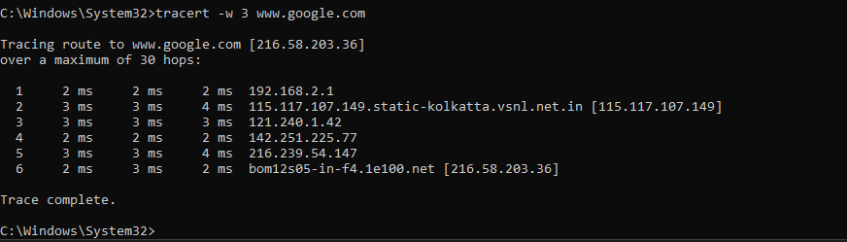

**tracert -4 www.google.com**

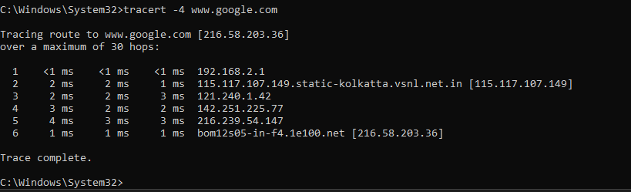

**tracert -d www.google.com**

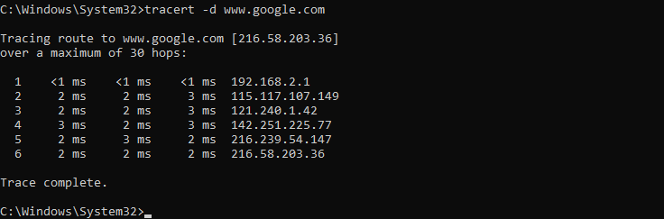

**5.arp**

* Stands for address resolution protocol.
* Works as an interface between two layers of network – data link layer and network layer.
* Finds address of computer in a particular network, resolves IP for it.
* Request sent from client to server -> server identifies the network system in which the targeted address is present and resolves it and sends it back to client.

**Options in arp**

**arp -a**

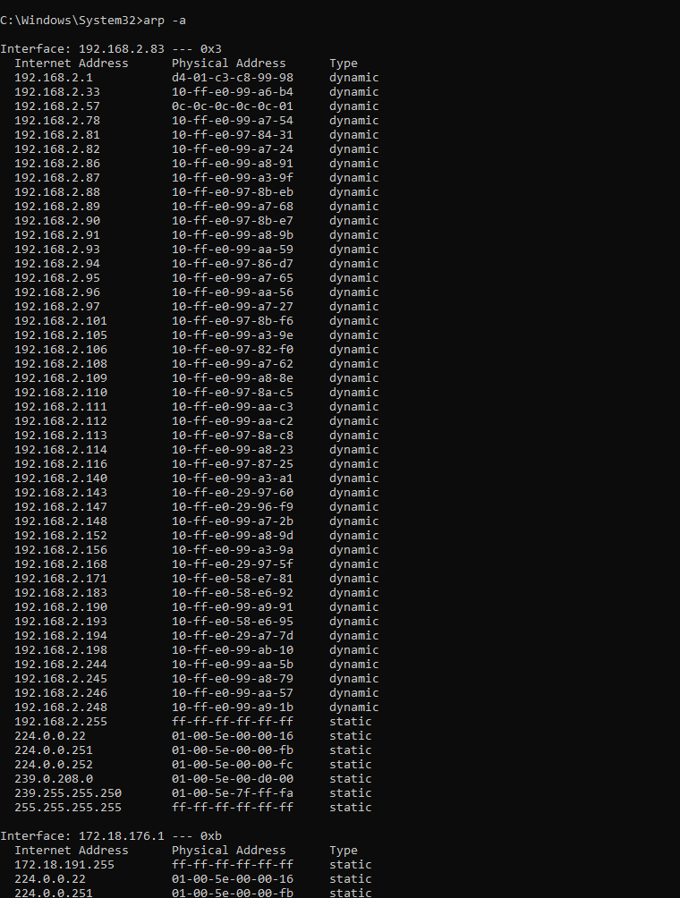

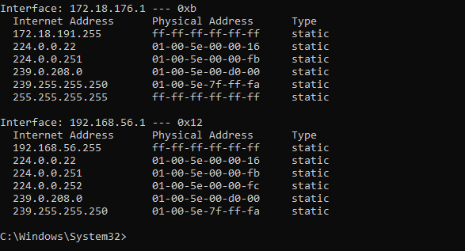

**arp -s**

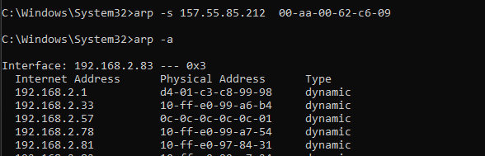

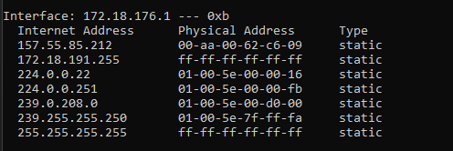

**arp -d**

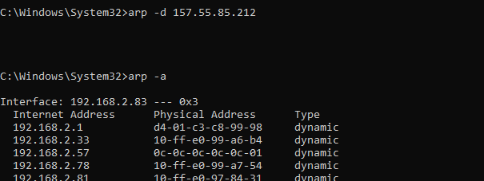

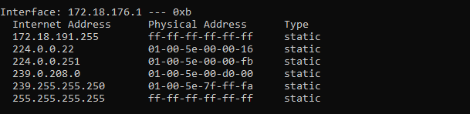

**arp -a -v**

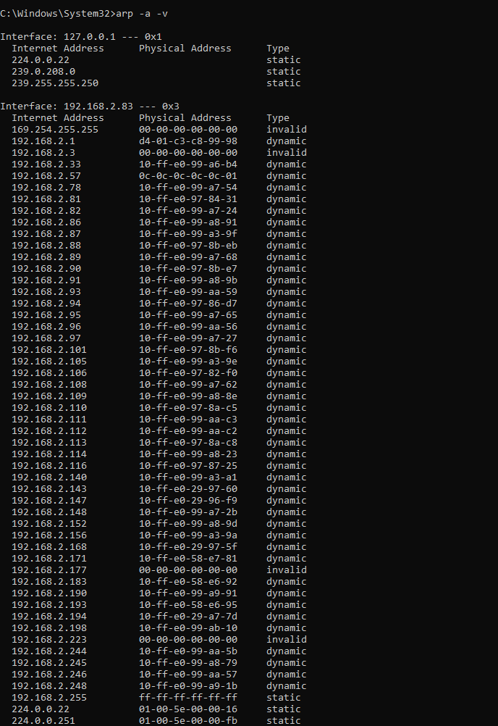

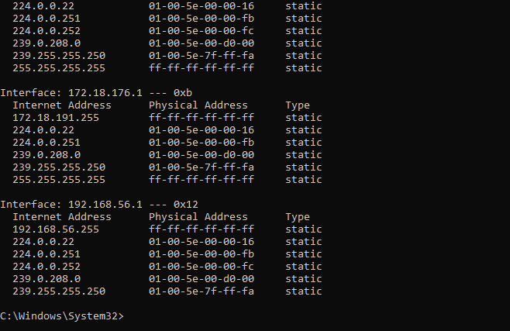

**6. tasklist**

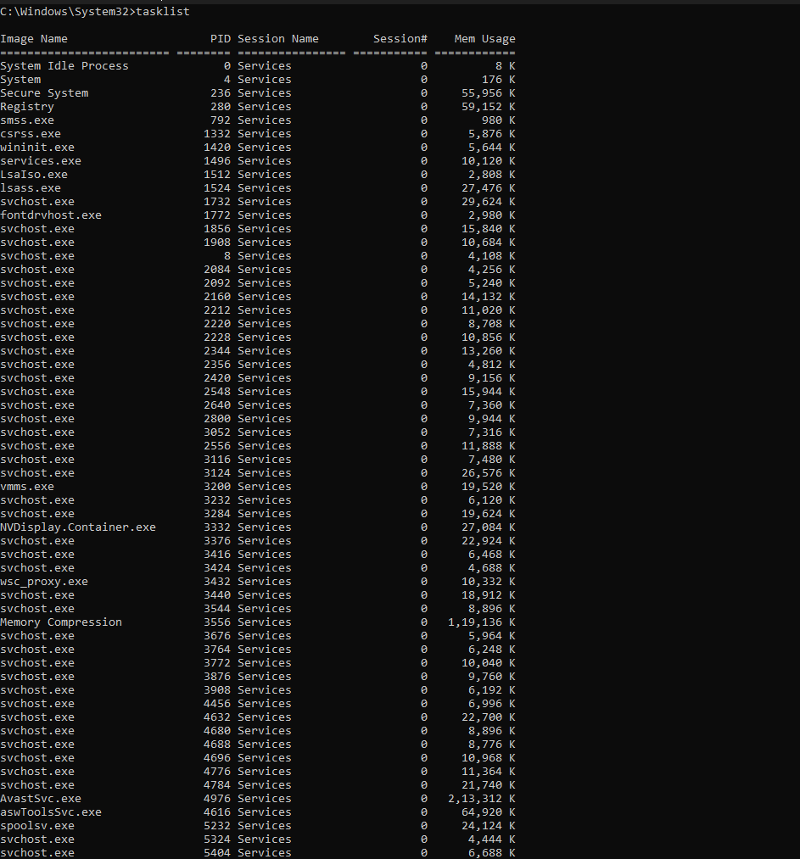

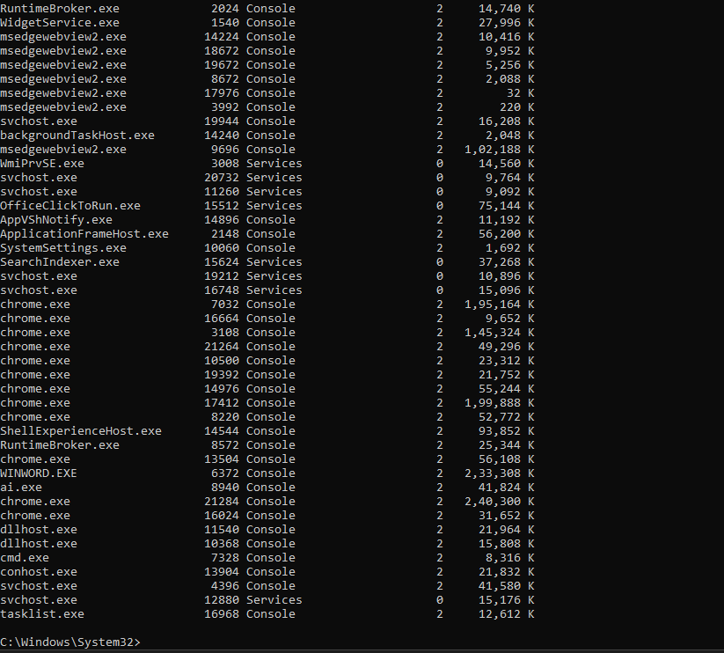

**7. systeminfo**

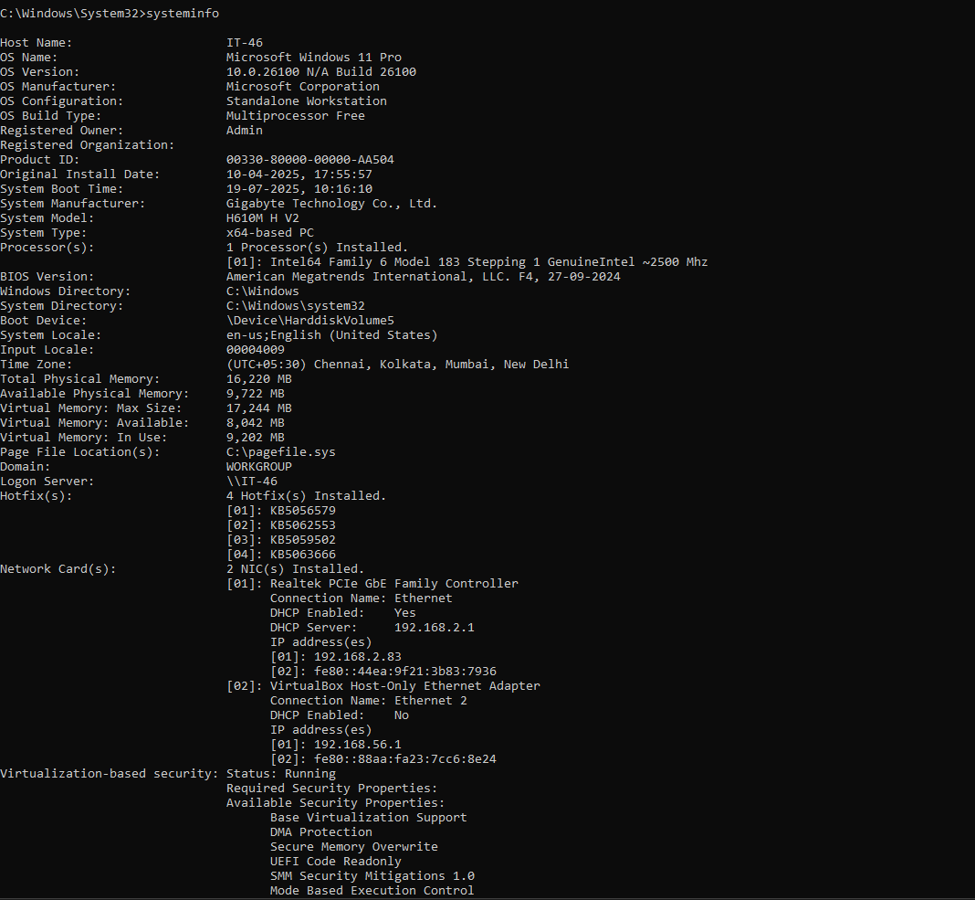

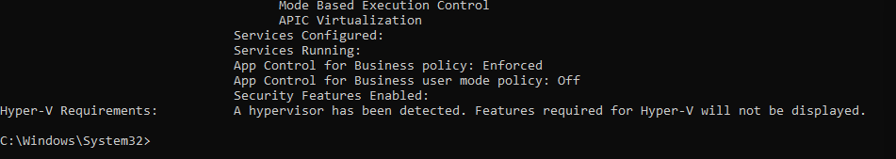

**8. gpupdate**

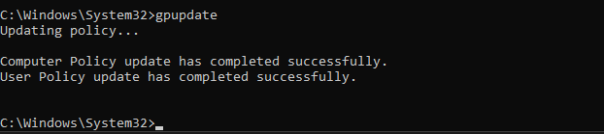

**9.chkdsk**

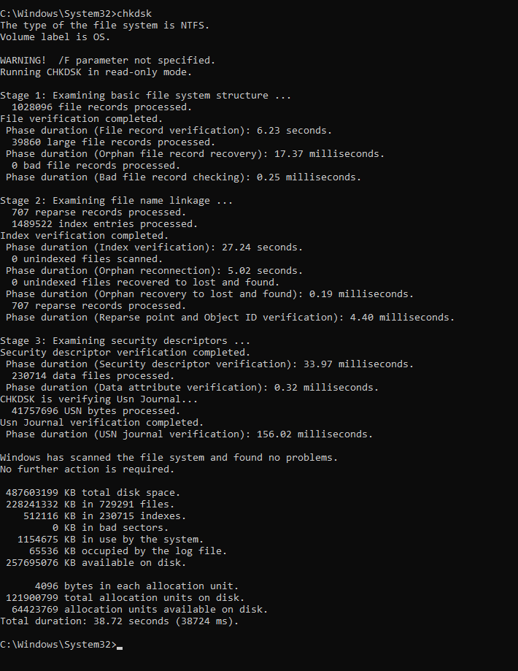

**ETHICAL HACKING PRACTICAL 6**

**CANE AND ABEL FOR DICTIONARY ATTACK**

**STEPS TO DOWNLOAD CAINABEL:**

Close the firewall of the system

Download npcap

Download Cainabel

Extract the main file

Then extract the file inside it with WINRAR - > extract with ca/setup option

Enter the password (123456)

CainAbel opens-> click more->run anyways

**1.DICTIONARY ATTACK**

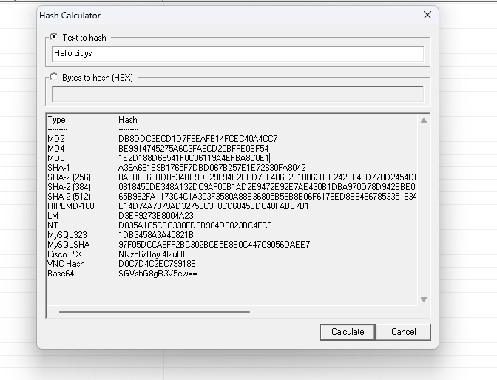

**COPY THE MD5 HASH CODE**

**CLICK ON CRACKER AND SELECT THE ALGORITHM OF WHOSW HASH CODE YOU COPIED**

**CLICK ON ADD AND PASTE THE HASH CODE**

**RIGHT CLICK THE CODE AND SELECT DICTIONARY ATTACK**

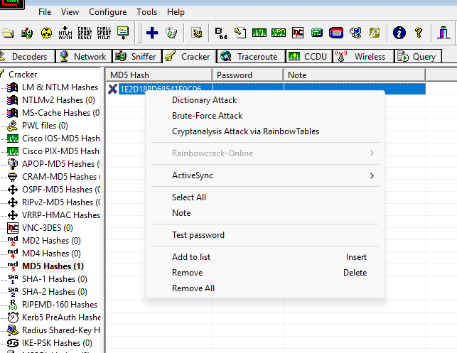

**OUTPUT IF THE TEXT IS PRESENT IN THE WORDFILE**

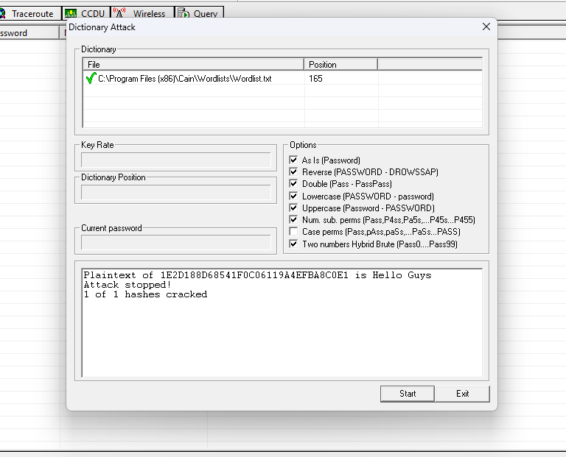

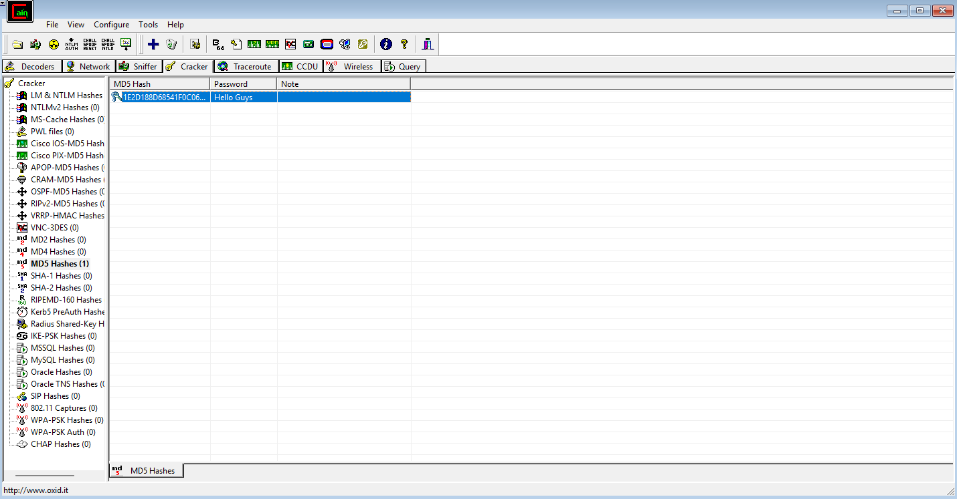

**OUTPUT IF THE TEXT IS NOT PRESENT IN THE WORDFILE**

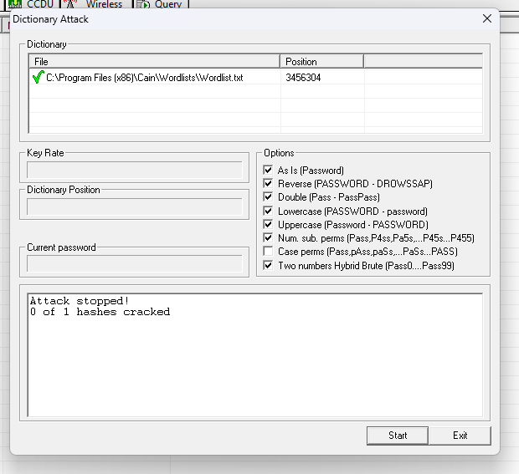

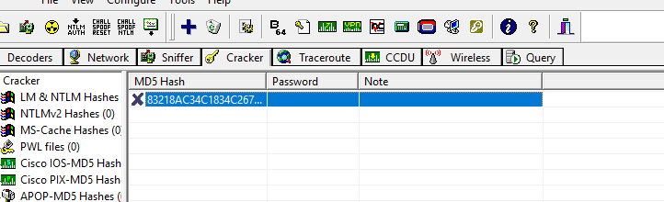

**ETHICAL HACKING PRACTICAL 7**

**ARP POISIONING (SNIFFING) USING CAIN**

**AND ABEL.**

**AIM:** To perform ARP poisoning (sniffing) using tool Cain and Abel.

Make security settings

Go to control panel

Select Network and Sharing Center

Select change adapter setting

Click Ethernet and go to its properties

Uncheck IPv6 and click on IPv4

Then click on properties

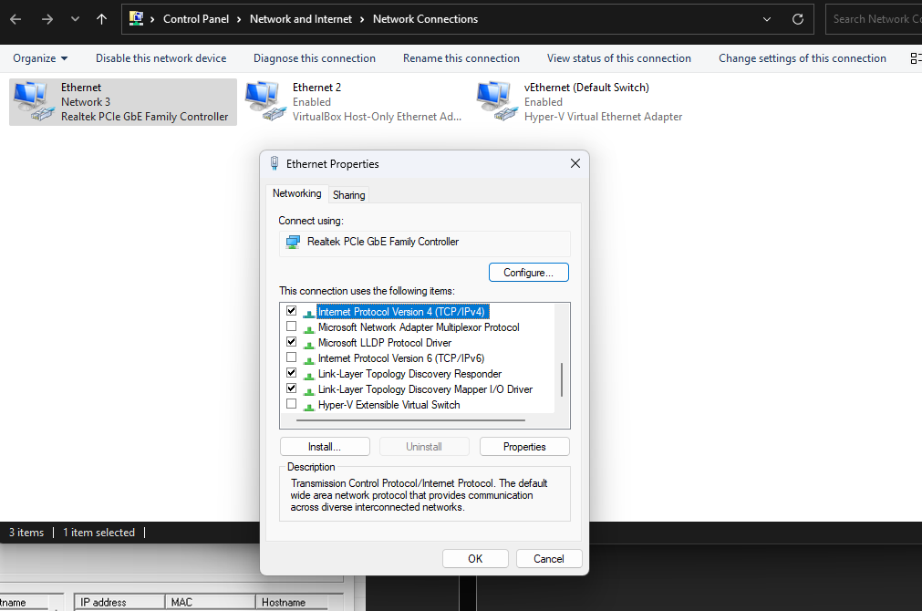

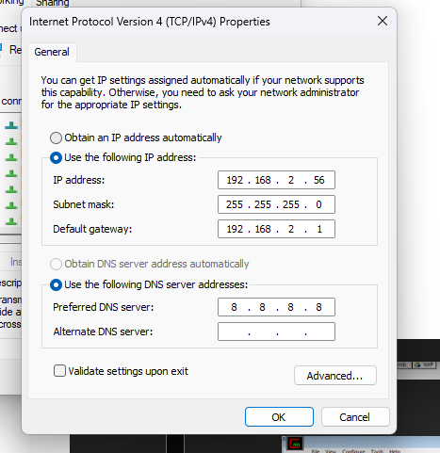

Go to advanced

In advanced go to DNS

Check if the last two checkboxes are selected , if not select them both

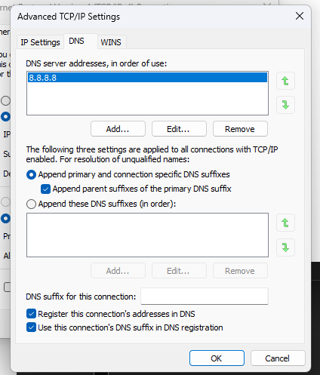

Click ok for every frame now

Open Cain and Abel

Click on configure and select the device having the IP address

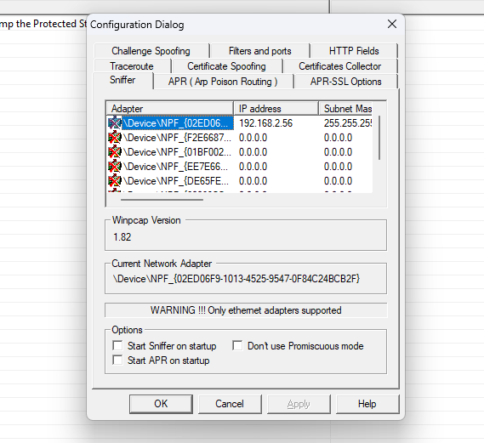

Click apply and ok

Then click on sniffer and start arp

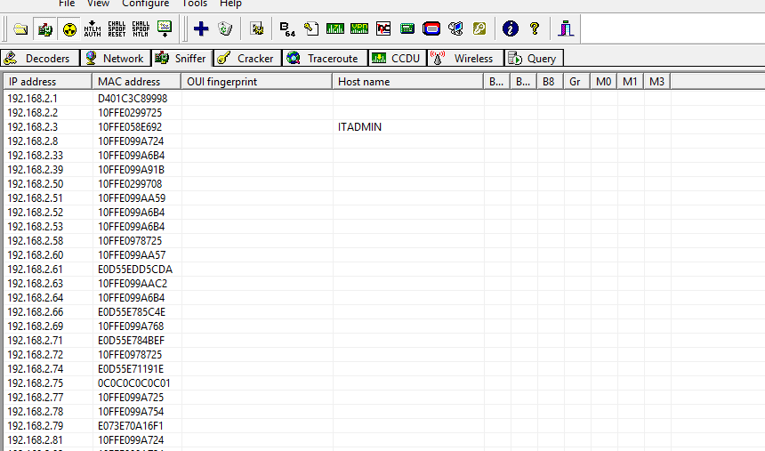

**After starting sniffer (yellow round) click on any IP address and click on Scan MAC Address.**

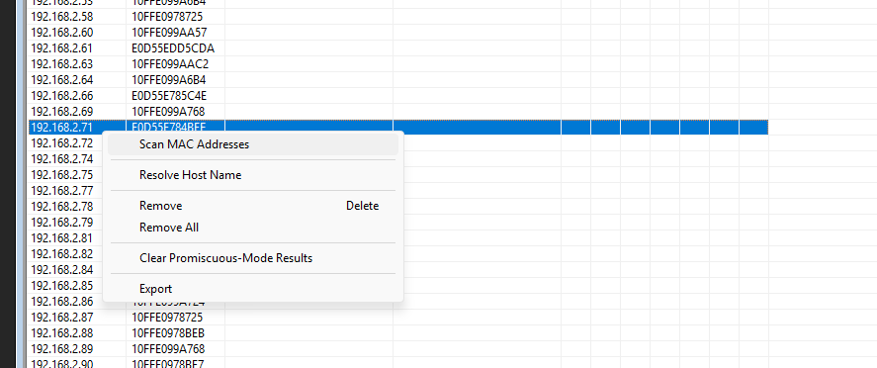

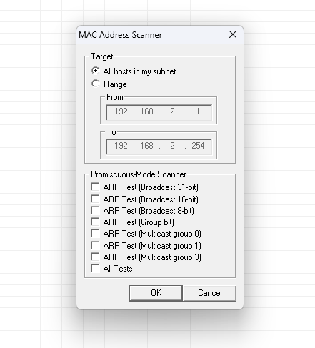

**Now go to APR and add the selected IP address there and start the sniffer**

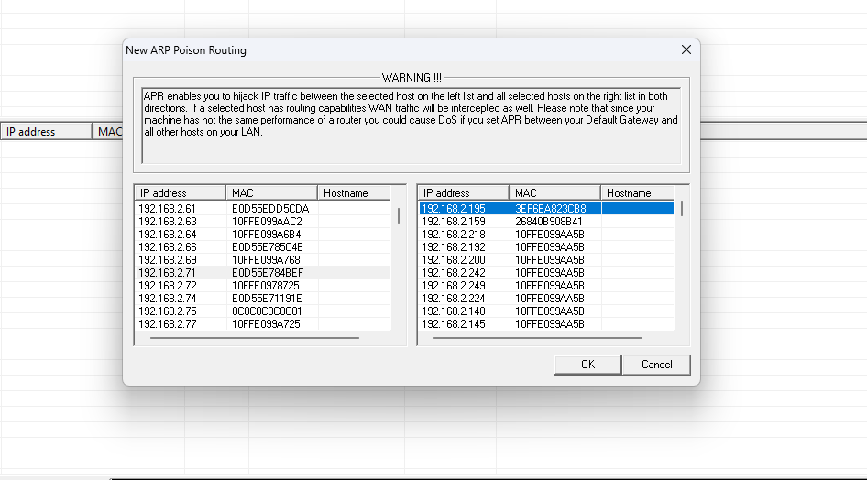

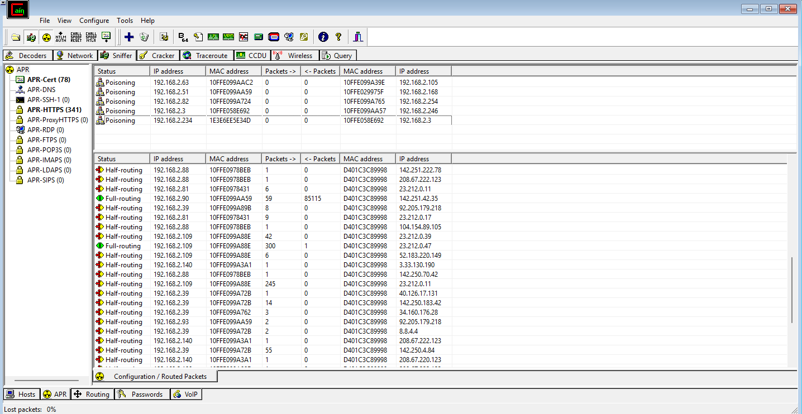

**Now login on the vulnerable website and then in the password section check if the password is visible**

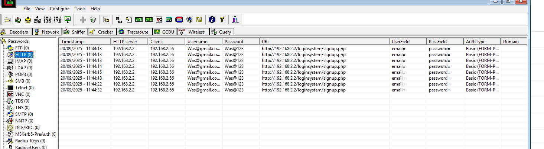

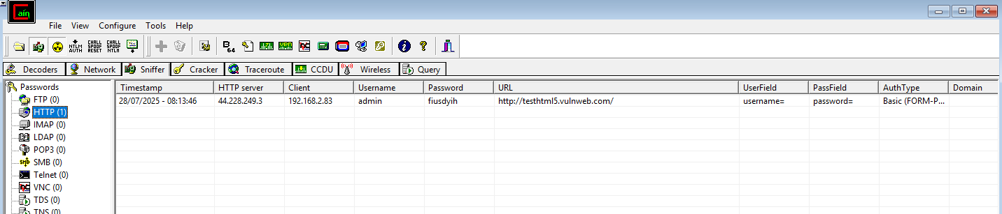

**ETHICAL HACKING PRACTICAL 8**

**SCANNING**

**Nmap – Versatile network scanner**

**1. www.google.com**

**Intense Scan**

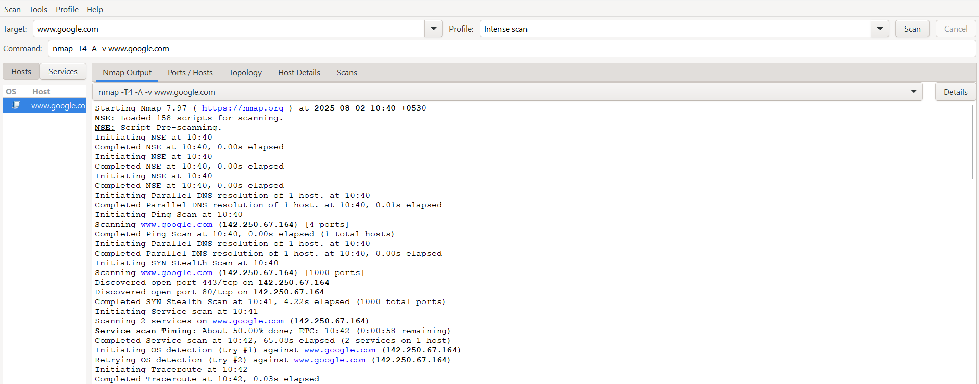

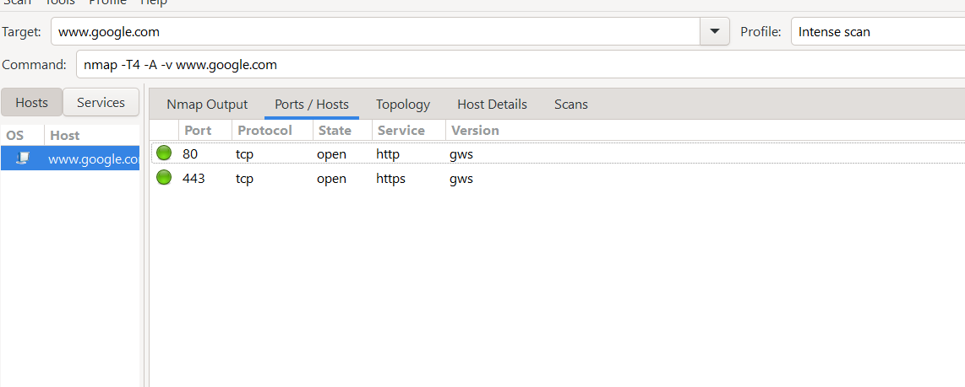

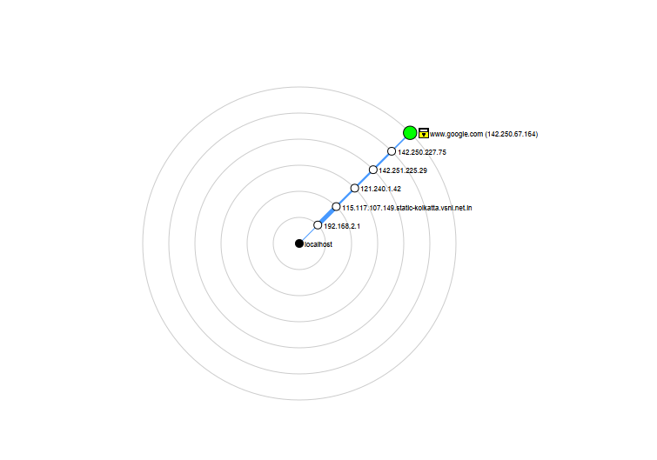

**Quick Scan**

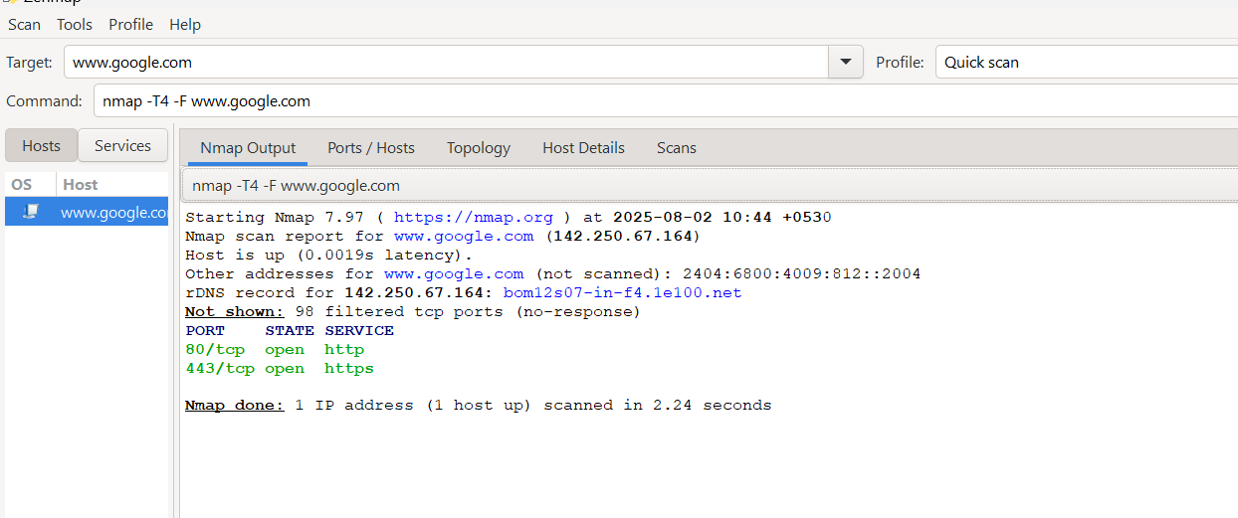

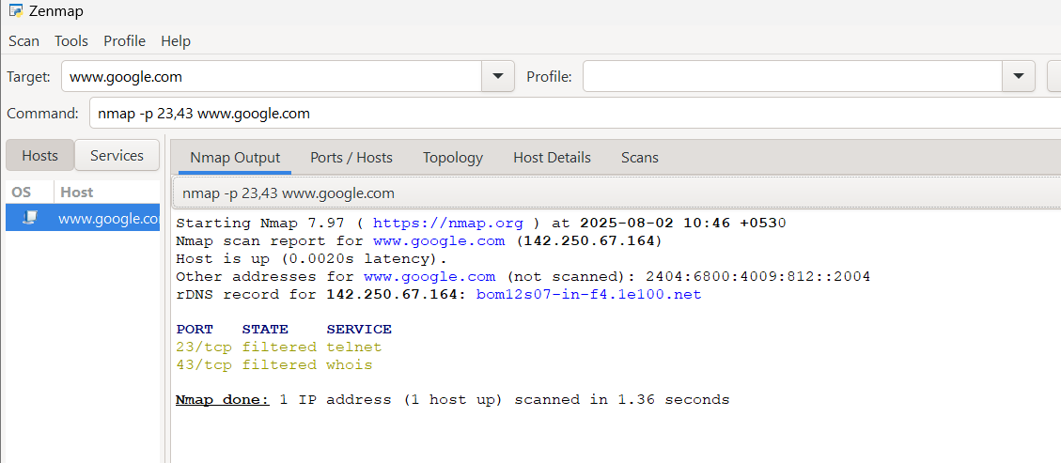

**2. SYN**

**Description**

The SYN scan (also known as half-open scan or stealth scan) is one of the most popular and commonly used scan types in Nmap. It operates by sending TCP SYN packets to target hosts and analyzing their responses to determine open ports and services. In a SYN scan, Nmap sends TCP SYN packets to specific ports on the target host. If the port is open, the target server responds with a SYN/ACK packet. Nmap then immediately sends a RST (reset) packet to close the connection. This behavior makes the SYN scan stealthy because it never establishes a full connection with the target, leaving no traces in the server's logs. It allows or initiates hand-shake protocol.

**Command: nmap -sS www.google.com**

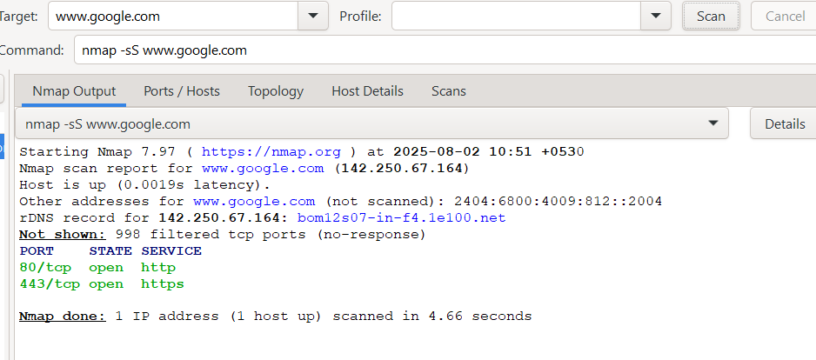

**Topology**

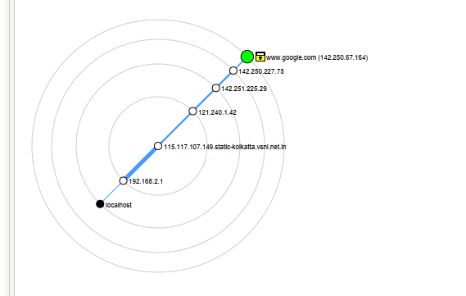

**3. ACK**

**Description**

The ACK scan is used to identify how a target host responds to TCP ACK packets. The responses can reveal information about the firewall rules and packet filtering in place on the target system. The responses can reveal information about the firewall rules and packet filtering in place on the target system. If the target host does not respond (no RST packet received), it indicates that the port is filtered, and a firewall is likely dropping the ACK packets silently.

**Command: nmap -sA www.google.com**

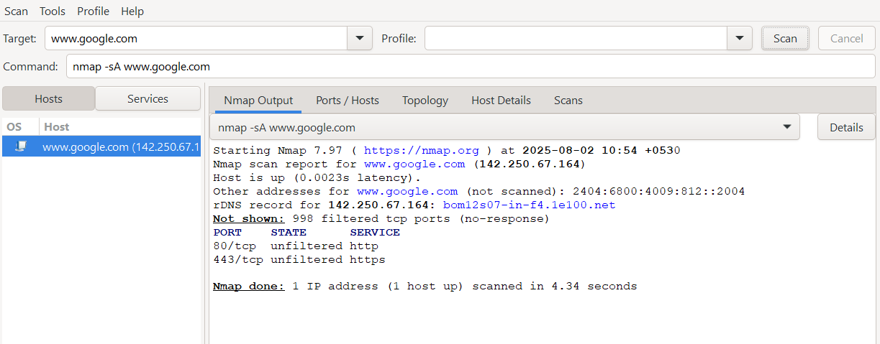

**4. FIN**

**Description**

FIN scan operates by sending TCP packets with the FIN (finish) flag set to the target ports. The goal is to observe how the target host responds to these packets. The response can provide valuable information about the state of

the scanned ports. If the target port responds with a RST (reset) packet, it means the port is closed, and the RST is sent in response to the unexpected FIN packet. If the target port does not respond (no RST packet received), it means the port is open or filtered. Unlike the SYN scan, which uses the absence of a response to indicate a filtered port, the FIN scan considers a lack of response as an indication of an open or possibly filtered port.

**Command: nmap -sF www.google.com**

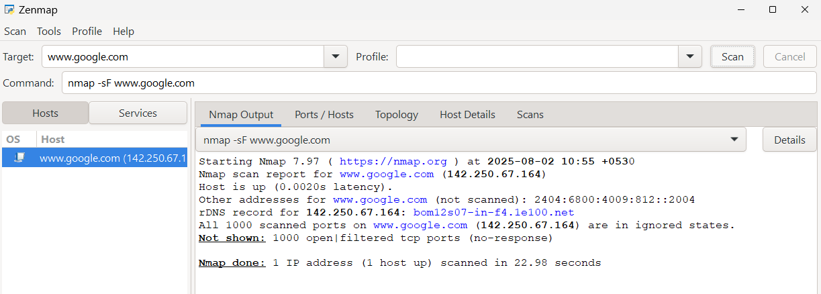

**5. NULL**

**Description**

NULL scan operates by sending TCP packets with all flags unset. The goal is to observe how the target host responds to these unusual packets. If the target port responds with a RST (reset) packet, it means the port is closed, and the RST is sent in response to the unexpected NULL packet. If the target port does not respond (no RST packet received), it means the port is open or possibly filtered. Similar to the FIN scan, the NULL scan interprets a lack of response as an indication of an open or filtered port.

**Command: nmap -sN www.google.com**

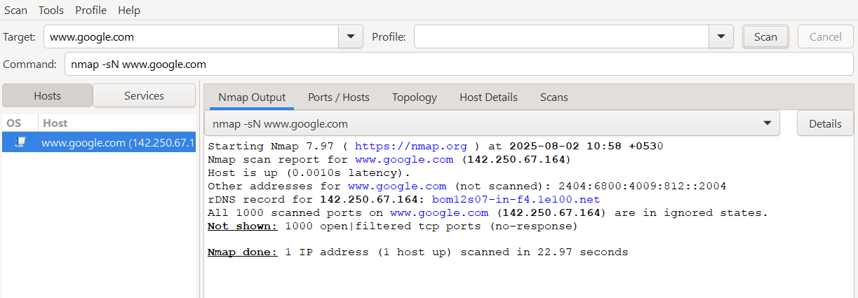

**6. XMAS**

**Description**

XMAS is a type of scan in Nmap that operates by sending TCP packets with specific flags set, simulating an "Xmas tree" pattern of lights. Nmap sends TCP packets with the FIN, URG, and PUSH flags set to specific ports on the target host. The goal is to observe how the target host responds to these non standard Xmas packets. ( URG is urgent flag and indicates that the data in the packet is urgent and should be prioritized by the receiving system. PUSH is push flag that instructs the receiving system's TCP stack to deliver the data to the application immediately without waiting for the TCP buffer to fill up.) If the target port responds with a RST (reset) packet, it means the port is closed, and the RST is sent in response to the unexpected Xmas packet. If the target port does not respond (no RST packet received), it means the port is open or possibly filtered.

**Command: nmap -sX www.google.com**

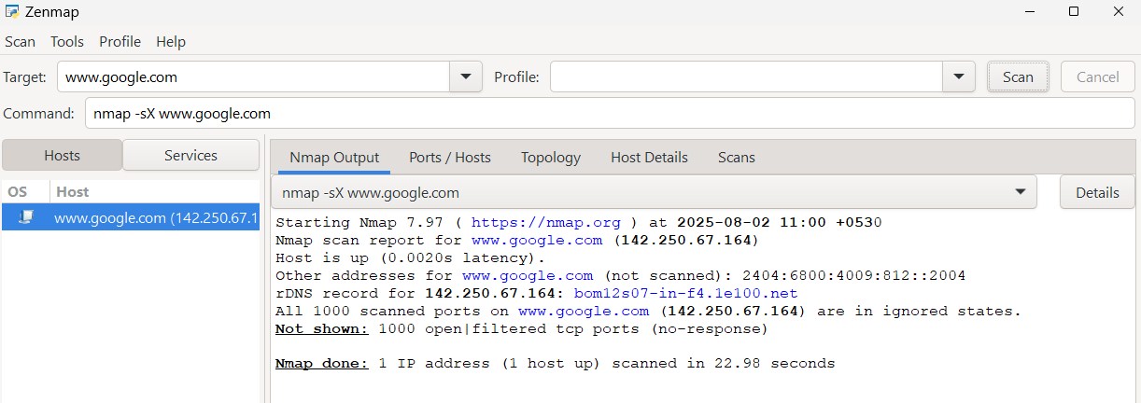

**ETHICAL HACKING PRACTICAL 9**

**WIRESHARK (SNIFFER)**

**Aim : Use Wireshark (Sniffer) to capture network traffic and analyze and thus check vulnerability of network systems.**

**1.Inspect traffic for a specific IP address.**

**Filter :** ip.addr==192.168.0.107

(Check the IP address of machine using ipconfig command in cmd line)

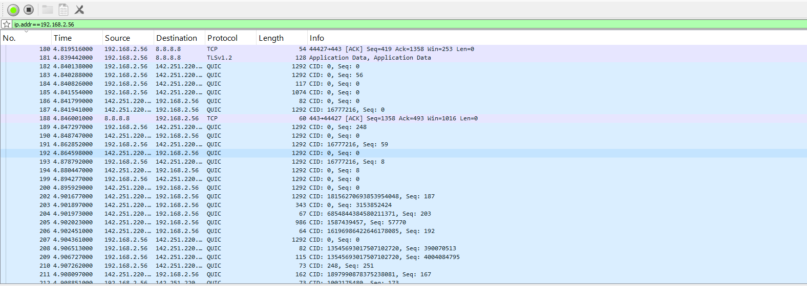

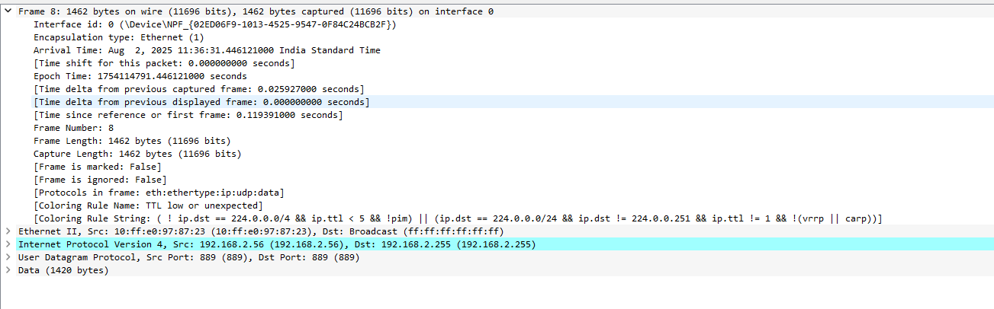

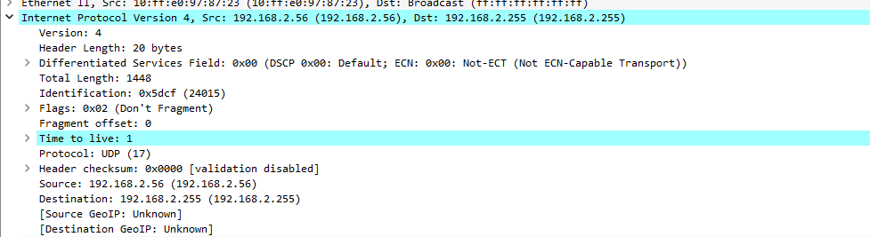

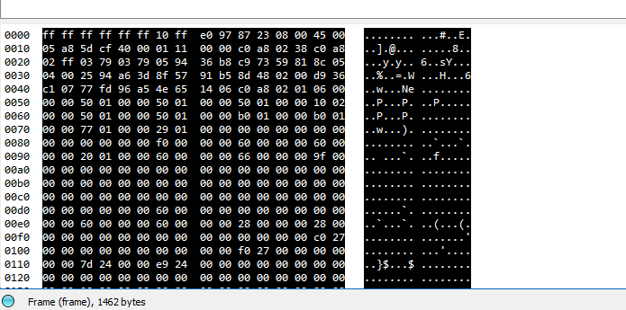

**2.Sniff the credentials details from a vulnerable website:** techpanda.com.

**Filter :** Keep scanning first. Goto website and then stop scanning and put filter “http”. Click the blue arrow at the side.

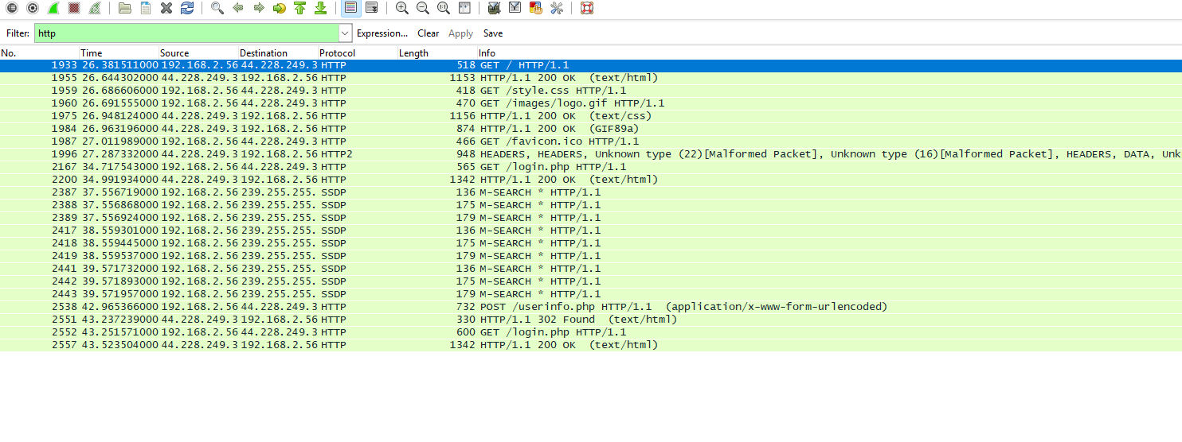

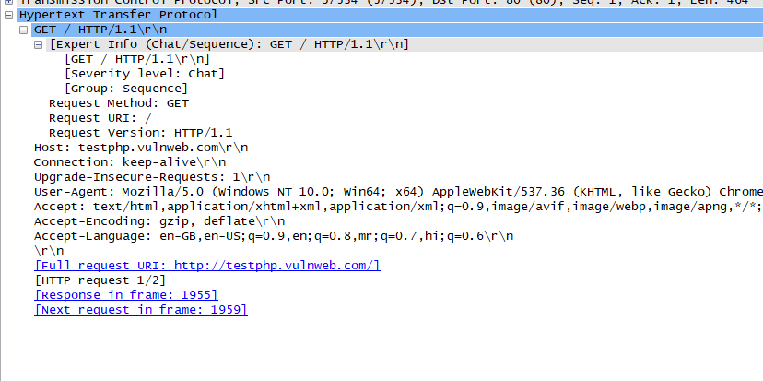

**Comments :** The new area in console Hypertext Transfer Protocol has appeared. It shows the host i.e. the website we logged in into, the user agent i.e. the browser that it works on and other details. While logging in, the get method was used.

**3.Check what user has typed in browser-** http://testphp.vulnweb.com/

**Filter :** http.referer contains "search"

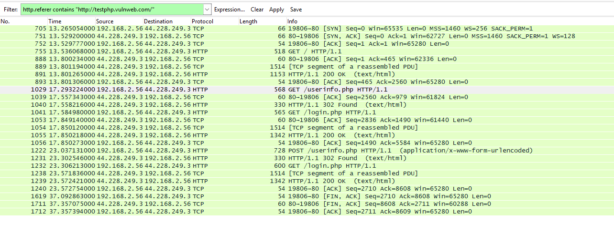

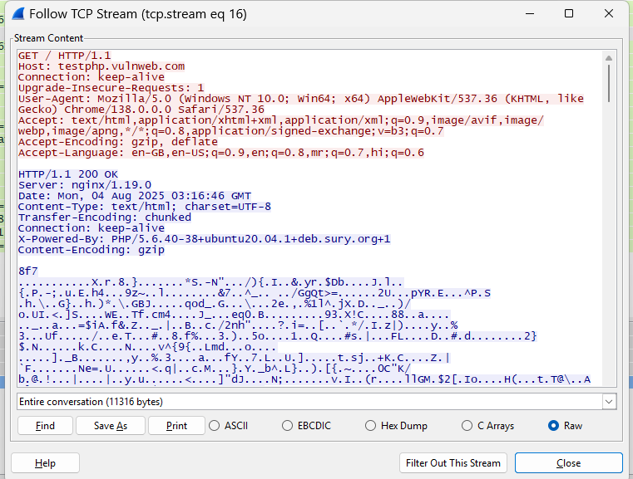

**Comments :** The details for the search appear in the console.

**5. Find out packets which are getting the response as PAGE NOT FOUND.**

**URL used :** http://info.cern.ch/authentication

**Filter :** http.response.code==404

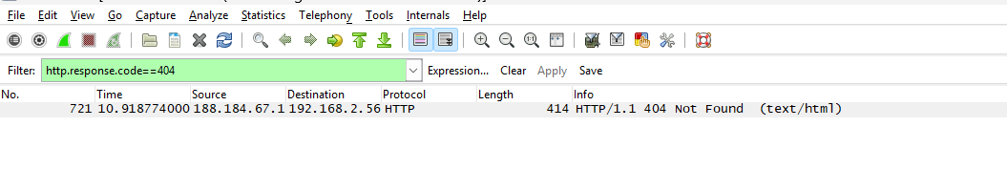

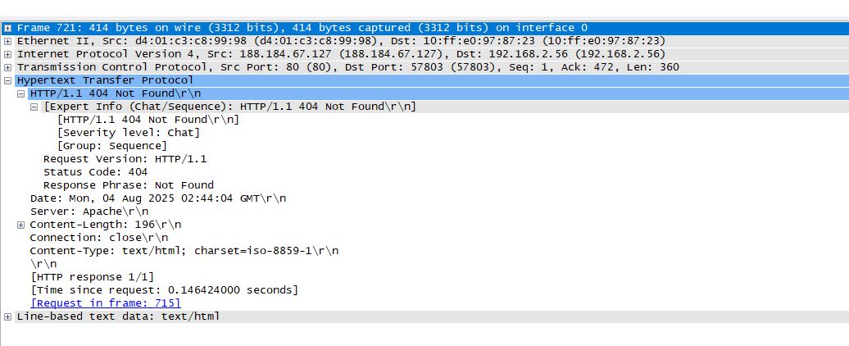

**Comments :**

404 code is for page not found. So thus when you search for the page, the browser throws a 404 not found error. Wireshark sniffs this as well and when we put the above filter details regarding the search appears.

**6. Find out those packets which are getting responses.**

**Filter :** http.response.code==200

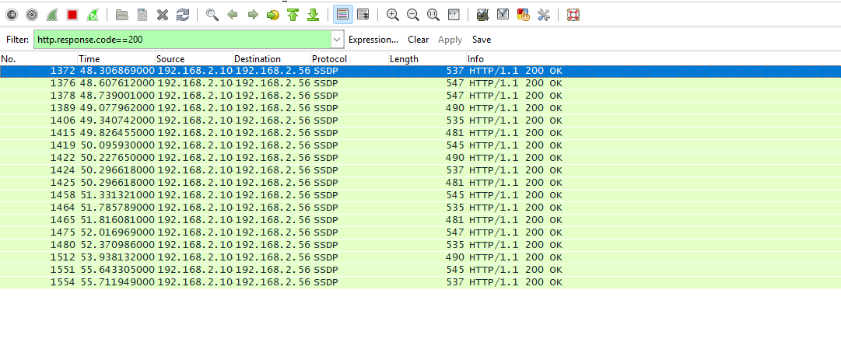

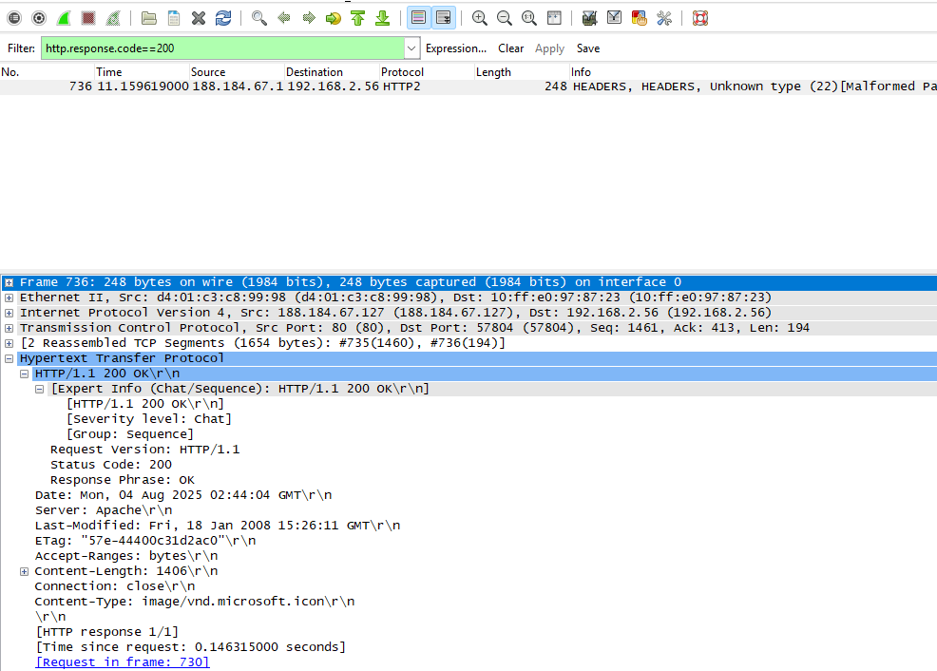

200 code is for page found/all ok. So thus when you search for the page, the browser returns the status of the page as 200 i.e. found the searched page. Wireshark sniffs this as well and when we put the above filter details regarding the search appears.

**7. Find Packets-: Browser Specific.**

**Filter :** http.user_agent contains Firefox

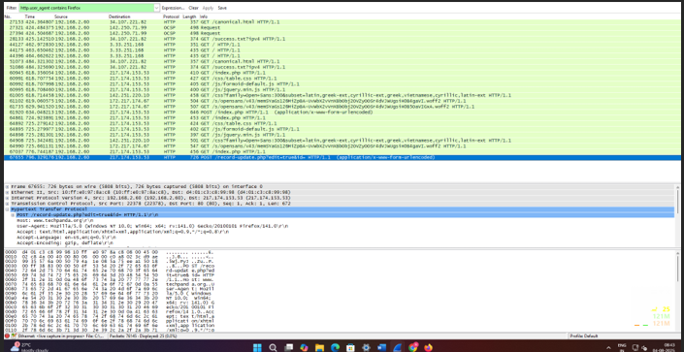

**8. Inspect traffic between specific source and destination**

**Filter** : ip.aadr==192.168.0.107 && ip.addr==192.168.0.108

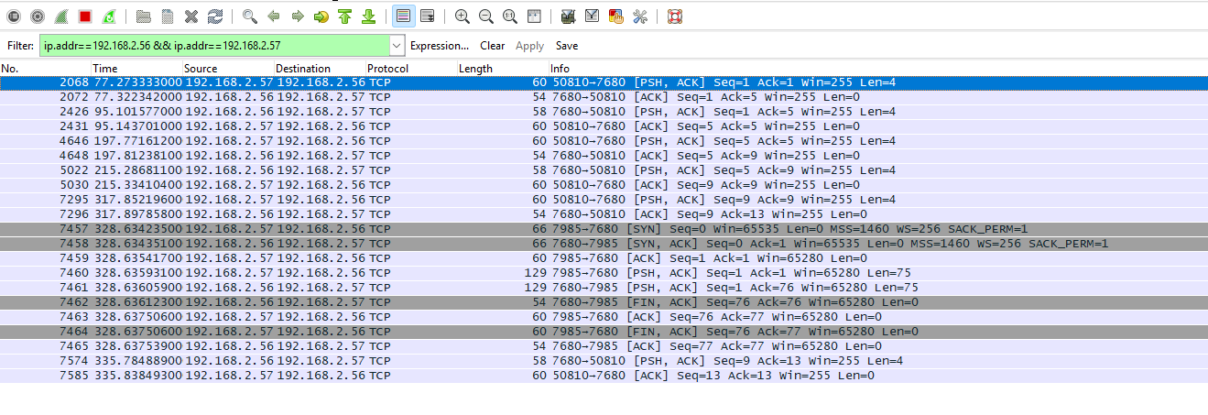

**Comments :**

The traffic i.e. data packets being sent between the two IPs is

sniffed.

**9. To sniff communication between client and server**

**Comments :**

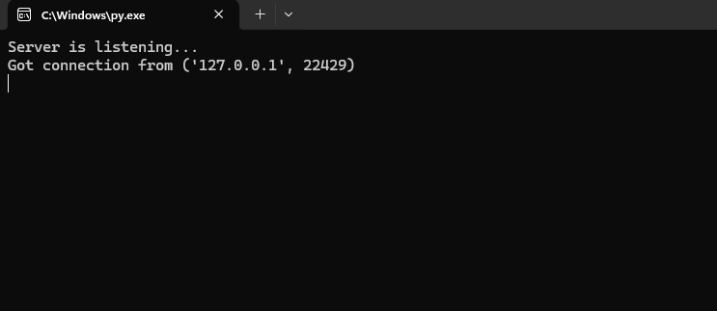

**SERVERCODE**

import socket

s = socket.socket()

port = 8080

s.bind(('localhost', port))

s.listen(5)

print("Server is listening...")

while True:

c, addr = s.accept()

print("Got connection from", addr)

c.sendall('Thank you for connecting!'.encode())

c.close()

**CLIENT CODE**

import socket

s = socket.socket()

port = 8080

s.connect(('localhost', port))

print(s.recv(1024).decode())

NO TRACING POSSIBLE IN LOCALHOST MODE – NEED TWO PC TO CONNECT

**Server:**

**import socket**

s = socket.socket()

print("Socket created successfully!")

port = 8080

s.bind(('0.0.0.0', port)) # Use '0.0.0.0' to accept connections from any IP

print("Socket binded to %s" % (port))

s.listen(5)

print("Socket is listening...")

while True:

c, addr = s.accept()

print("Got connection from", addr)

c.sendall('Thank you for connecting!'.encode())

c.close()

**client:**

import socket  
  
s = socket.socket()                 # Create a TCP socket  
port = 8080                         # Define the target port  
s.connect(('192.168.2.60', port))   # Connect to server at IP and port  
print(s.recv(1024).decode())

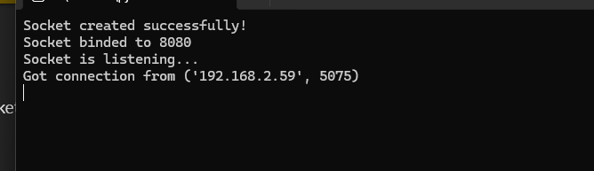

**ETHICAL HACKING PRACTICAL 10**

**DoS USING COLASOFT**

**Aim : DoS using ColaSoft by flooding the destination with data packets.**

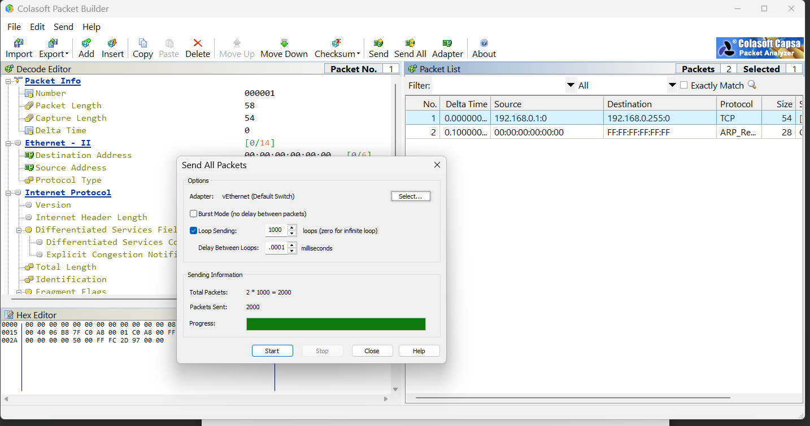

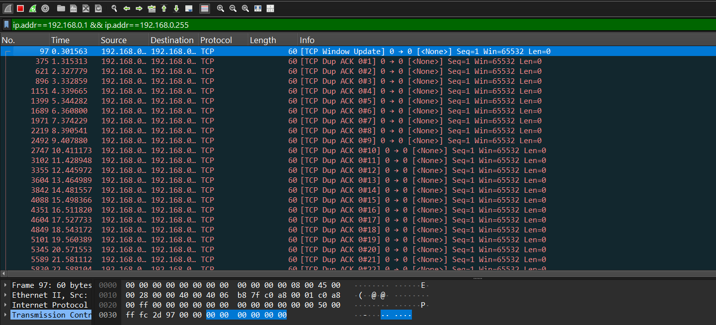

**ETHICAL HACKING PRACTICAL 11**

**ZAP (ZED ATTACK PROXY) – WEB APPLICATION SECURITY SCANNER**

**ACTIVE ATTACK ON** [**http://techpanda.com**](http://techpanda.com)**:**

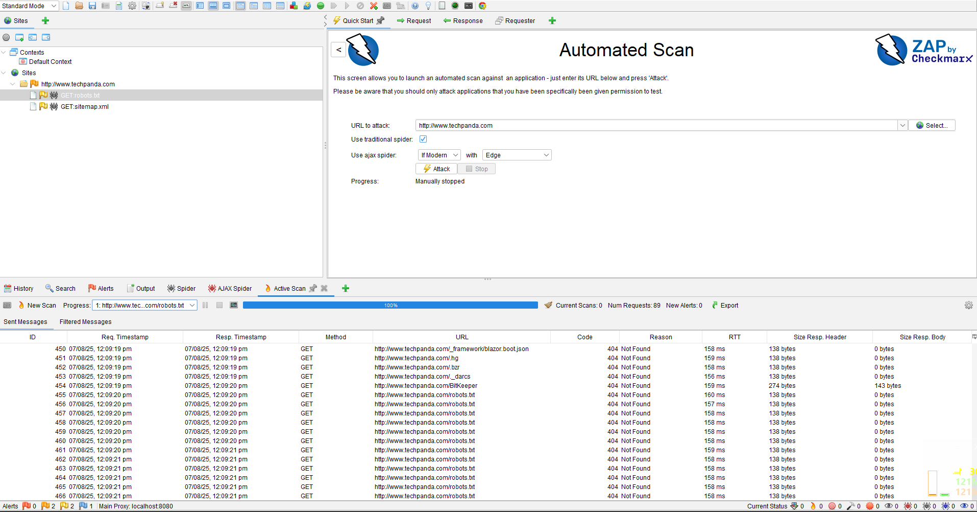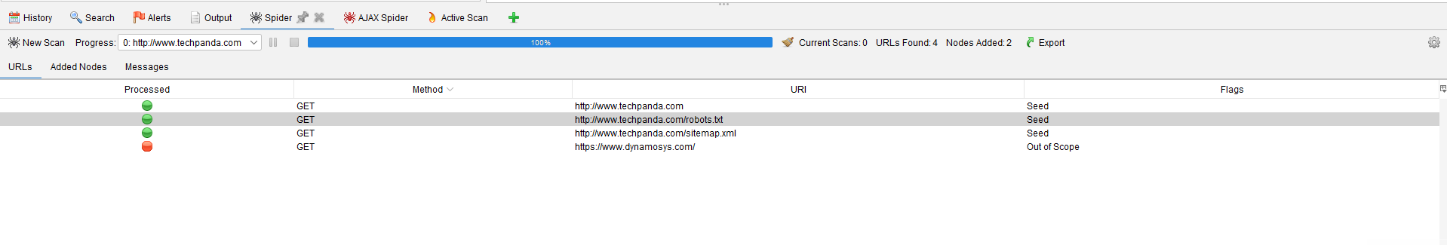

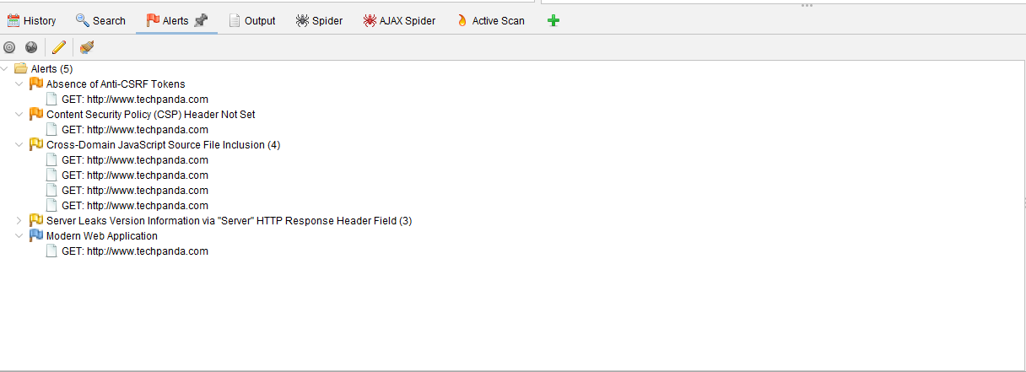

**ATTACK ON** [**http://testphp.vulnweb.com/**](http://testphp.vulnweb.com/)

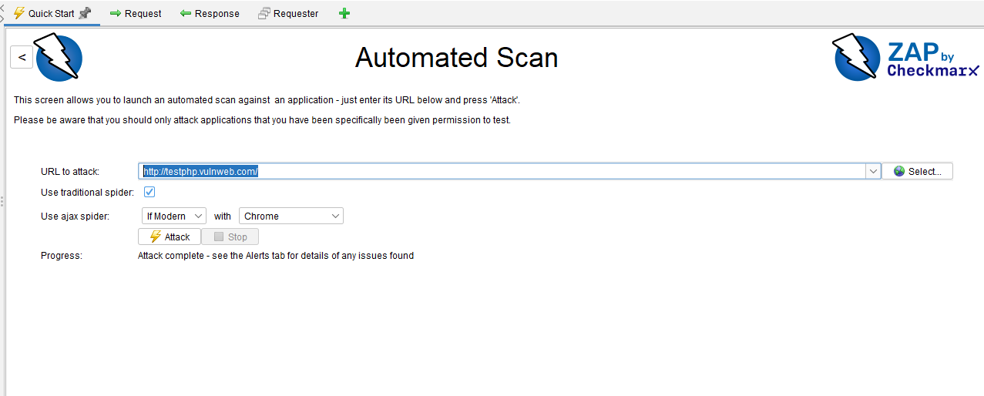

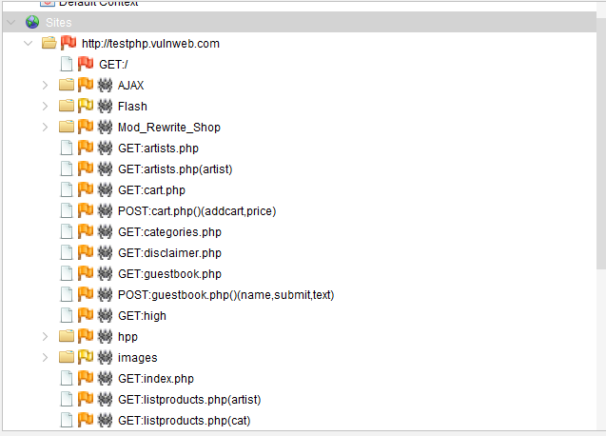

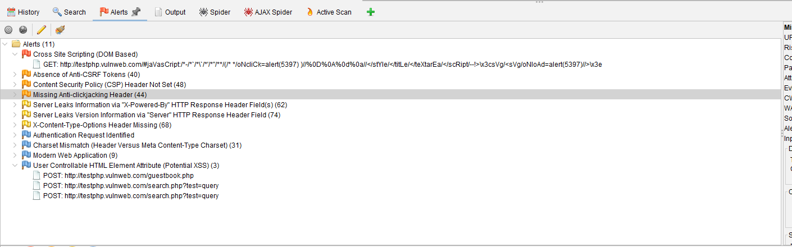

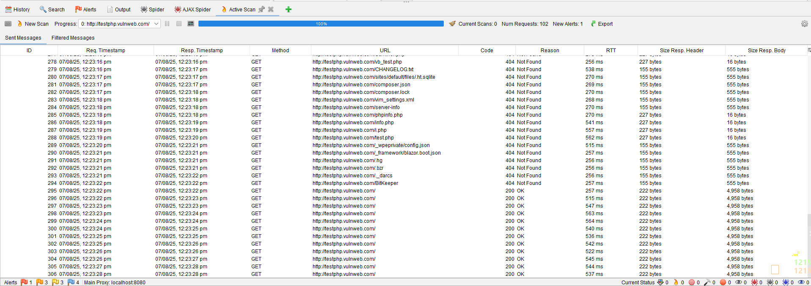

**ATTACK ON** [**https://chatgpt.com/**](https://chatgpt.com/)

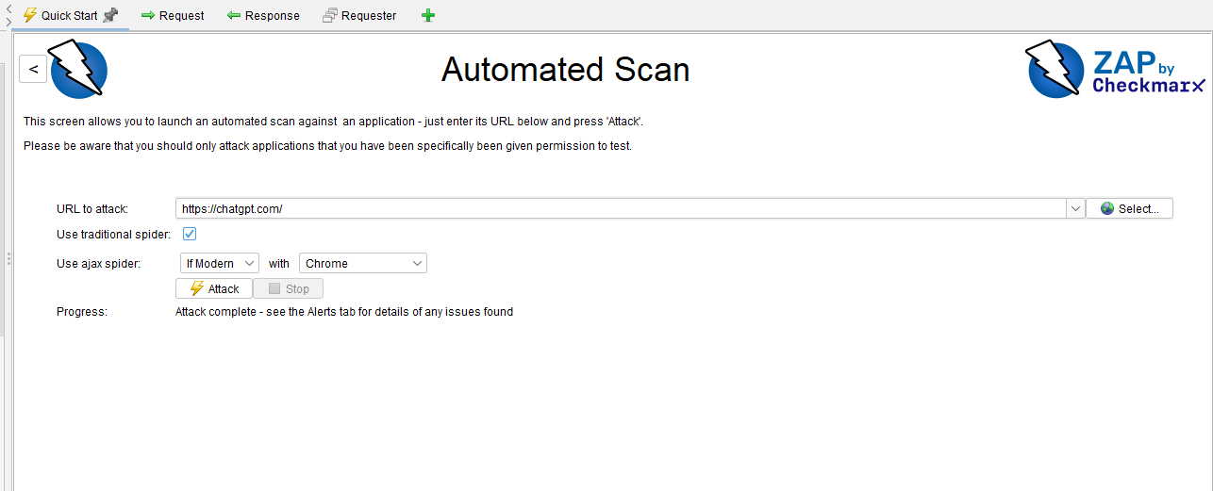

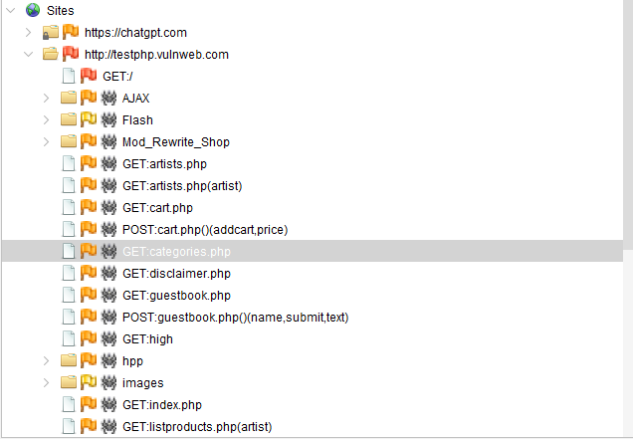

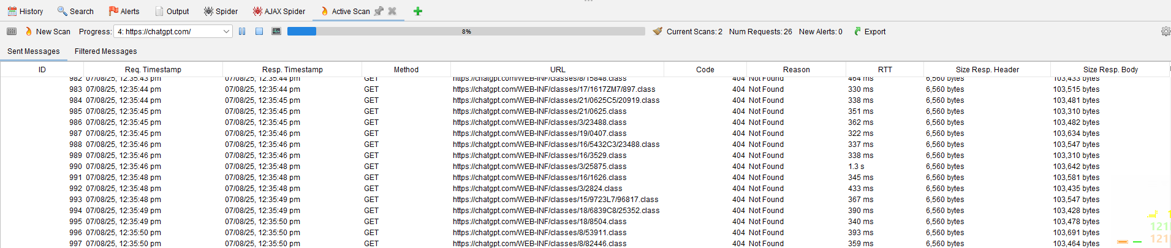

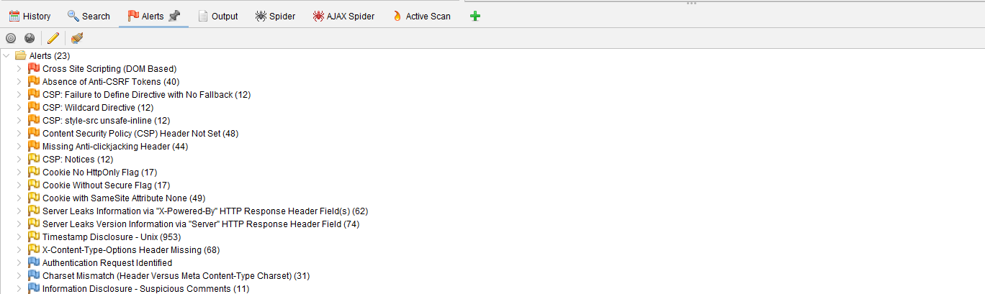

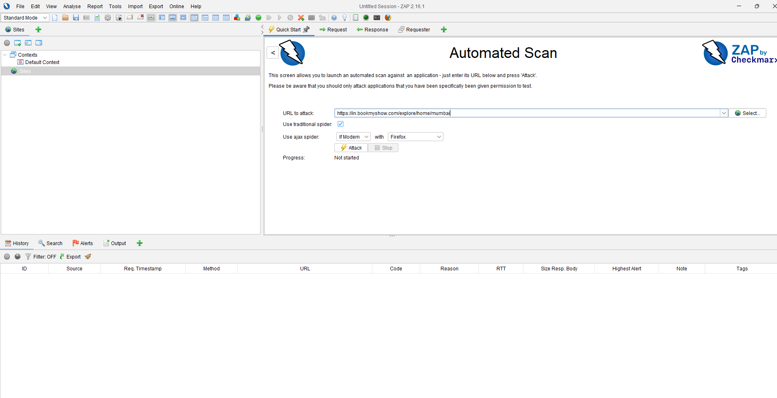

**Passive Attack in standard mode**

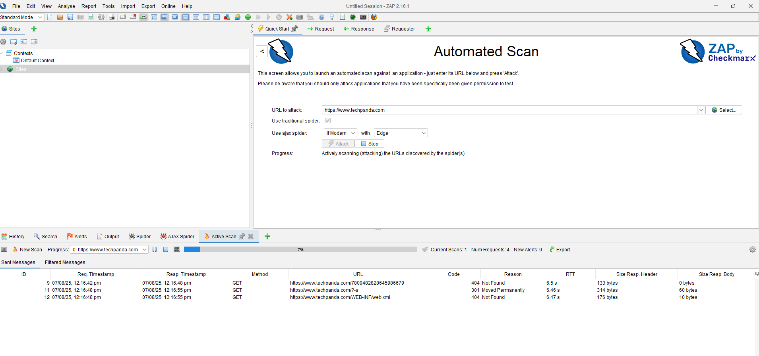

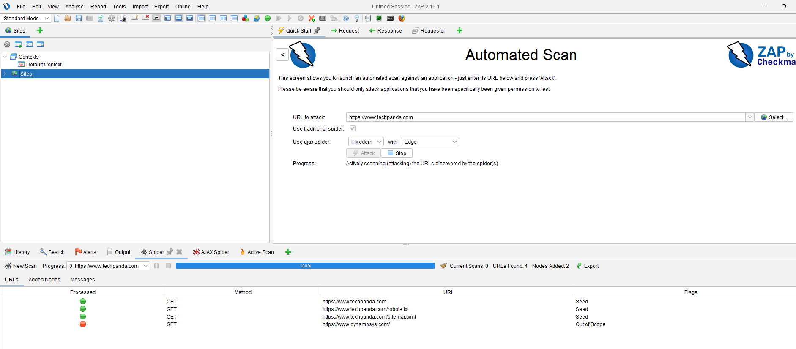

**Passive Attack in attack mode**

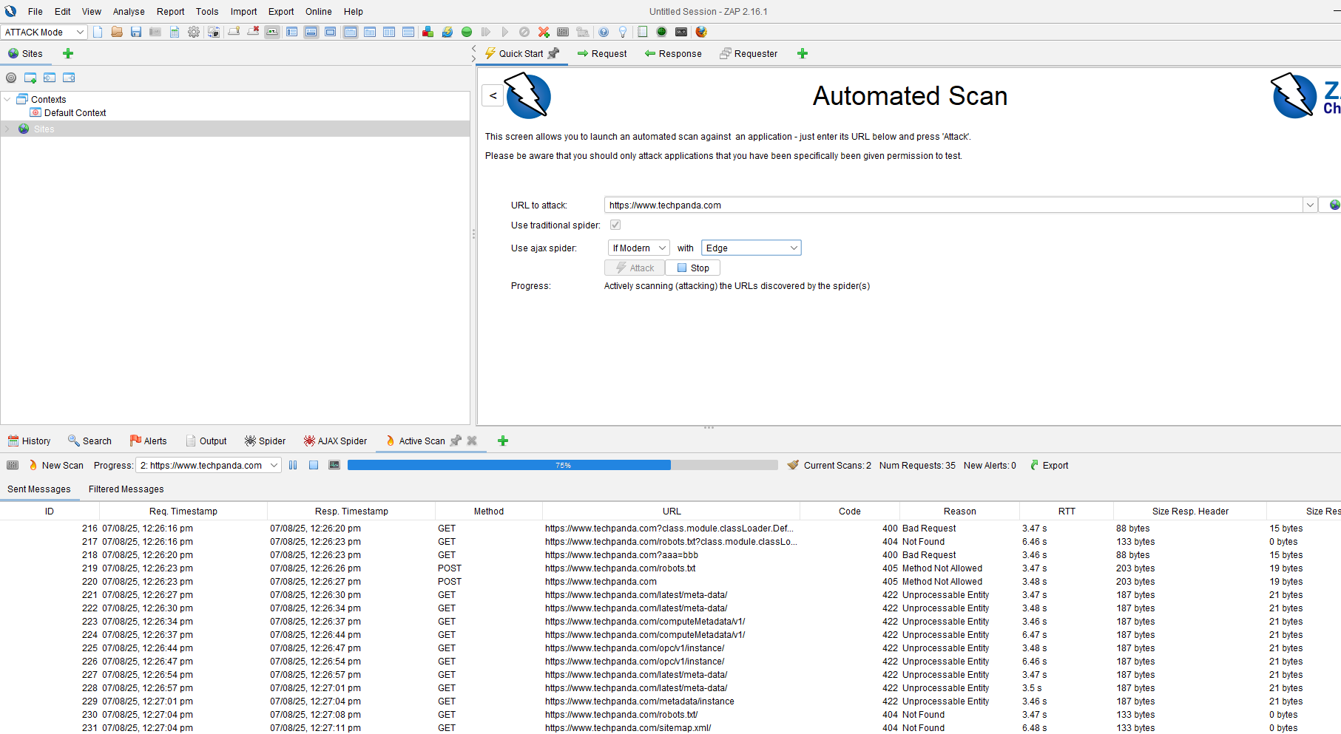

**ETHICAL HACKING PRACTICAL 12**

**Various methods/tools for hiding files in Windows/Stealth Files**

**i. Hide a File Using Command Prompt**

Command: attrib +h +s demo.txt

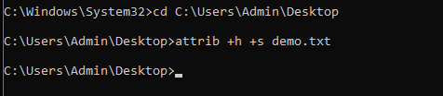

To show the file

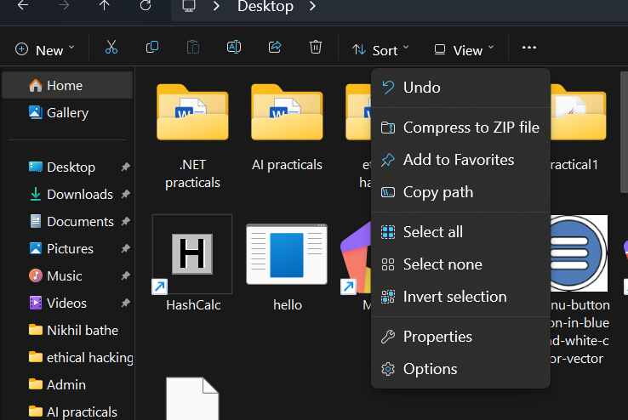

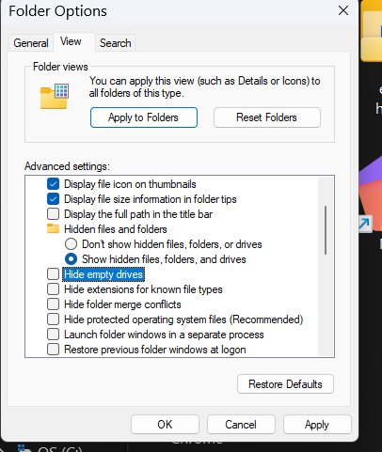

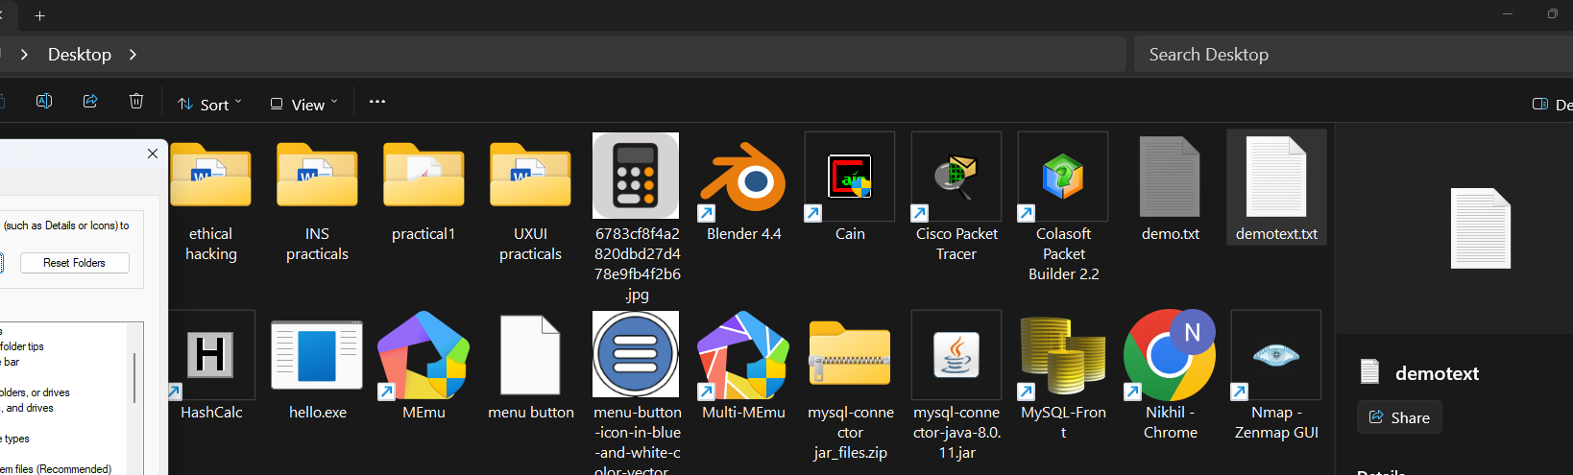

**ii. Rename the File to Disguise Its Type**

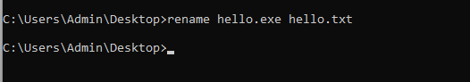



**iii. Create a File With Double Extensions**

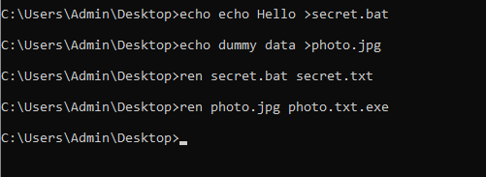

**ETHICAL HACKING PRACTICAL 13**

**->SESSION IMPERSONATION**

**CHROME**

**STEP1: DOWNLOAD COOKIE EDITOR AND ADD ITS EXTENSION TO THE CHROME**

**STEP2: GO TO ‘HTTP’ WEBSITE. EX.,TECHPANDA.ORG  
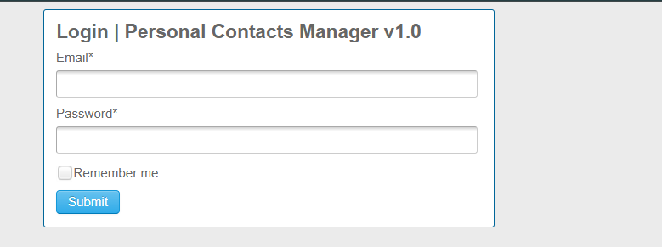**

**STEP2: LOGIN AND OPEN COOKIE EXTENSION ICON**

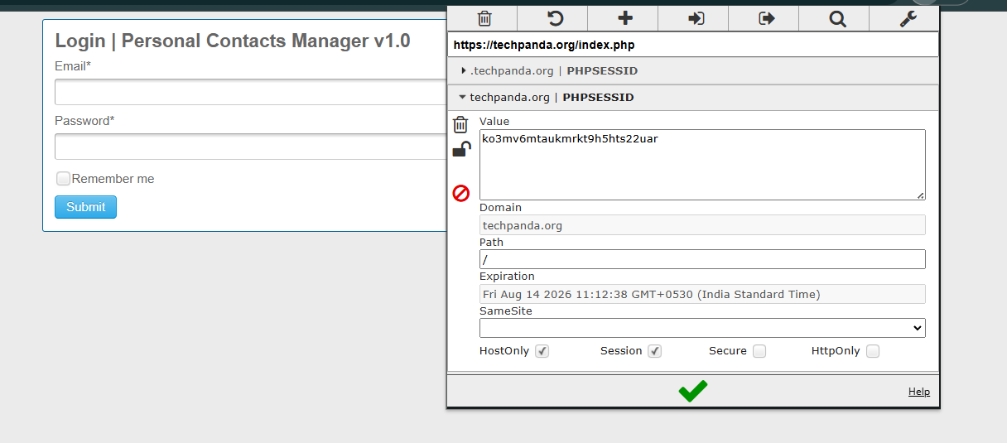

**STEP3: CLICK ON EXPORT**

**STEP4: PASTE THE JSON CODE TO NOTEPAD  
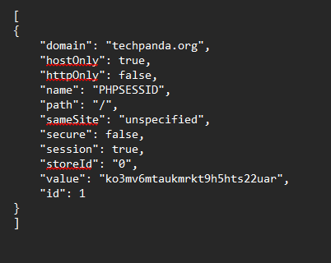**

**STEP5: LOG OUT OF THE TECHPANDA.ORG WEBSITE AND CLICK ON IMPORT AND ADD THE COPIED JSON TEXT TO IT**

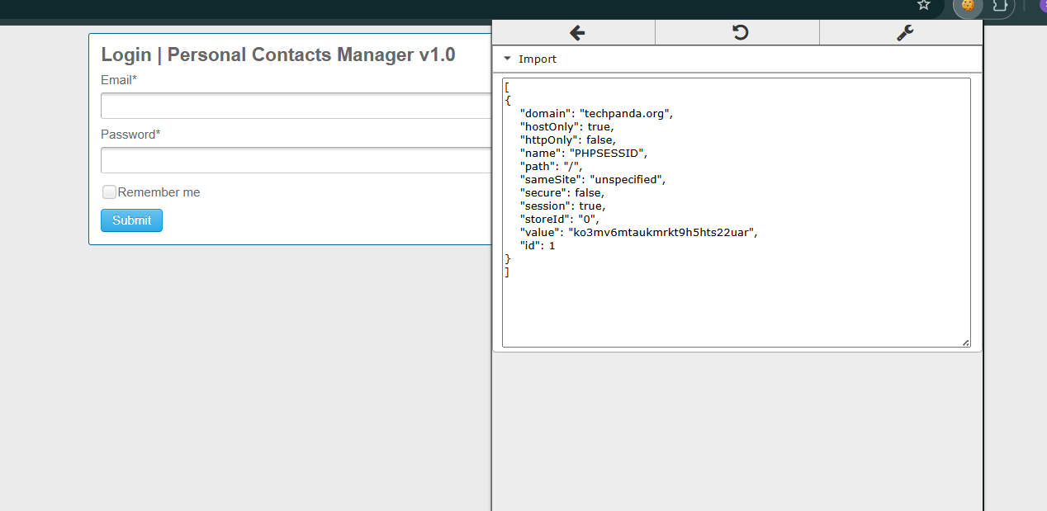

**STEP6: FINAL OUTCOME**

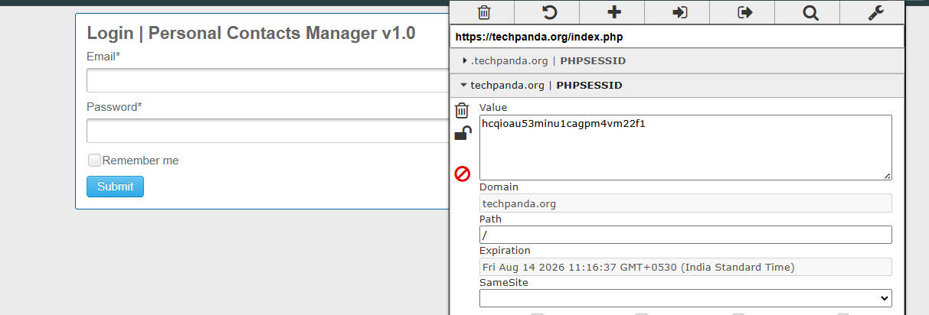

**TAMPER DATA EXTENSION WITH FIREFOX**

**STEP1: OPEN FIREFOX> CLICK ON 3 LINES ON RIGHT UPPER CORNER> CLICK ADD ONS AND THEMES> SEARCH FOR ADDONS> SEARCH TEMPER> CHOOSE TEMPER FF QUANTUM> ADD TO FIREFOX**

**STEP2: OPEN TECHPANDA.ORG ON FIREFOX AND CLICK ON EXTENSION AND SAY YES TO START TEMPERING DATA**

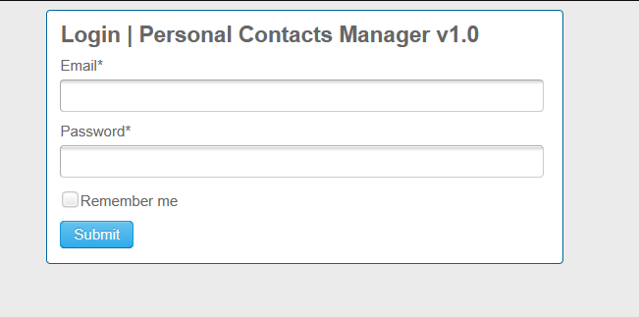

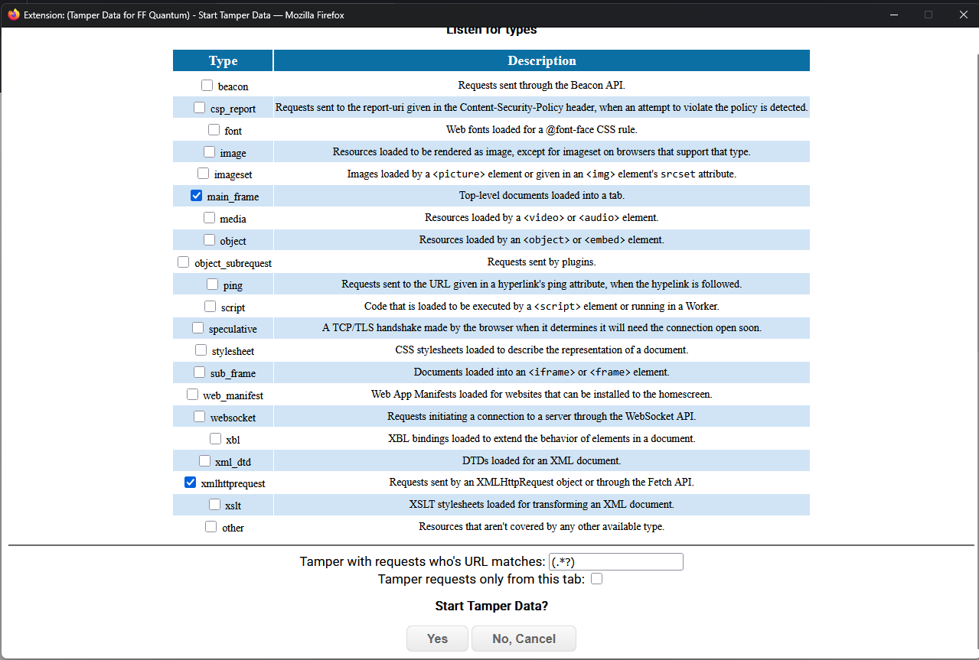

**STEP3:ENTER USERNAME AND PASSWORD AND IT WILL SHOW THE TAB OF INFO YOU ADDED**

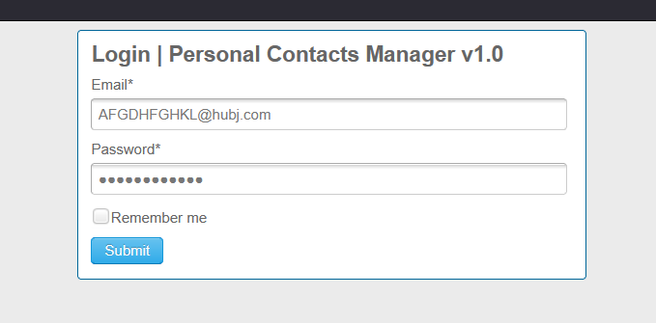

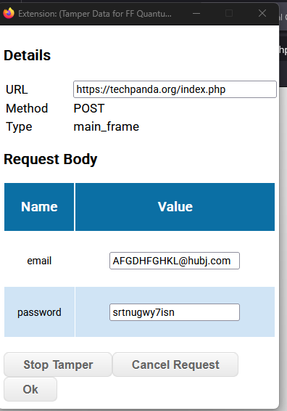

**STEP4: STOP TEMPERING DATA**

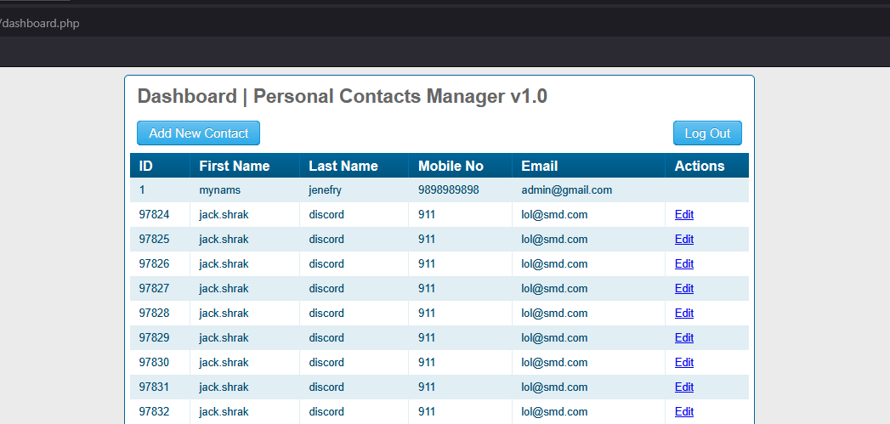

**->Stegnography using OpenStego**

**OpenStego**

**1. Choose a Cover File (e.g., a .png image).**

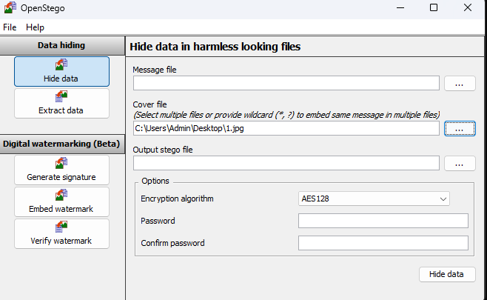

**2. Choose Secret Data (text or any file you want to hide).**

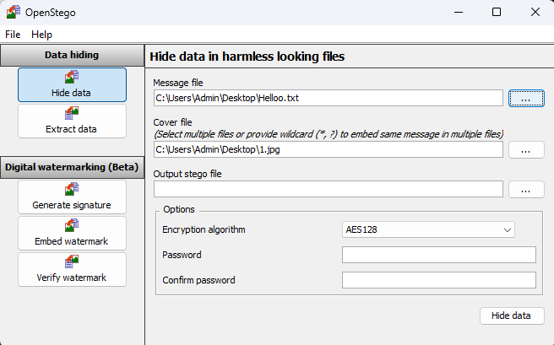

**3. Set a Password (optional but recommended for encryption).**

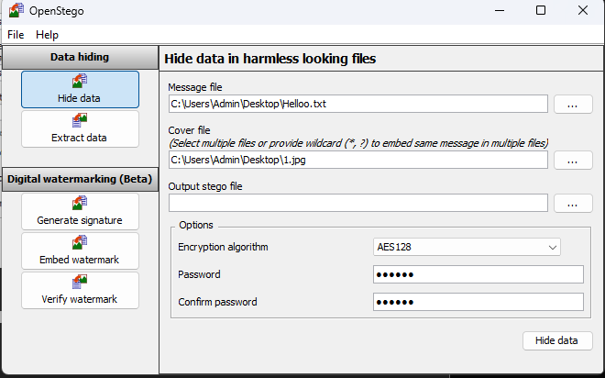

**4. Generate Stego File -> produces a new image file that looks identical to the original but contains hidden data. (In output stego give fike name as per you new)**

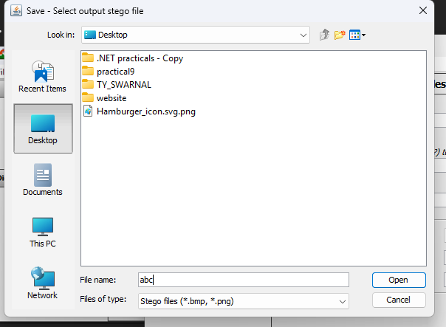

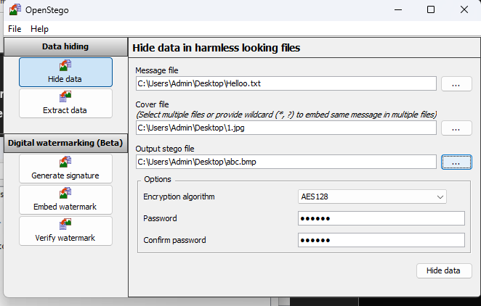

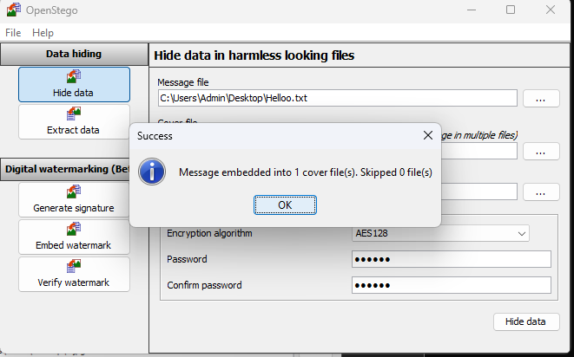

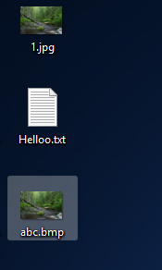

**5. Extract Mode -> given the password, you can recover the hidden data. (Give location of output file different)**

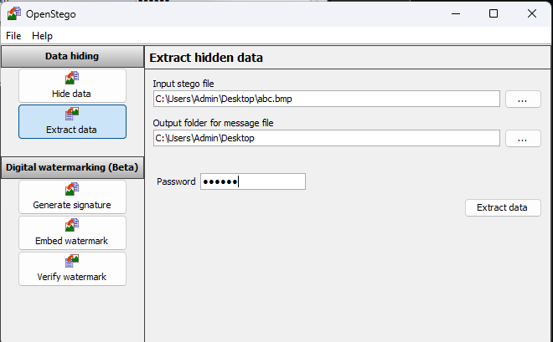

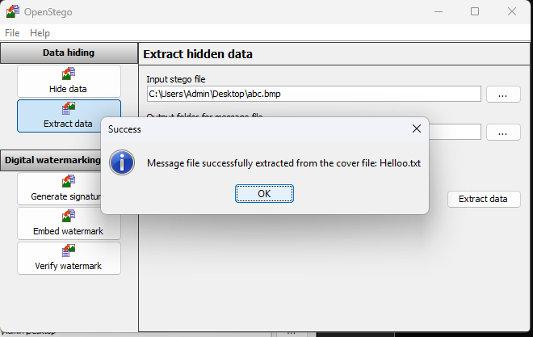

**StegSolve**

**1)Download the jar file and copy it.  
Paste it in This PC -> OS(C:) -> Program Files -> Java -> jdk-18.0.1.1 -> bin**

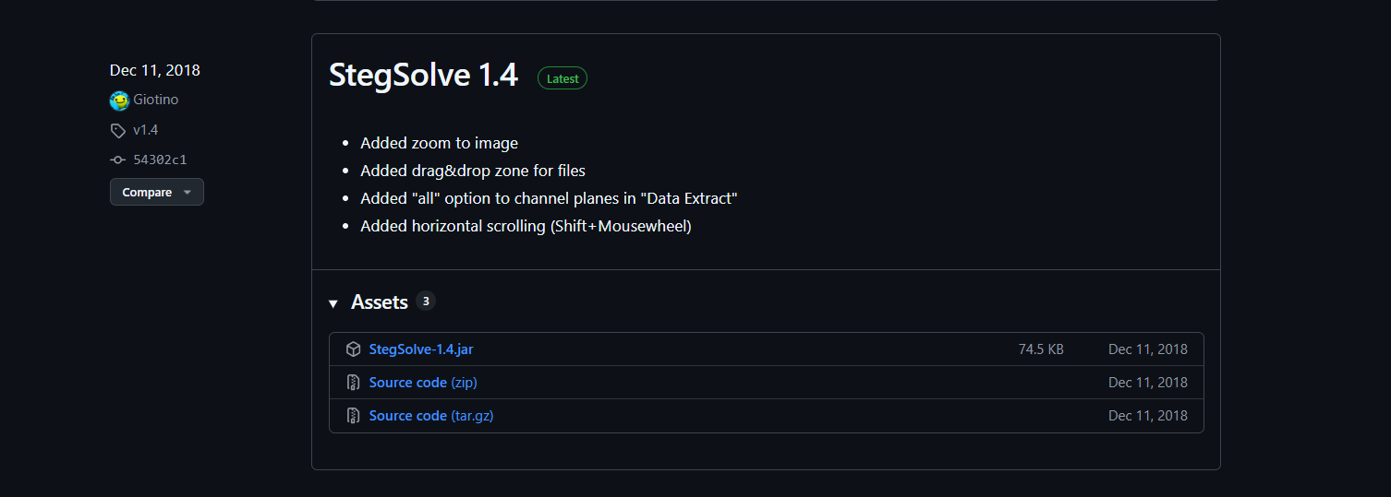

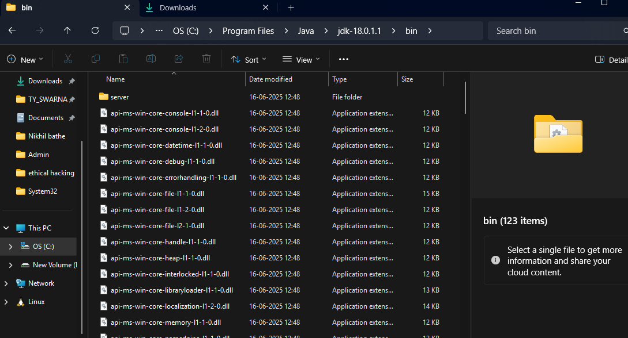

**2) Open the path in cmd**

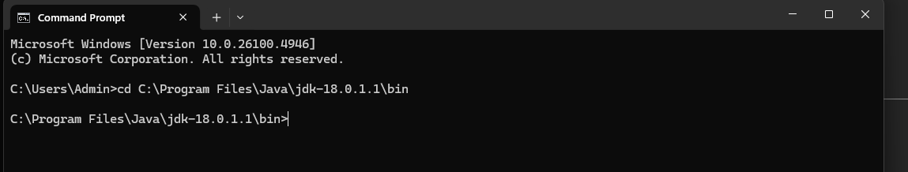

**3)Run the command   
java -jar StegSolve-1.4.jar**

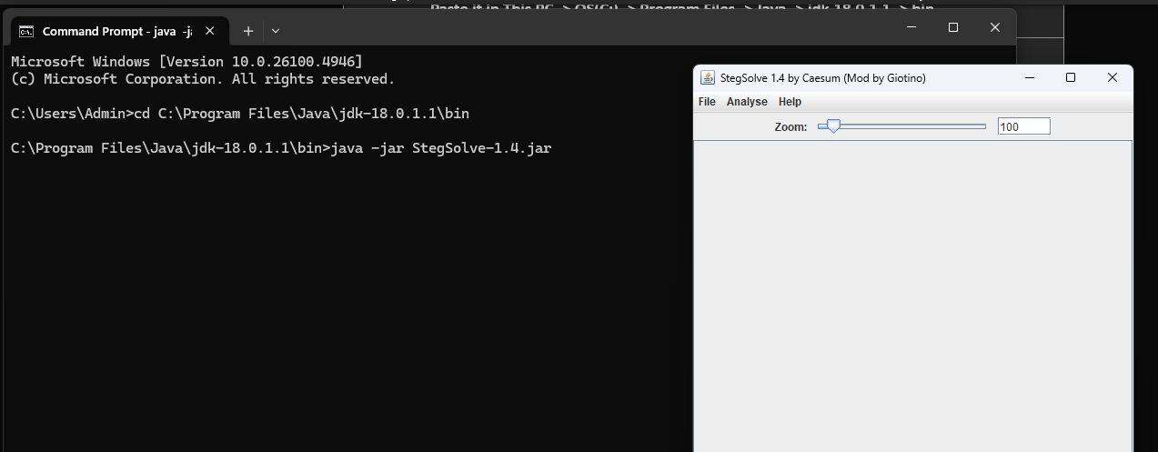

**4)Open file and select the encrypted file abc.bmp and open it**

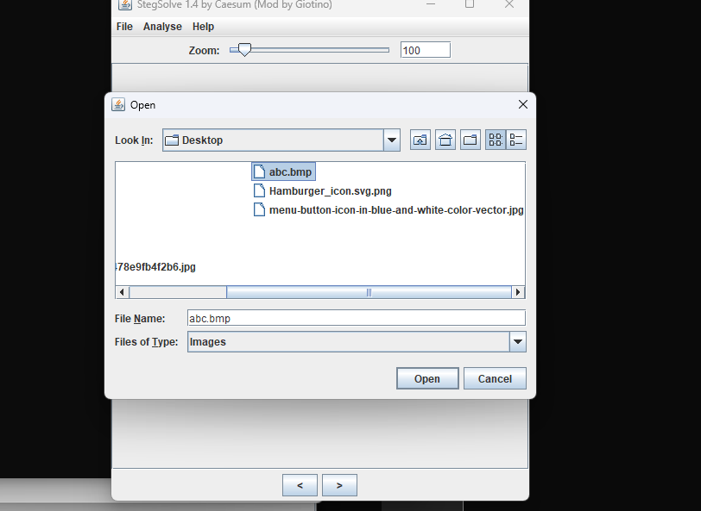

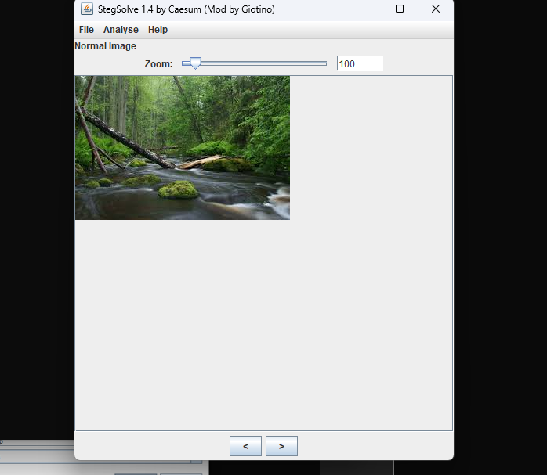

**5)Select Data Extract from Analyse option**

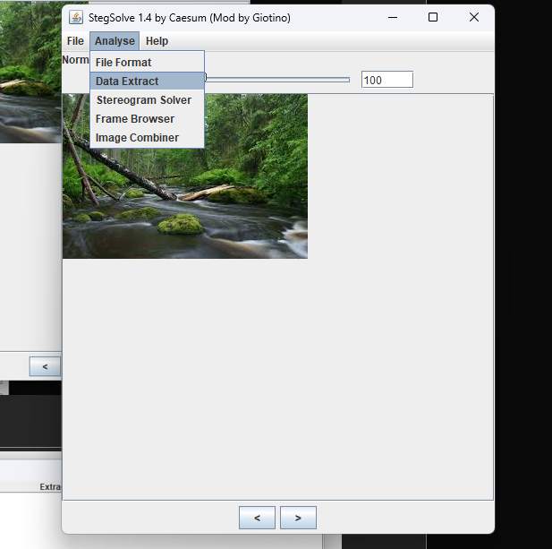

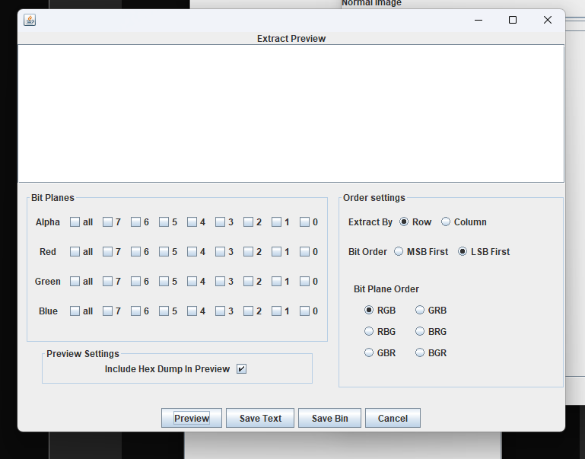

**6)Choose Red/Green/Blue LSB (Least Significant Bit).**

**Dump the extracted data to a file.**

